Classnote–10 Control of PM Pollution

H.W. Seinfeld and Pandis (2nd edition): 9.4, 9.5, 9.6;
De Nevesr: 8.2, 8.4, 8.8, 8.12, 8.26 (Due Nov. 11, 2008)

Dynamics of Single Aerosol Particle

Continuum and noncontinuum regions
If a particle is much greater than the mean free path of the surrounding fluid particles, the fluid behaves, as far as the particle is concerned, as a continuous fluid. The particle is said to move in a continuum region. If the particle is much smaller or of the same size of the fluid particles, the particle behaves as if it's one of the fluid particles with discrete movements between collisions with fluid particles. The fluid media is then noncontinuous to the particle and the particle is said to operate in a noncontinuum region. The distinction lies in the ratio of the mean free path to the size of the particle diameter.

Knudsen Number (Kn): The Knudsen number is defined as
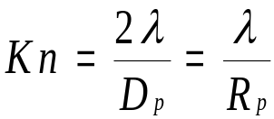
Where
= the mean free path of the fluid: m
D_{p}= the particle diameter; m
R_{p}= the particle radius; m

Mean free path: The mean free path is defined to be the average distance traveled by a molecule between collisions with other molecules.

The mean free path of a pure gas can be determined by

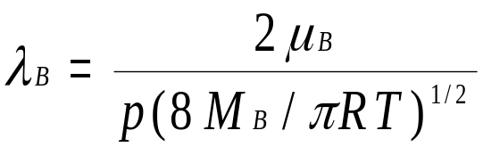

Where
λ_{B}= the mean free path of the fluid B,
μ_{B}= the fluid viscosity,
p= the fluid pressure,
M_{B}= the molecular weight of fluid B,
R= the gas law constant,
T= the fluid temperature.

Example: What is the mean free path of air under standard condition?

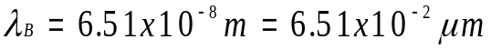

The mean free path of a gas in a binary mixture can be determined by
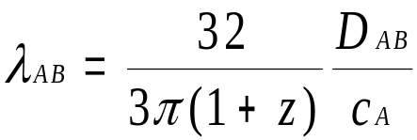

Where

λ_{AB}= the mean free path of molecule A in the mixture of A and B,
D_{AB}= the diffusivity of A,
z= M_{A}/M_{B},
M_{A}= the molecular weight of gas A,
M_{B}= the molecular weight of gas B,
c_{A}= the mean speed of gas molecule B.

Obviously,
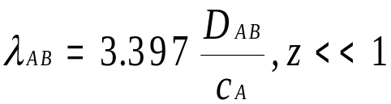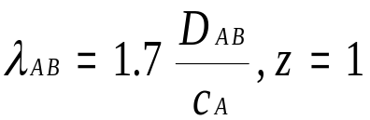
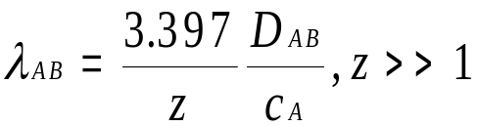

Drag on a Single Particle

Creeping flow around a solid sphere (Bird, 1960 p.56-60, 131-133)

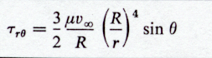
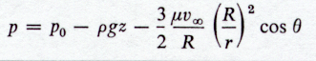
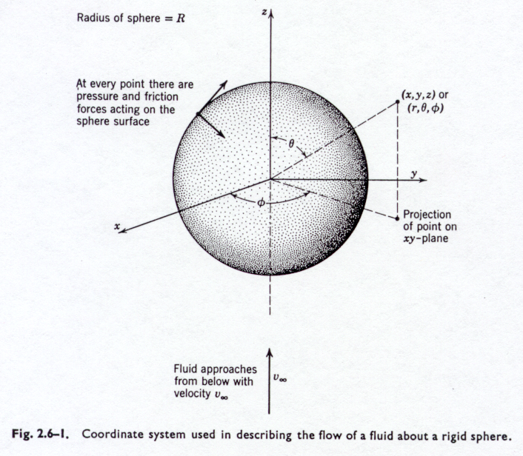

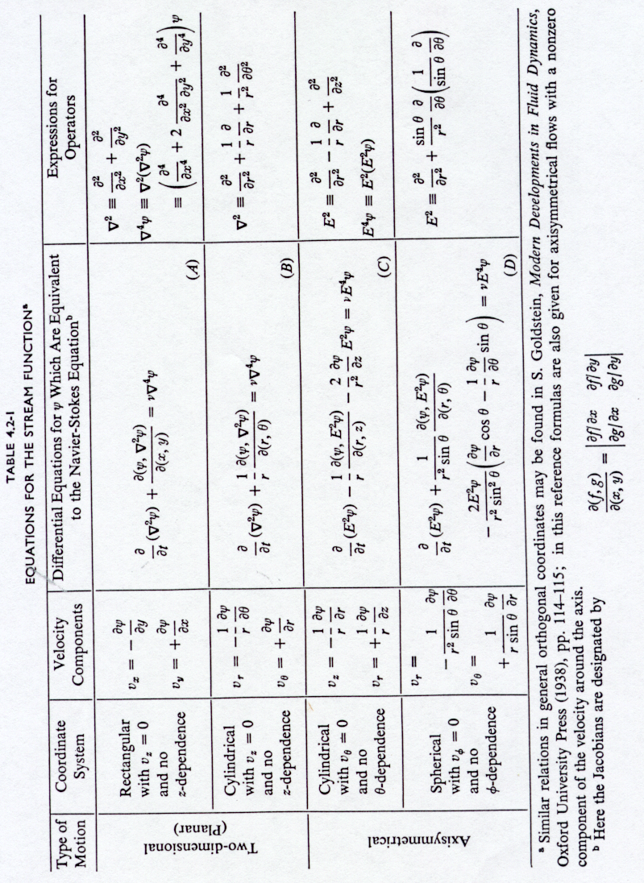
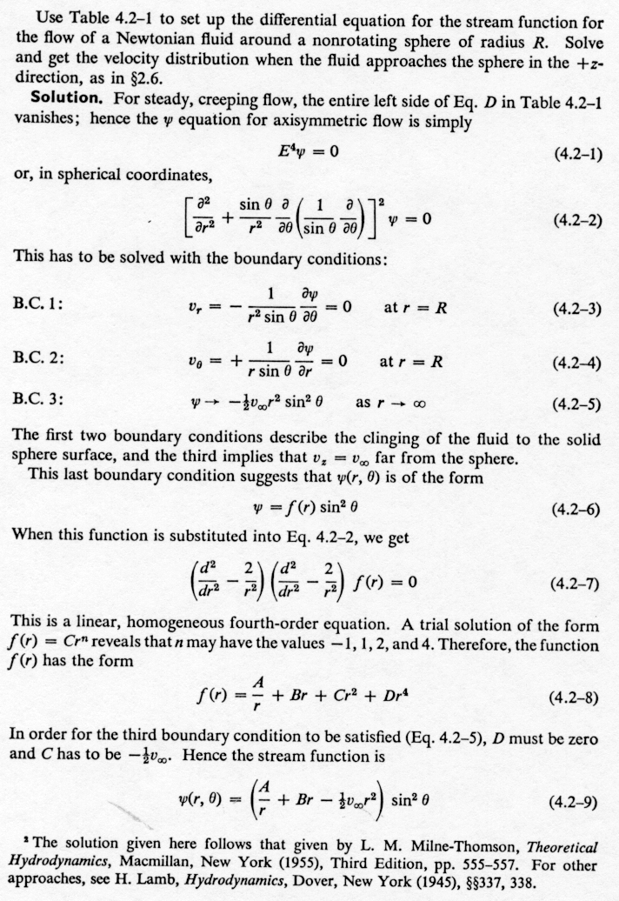

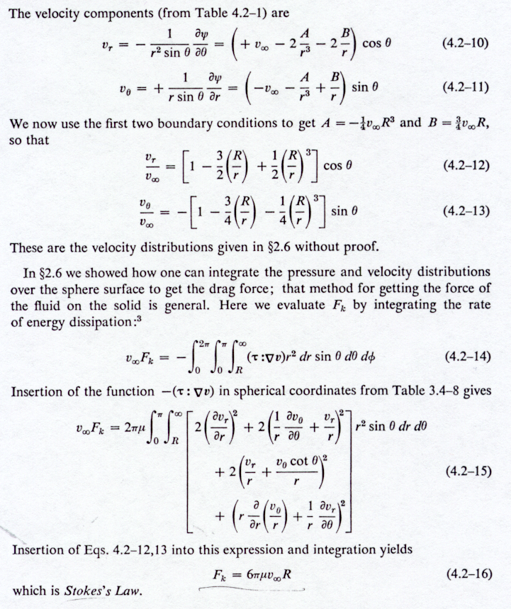

F_{drag} = 6πμv∞R expresses the drag force experienced by a particle in a fluid field and the relationship is call the Stokes’ Law.
Corrections to Stokes' Law

a) Re > 1
The above stokes Law is derived for Re<<1. For Re > 1, the inertial term in the Navier-Stokes equation becomes significant. Experimentally, the drag force can be expressed as
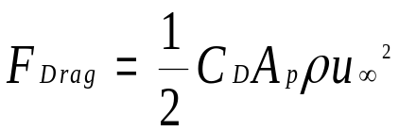
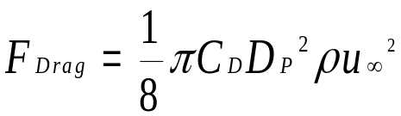Or
And C_{D} is given as
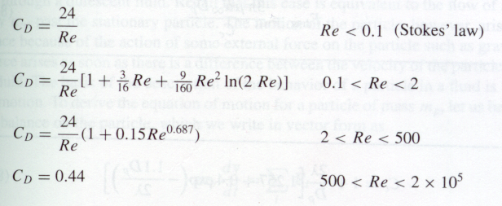

b) Re<<1
For Re<<1, although the inertial force can be completely ignored, unfortunately, the assumption of continuum is gradually fading away as the size of the particle decreases. In a way, the Knudsen number approaches 1. As a result, the drag force exerted by the fluid becomes smaller than predicted by Stokes' law. The slip correction factor is introduced into the Stokes' equation to account for this effect.
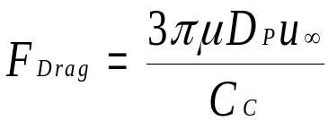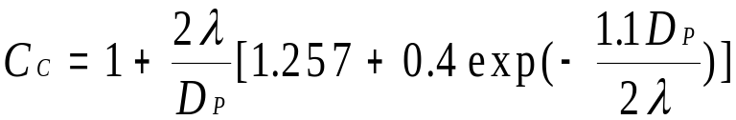
Gravitational Settling of a Particle
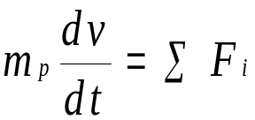
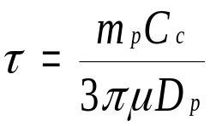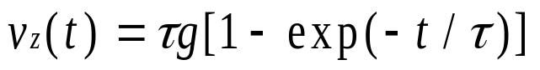
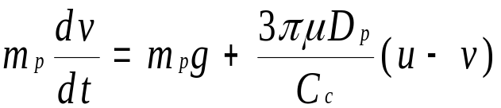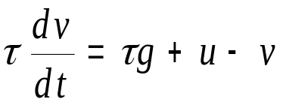If one solves the force balance equation, one obtains (assuming u = 0, i.e., there is no external force field at present in the flow field such that no other motion caused by the eternal field.) The external field could be an electric field with strength E.

For t>>τ, v_{t} = τ g or

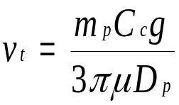
Since m_{p} is defined as
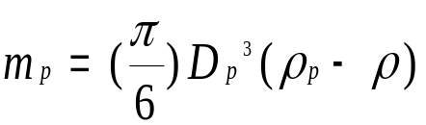
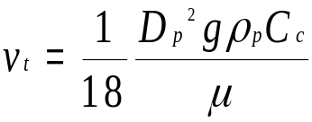We have
Settling of particles for Any Re
We shall apply the drag equation for Re>>1 in the force balance equation,
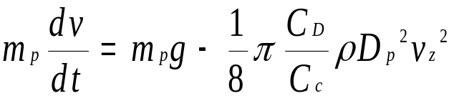

If the terminal velocity is reached as v_{t} and v_{t} = v_{z}, v_{t} can be expressed as:
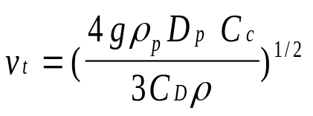
Note that v_{t} is a function of C_{D} and C_{D} is a function of the Reynold’s number. Thus, a try and error method needs to be used to solve for v_{t}. Pages 467-468 of Seinfeld’s book address this.

Diamter of Nonspherical Particles

Stoke Diameter, D_{st}
The diameter of a sphere having the same terminal settling velocity and density as the particle. For a spherical particle the Stokes diameter is equivalent to the actual physical diameter (D_{st}
= D_{sphere})

Classical Aerodynamic Diameter, D_{ca}
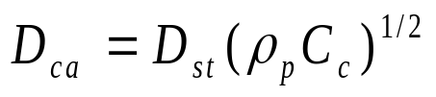The diameter of unit density sphere (ρ_{part} = 1 g/cm³) having the same terminal velocity as the particle. Given the Stokes diameter D_{st}, the classical aerodynamic diameter D_{ca} is given by

PM Removal By Gravity, Centrifugal Force, and Electrostatic Force

Gravitational Settling Chamber
As discussed in the previous section with respect to the Stokes Law, particles will settle towards a wall due to gravity. A gravitational settling chamber is a device that provides sufficient room for the particle-laden air steam to move in one direction while particles settle towards the wall that is perpendicular to the direction of the air stream.

If the length of the chamber is L and the cross section of the chamber is represented by Width (W) x Height (H), the average velocity in the direction along the chamber floor is V_{avg} = Q/(WH), where Q is the flow rate.

The residence time for the air stream inside the chamber is t = L/ V_{avg} . Therefore, the distance traveled by a particle in the direction perpendicular to the flow direction is

L_{vertical} = V_{t} x t

Where V_{t} is particle velocity in the vertical direction (or the direction perpendicular to the flow direction). For large particles, V_{t} would be unsteady-state and accelerates in the vertical direction towards the wall by Newton’s law. These particles (or should be called objects) will settle very rapidly or should not even be present in the chamber are not discussed in this section. For small particles, the Stokes law indicates that a terminal speed should be reached and thus the notation is given to indicate a terminal velocity.

Different size of particle has different terminal velocity and, depending on the initial location of the particle inside the chamber, different settling distance to reach the wall. Mathematical models can be developed to show the efficiency of particle settling for different sizes of particles.
If we assume that particles are uniformly distributed across the inlet of the chamber and the no interaction occurs among particles during the settling (block flow assumption), the fraction of particles captured by the wall (removal efficiency) can be expressed as below:

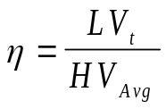
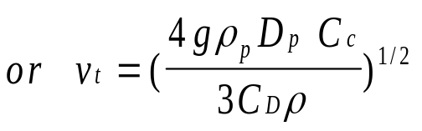
and

A more refined approach is to assume that particles are well mixed inside the chamber and to consider mass conservation at different cross section downwind of the inlet (mixed flow assumption). The removal efficiency can then be presented as:
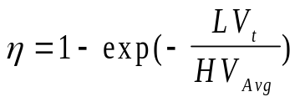
and V_{t} is defined as before.

Cyclone PM remover
Cyclone PM removers are devices designed to taking advantage of the principle of gravitational settling with two modifications:

- The chamber length is defined to be the spiral curves inside the cyclones to save space
- The centrifugal force is used instead of the gravitational force

The centrifugal acceleration is defined as V²/r compared to the gravitational acceleration of g. The centrifugal force can be orders of magnitude greater than the gravitational force. For instance,

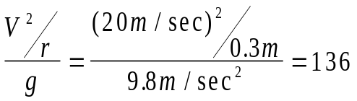

Electrostatic Precipitator
Even with the cyclone PM removers many fine particles still require a larger residence time to settle to the wall. This would require a force even more powerful than the centrifugal force to shorten the residence time. Electrostatic precipitator is designed to provide electrostatic force to remove particles. The electrostatic force is provided between two charged plates where the air stream is channeled to pass between the two plates.

Thermophoresis, Photophoresis and Diffusiophoresis
Ultrafine particles may still escape from the removal mechanisms provided by the above-mentioned removal principles. Several effects induced by forces other than the traditional ones are used to remove the ultrafine particles. These are thermophoresis (by diffusion of particles due to temperature gradient), photophoresis (by diffusion of particles due to radial energy gradient), and diffusiophoresis (by the diffusion of particles due to gas concentration gradient).

PM Removal By Filtration and Scrubbing
Filtration is used to collect particles by forcing the air stream to pass a filter. Particles are being removed from the filters by impaction, interception, (molecular and turbulent) diffusion, and deposition. These devices include filters, baghouses, microfibers.
Scrubbers are designed to collect particles with enhanced particle-filter (water drop) contact mechanism. Devices include: dry scrubber, wet scrubber, venturi scrubber, etc.

