Classnote–11 PM Removal By Gravity, Centrifugal Force, Electrostatic Force, and Filtration

H.W. # 11 De Never 9.2, 9.6, 9.13, 9.9
(Due April 16, 2007)

Gravitational Settling Chamber

Block Flow (Unmixed Flow)
As discussed in the previous section with respect to the Stokes Law, particles will settle towards a wall due to gravity. A gravitational settling chamber is a device that provides sufficient room for the particle-laden air steam to move in one direction while particles settle towards the wall that is perpendicular to the direction of the air stream.

If the length of the chamber is L and the cross section of the chamber is represented by Width (W) x Height (H), the average velocity in the direction along the chamber floor is
V_{avg} = Q/(WH), where Q is the flow rate.

The residence time for the air stream inside the chamber is t = L/ V_{avg} . Therefore, the distance traveled by a particle in the direction perpendicular to the flow direction is

L_{vertical} = V_{t} x t

Where V_{t} is particle velocity in the vertical direction (or the direction perpendicular to the flow direction). For large particles, V_{t} would be unsteady-state and accelerates in the vertical direction towards the wall by Newton’s law. These particles (or should be called objects) will settle very rapidly or should not even be present in the chamber are not discussed in this section. For small particles, the Stokes law indicates that a terminal speed should be reached and thus the notation is given to indicate a terminal velocity.

Different size of particle has different terminal velocity and, depending on the initial location of the particle inside the chamber, different settling distance to reach the wall. Mathematical models can be developed to show the efficiency of particle settling for different sizes of particles.
If we assume that particles are uniformly distributed across the inlet of the chamber and the no interaction occurs among particles during the settling (block flow assumption), the fraction of particles captured by the wall (removal efficiency) can be expressed as below:

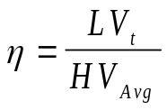
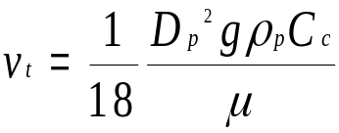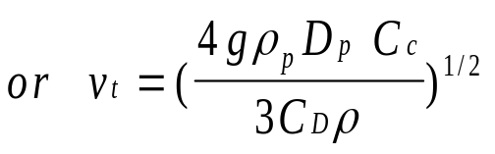
and

Mixed Flow

A more refined approach is to assume that particles are well mixed inside the chamber and to consider mass conservation at different cross section downwind of the inlet (mixed flow assumption). The removal efficiency can then be presented as:
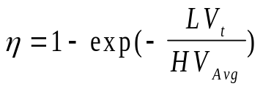
and V_{t} is defined as before.

We started with the assumption that the gas flow is totally mixed in the direction perpendicular to the direction of the mean flow. The fraction of particles collected on the floor of the gravitational chamber can be expressed as

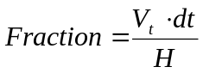

Thus, the change in concentration becomes 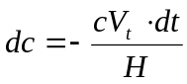

Also, 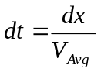, thus

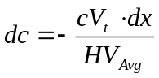

Integrate the above equation from x=0 to x=L (while c varies from c_{in} to c_{out}), we have
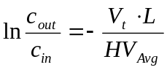
or
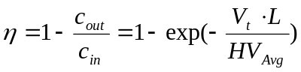

Substituting Vt with the Stoke’s terminal velocity,

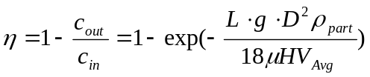

Cyclone PM remover
Cyclone PM removers are devices designed to taking advantage of the principle of gravitational settling with two modifications:

- The chamber length is defined to be the spiral curves inside the cyclones to save space
- The centrifugal force is used instead of the gravitational force

The centrifugal acceleration is defined as V²/r compared to the gravitational acceleration of g. The centrifugal force can be orders of magnitude greater than the gravitational force. For instance,

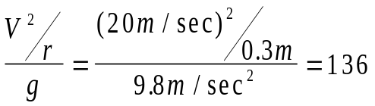

Design of Centrifugal Separators

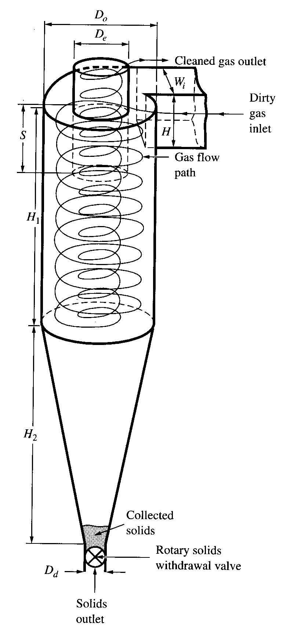

We shall replace the gravity force with centrifugal force and compute the Stokes’ terminal velocity . That is to replace the term g by 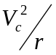
As a result, we have

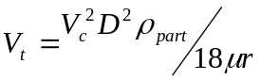

Going through the same derivation as shown in gravitational settling chamber,
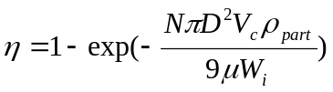 for mixed flow

Electrostatic Precipitator (ESP)
Fine particles (mostly <5 μm) require a larger residence time to settle to the wall. This would require a force even more powerful than the centrifugal force to shorten the residence time. Electrostatic precipitator is designed to provide electrostatic force to remove particles. The electrostatic force is provided between two charged plates where the air stream is channeled to pass between the two plates.

The electrostatic force on a particle is F = q E_{p}, where q is the electric charge on the particle and E_{p} is the local electric field strength. Q is defined in Equation 9.23 of DN. The terminal/drift velocity of particle can be developed by replacing the gravity force term in the the Stokes’ law with the electrostatic force discussed here.

Thermophoresis, Photophoresis and Diffusiophoresis
Ultrafine particles may still escape from the removal mechanisms provided by the above-mentioned removal principles. Several effects induced by forces other than the traditional ones are used to remove the ultrafine particles. These are thermophoresis (by diffusion of particles due to temperature gradient), photophoresis (by diffusion of particles due to radial energy gradient), and diffusiophoresis (by the diffusion of particles due to gas concentration gradient).

PM Removal By Filtration and Scrubbing

Filtration

Surface Filter
Surface filter serves as a surface for growing cake (an accumulation of particles in depth) while the cake serves as the actual filter for particle removal.

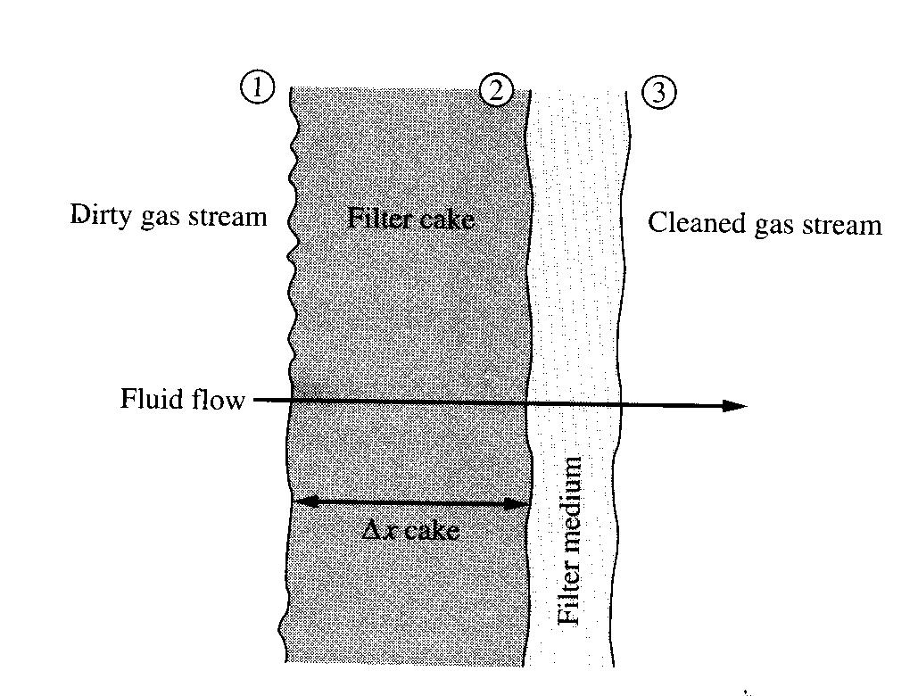
Based on the flow in porous medium, the air flow will be

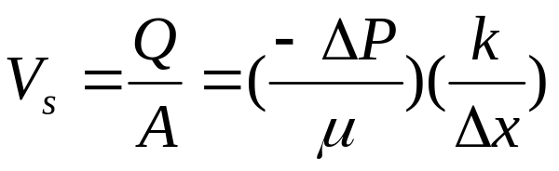
where Vs = the surface velocity of the air stream at the filter medium
Q = the flow rate of the air stream
A = the cross sectional area
ΔP = pressure drop
k = permeability
Δx = thickness of the medium

Apply the above equation to the filter with a layer of filter cake,
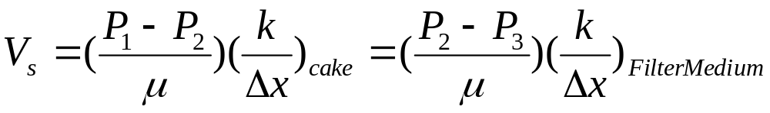

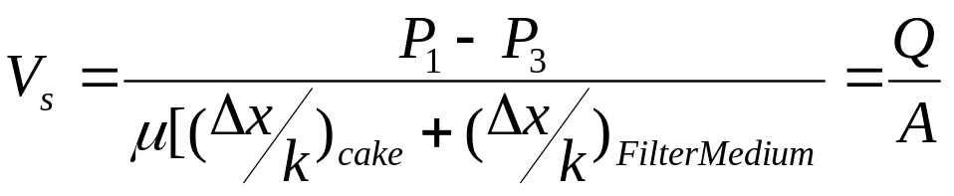

Examples of filter medium used in industry

Shake-deflate Design

Pulse-jet Design

Depth Filter
Depth filter captures particles by the filter medium itself without the filter cake.

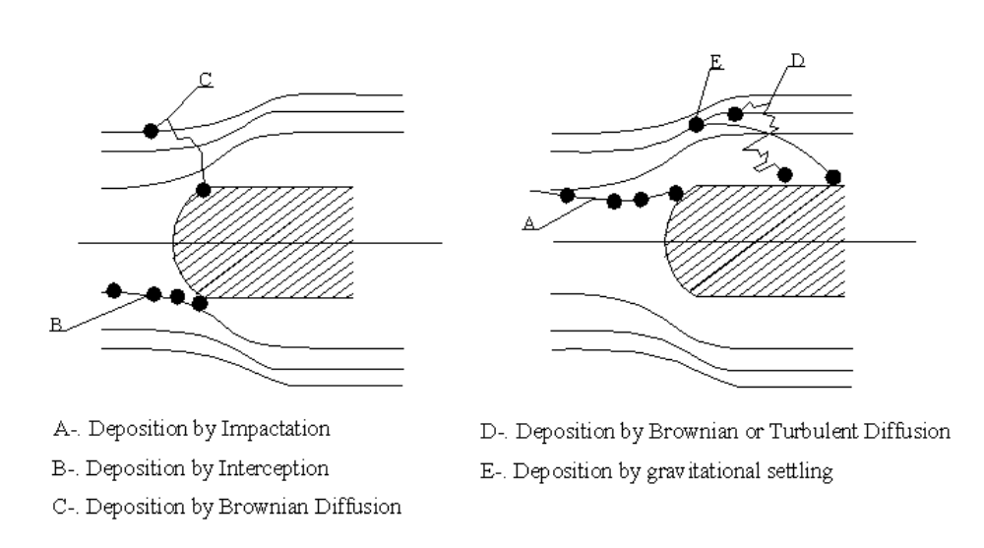
Among the five mechanisms of particle removal by a depth filter, depositions (capturing of particles by the medium) by impaction and by interception appears to be the dominant mechanisms. Both mechanisms can be quantified using Stokes law. As discussed by De Never (p292 –298), the particle capture efficiency depends on the size of the particles, the size of the medium, the velocity of the air stream, fluid viscosity, and the particle density. A figure is constructed for the relationship between the capture (target) efficiency, η, and the separation number, Ns.

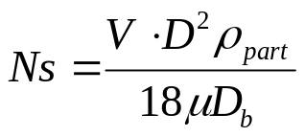

where V = the air stream velocity
D_{b} = the diameter of the medium
D = the diameter (size) of the particle of concern

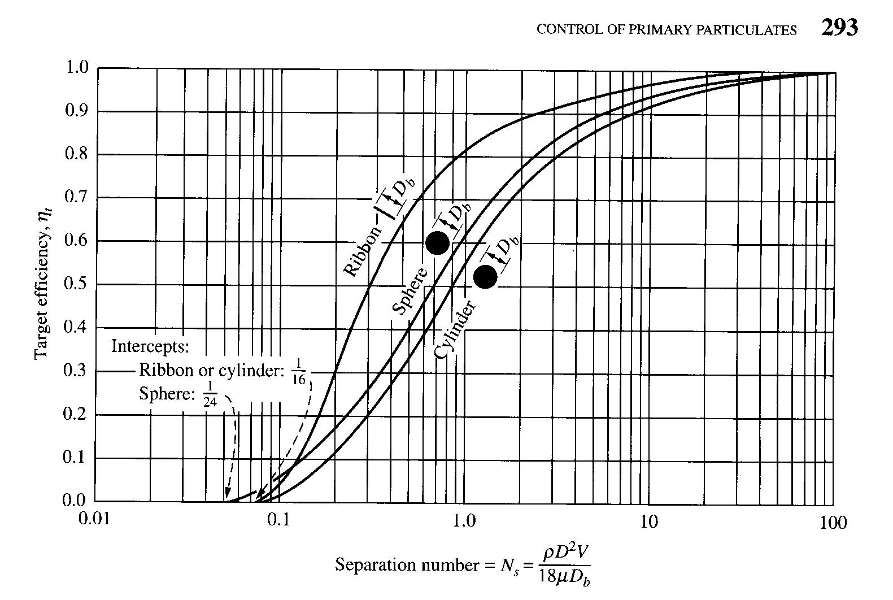

Scrubbers

Scrubbing of PM in a stagnant air
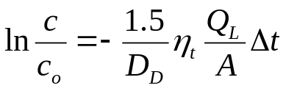

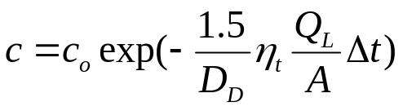

Scrubbing of PM in a cross flow

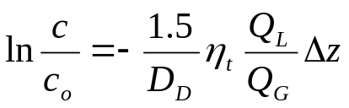

Scrubbing of PM in a counter flow
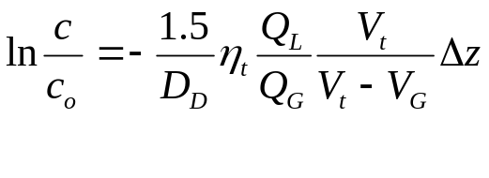

Scrubbing of PM in a co-flow flow


