CE 5326: Indoor Air Pollution

The Perception of Indoor Air Quality Poor indoor air quality rarely, clinically or sub-clinically, results (or have not been concluded to result) in serious adverse health effects, which of course does not include accidental releases of natural gas, mobile exhaust, toxic chemicals. However, many factors cause the sum of the sensations leading to the total perception of the indoor air quality. These factors are:

- Thermal Environmental
- Air temperature (T)
- Mean radiant temperature (mrt, or the average temperature of surfaces that surround a person)
Stuffy: T - mrt >3 ºC
Fresh: mrt - T >0 ºC
- Rate of air movement (v) <0.3 m/sec
- Relative humidity (H) between 40 to 60 %
- Insulation value of clothing worn
- Metabolic rate of task being performed

- Sensory Perception
- Skin sensory
- Olfactory sensory
- Odor threshold (WHO 1987)
Detection threshold level: the lowest concentration that can be detected in 50 % of tests
Recognition threshold level: the lowest concentration that can be identified in 50 % of tests
Nuisance threshold level: the concentration at which not more than a small proportion of the population (<5 %) experience annoyance for a small part of the time (<2 %)

- Use of untrained observers
- Use of trained observers
- Use of a unit of pollution (decipol)
- Use of total volatile organic compounds (VOCs)
- Use of specific VOCs

Characterization of Indoor Air Quality

Health Effects resulting from exposures to Bacteria, Fungi, and Other Micro-organisms
The sources of microbiological contamination of the indoor air are associated with warm temperature and high humidity in the indoor environment. These sources include humidifiers, chillers, air ventilation ductwork, water leaks, air conditioning, air filters, food residues, and occupants. Diseases and health symptoms related to exposures to microbiological contaminants can be summarized as below:

Extrinsic allergic alveolitis: A severe disease of the gas exchanging parts of the lungs (alveoli) which can lead to permanent disability and occasionally to premature death. The acute form of the disease starts 6 to 8 hours after the exposure with a "flu-like illness, fever, chills, breathlessness, cough and general aches and pains. The chronic form comes with weight loss and progressive breathlessness. Main sources of the disease are mouldy hay, birds, humidifiers.

Humidifier fever: Similar to those of extrinsic allergic alveolitis with fever, sweating, aches in the limbs, sometimes breathlessness and wheeze.

Asthma: Asthma is a disease of the airways which become inflamed and narrow resulting in variable breathlessness, chest tightness and often wheeze. Main sources of the disease are dust mites, lower humidity, occupant psychology, etc

Allergic rhinitis: Allergic rhinitis is a disease similar to hay fever where the nose is inflamed and sneezing occurs. Running or blockage of the nose is also a symptom. Most reactions occur shortly after exposure although occasionally late reactions may develop Main sources of the disease are house dust mites, moulds, etc.

Infection: Infections may be spreaded via the indoor air environment or by the ventilation systems.

- Legionnella
- Tuberculosis

Sick building syndrome: Illness or symptoms related to living or working in a particular building. Main symptoms include sore eyes, running eyes, nasal blockage, running or sneezing, dry throat, lethargy, headaches and sometimes asthma. Factors related to the sick building symptoms are:

- Personal factors
- Agents in the workplace
- Organizational factors
- Building related factors

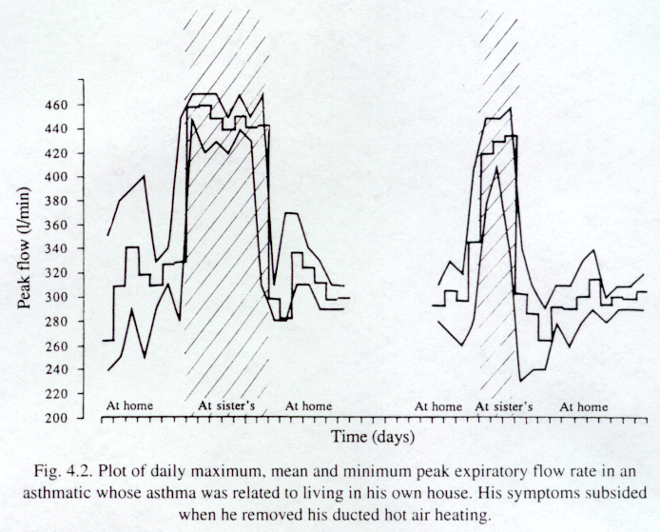
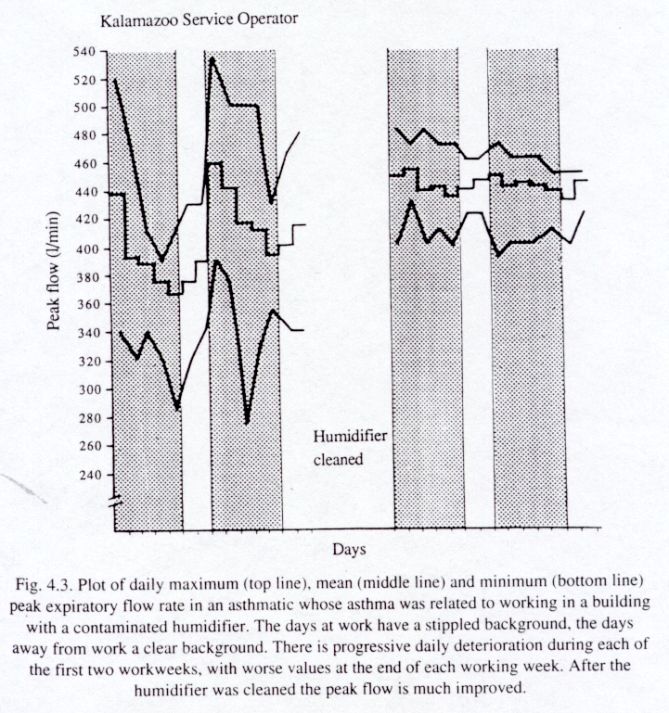
PEFR (L/min) = [Height (cm) - 80] x 5

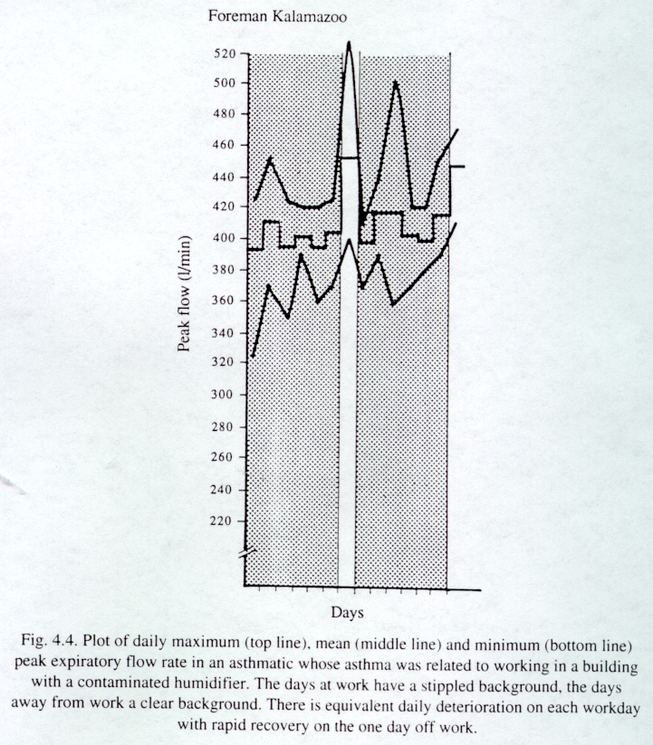

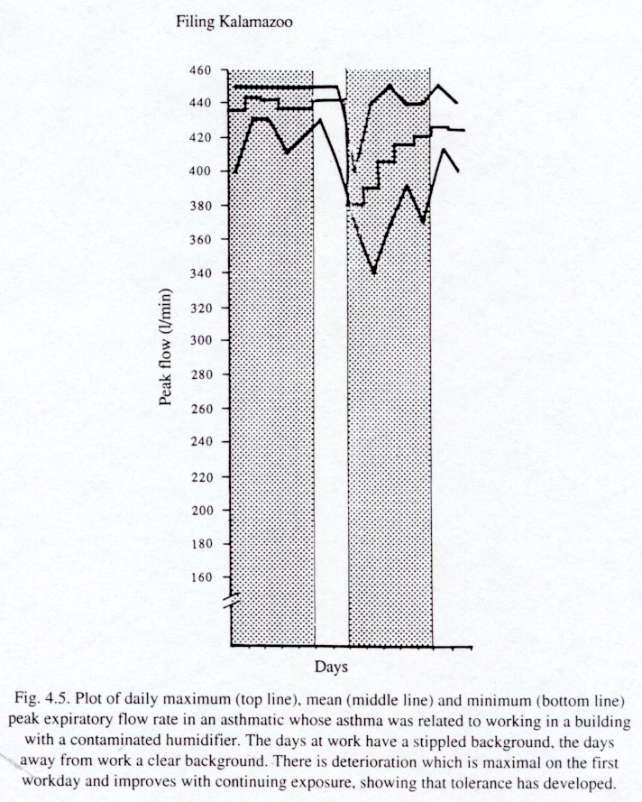

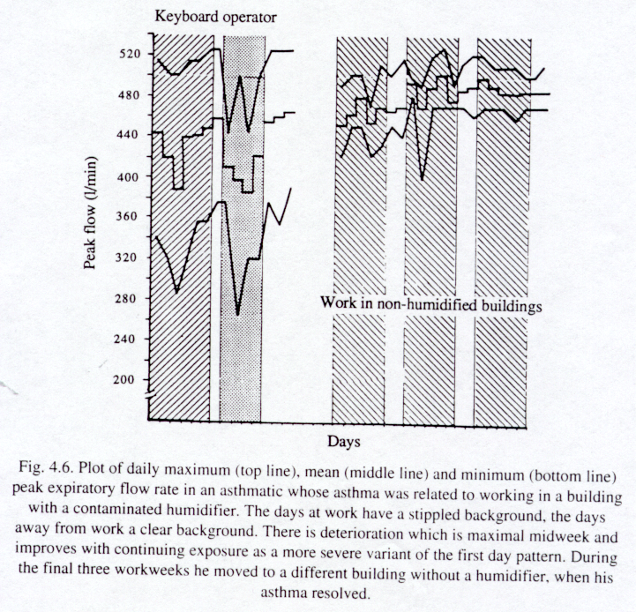

Health Effects resulting from exposures to Chemicals
Major air pollutants in indoor environment are:

Carbon monoxide

Nitrogen oxides

Tobacco smoke

Asbestos and fibrous particles

Formaldehyde: a low molecular weight aldehyde (CH₂O, M.W. = 30) with pungent colorless gas. It's soluble in water. Methanol is commonly added at a 10 - 15 % concentration to formalin solution as a stabilizer to prevent polymerisation to paraformaldehyde solid. It is used widely in urea-formaldehyde foam insulation (UFFI). Indoor formaldehyde concentrations of 0.1 - 0.8 mg/m³ in houses with UFFI and 0.5 mg/m³ in mobile homes are commonly found. Exposure to formaldehyde gas is generally limited by the pungent and irritant nature of the molecule with significant symptoms being experienced above 1 mg/m³. Acute exposure of high level of formaldehyde of >15 mg/m³ is lethal with marked pulmonary, nasal and ocular muscous membrane effects. Chronical exposure may result in pathological changes of the nasal mucosa and diminishing lung function.

Particulate matter

Radon and radon daughters

Ozone

Carbon dioxide

Volatile organic compounds

Sources of indoor air pollution
- Combustion: gas-fired appliance, wood burning/stove/fireplace
Contaminants from wood burning:
CO, NOx, Sox, formaldehyde, acetaldehyde, phenols, PM, benzo(a)pyrene
- Smoking
Environmental tobacco smoke (ETS) has three specific sources: 1) a cigarette burns to produce a plume of sidestream smoke between a smoker's exhaled puffs; 2) smoke exhaled by a smoker; and 3) gases and other materials that may diffuse through the cigarette paper or filter. The smoke exhaled from a smoke can be further divided into two categories: a) exhaled mainstream smoke, and b) waste smoke exhaled by the smoker but escaped without being taken into lung.

- Mainstream smoke: 70 % adsorbed/trapped/filtered in the smokers' lungs
- Sidestream smoke: unfiltered smoke (second-hand smoke)
- Each smoker in a home contribute approximately 20 ug/m³ to the annual indoor respirable particulate concentrations
- Approximately 50 - 75 % of American homes have 1 or more smokers in 1981.

- Building materials

- Radon daughters
- Formaldehyde: particle boards, foams
- Asbestos: by fallout, contact, impact

- Office machines and domestic air cleaners

- Electrostatic air cleaners
- Carpet
- Photocopying machines
- Printmaking
- Air refresher
- Toilet

- Other sources

- Furnishing
- Adhesives
- Paints
- Household chemicals: pesticide, solvents, PCB, and other organic compounds
Common used solvents and the chemical compounds are: Aromatic hydrocarbons (benzene, ethyl benzene, styrene, toluene, o-, m-, p-xylene), Aliphatic hydrocarbons (n-hexane, methyl n-ehtyl ketone, methyl n-butyl ketone), chlorineate hydrocarbons (dichloromethane, carbon tetrachloride, chloroform, tetrachloroethylene, 1,1,1-trichloroethane, trichloroethylene), petrol, white spirit.

- Welding/metal work (hobbies)
- Contaminated water
- Animals

- Human

- Bacteria/virus
- Carbon dioxide
- Organic and inorganics

Indoor Air Quality Modeling One compartment model.

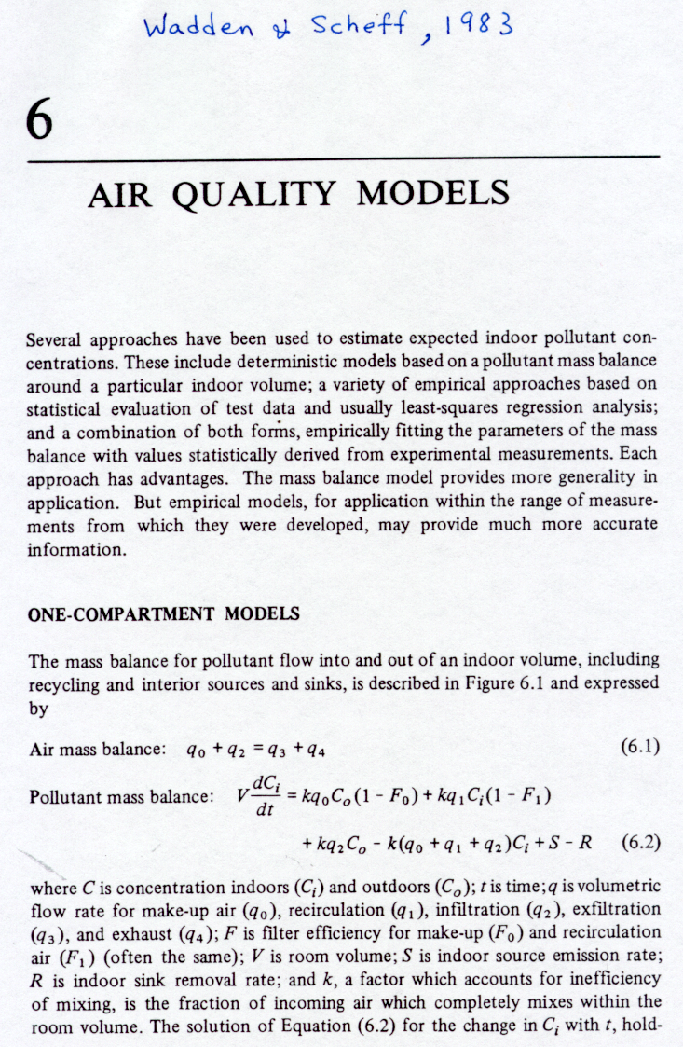

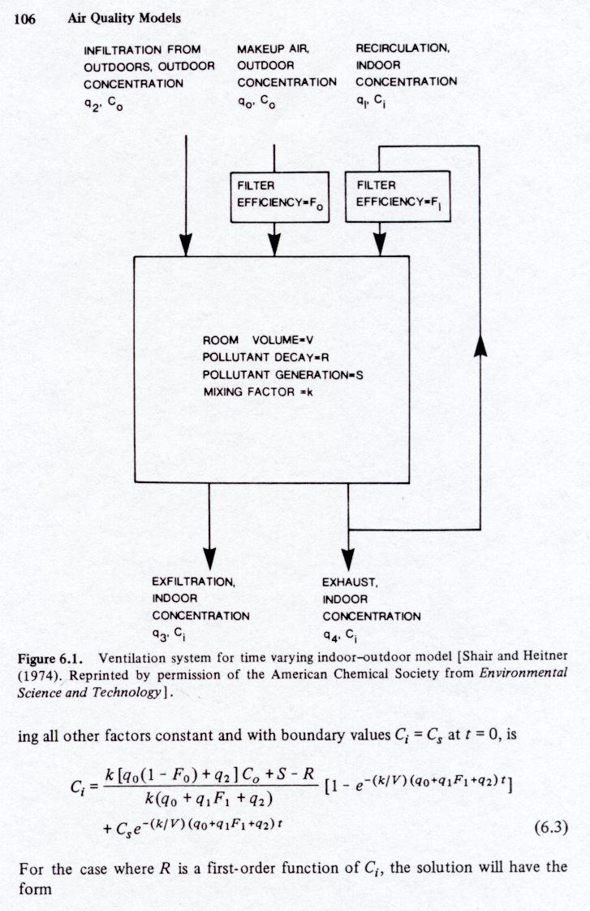

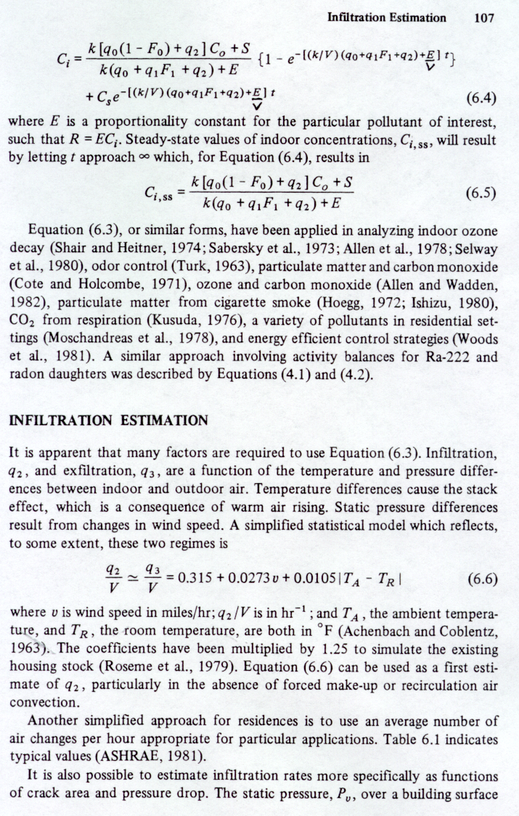
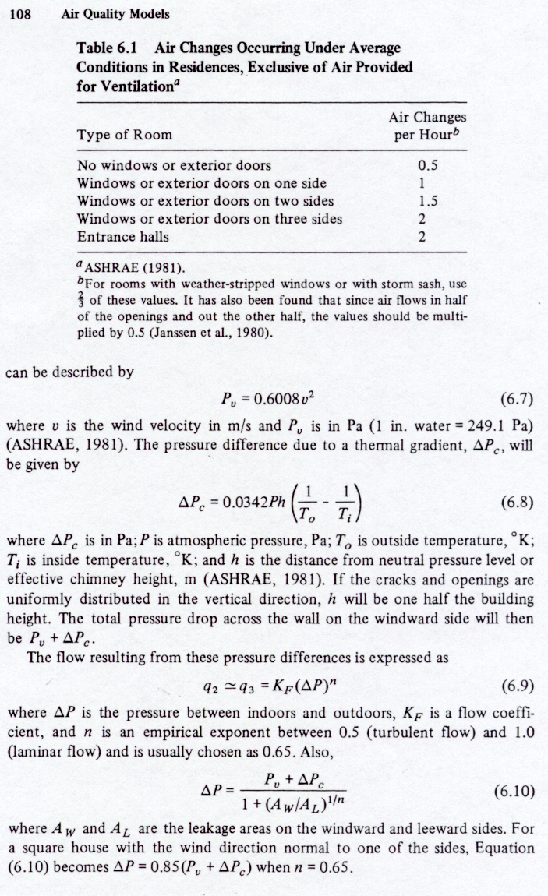
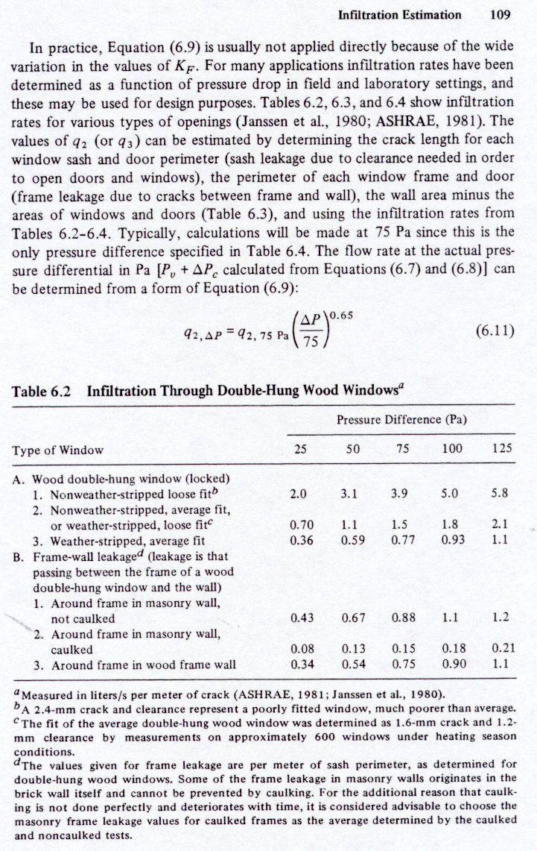
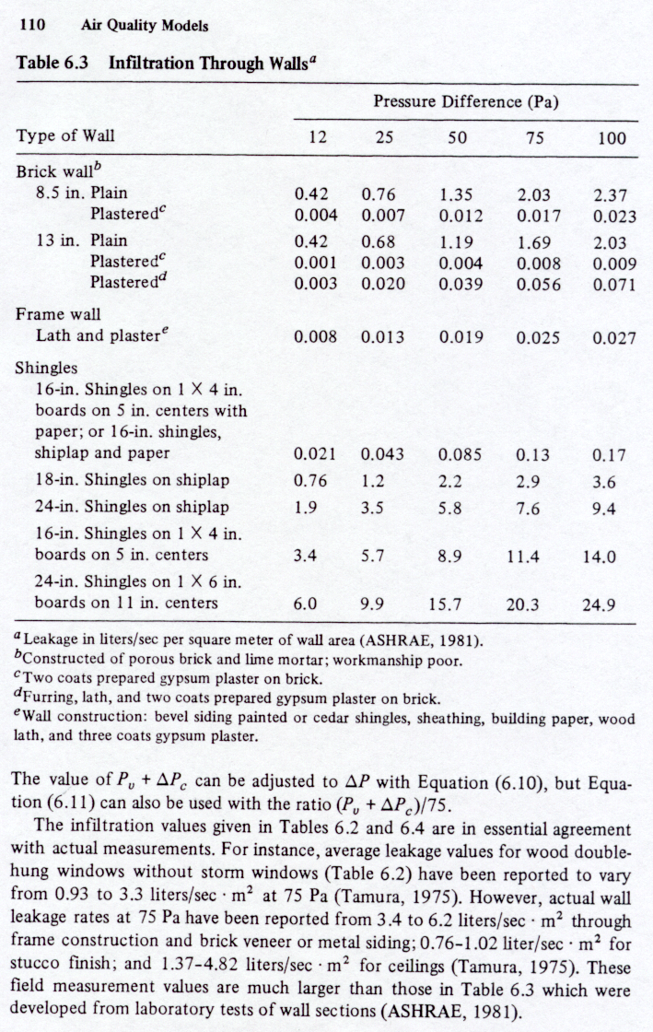
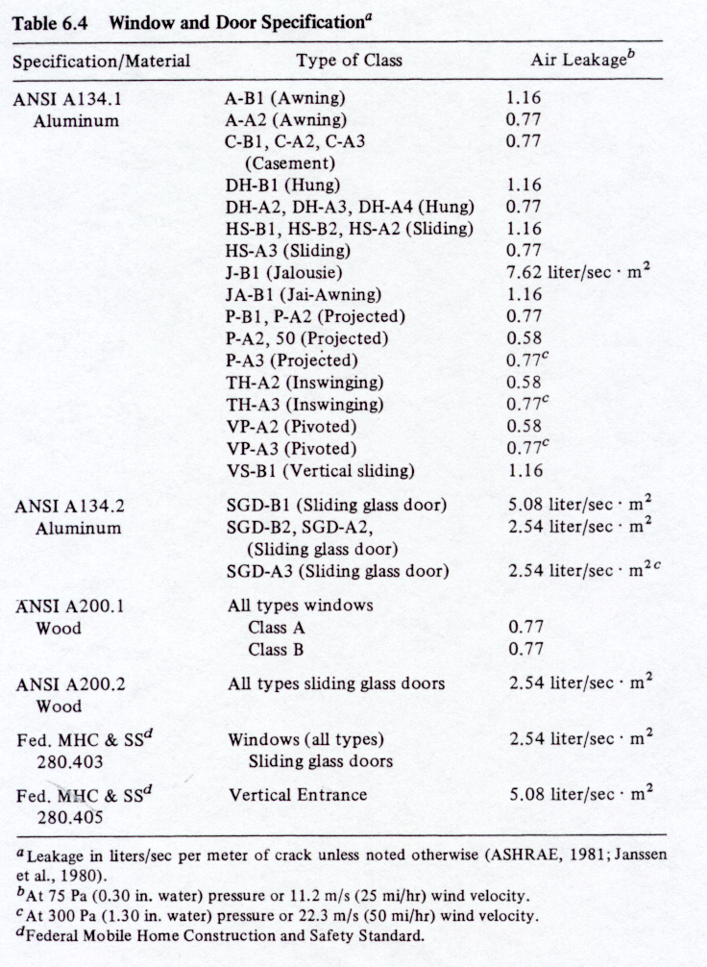

One-compartment Indoor Air Quality Model
Air Mass Balance

Pollutant Mass Balance
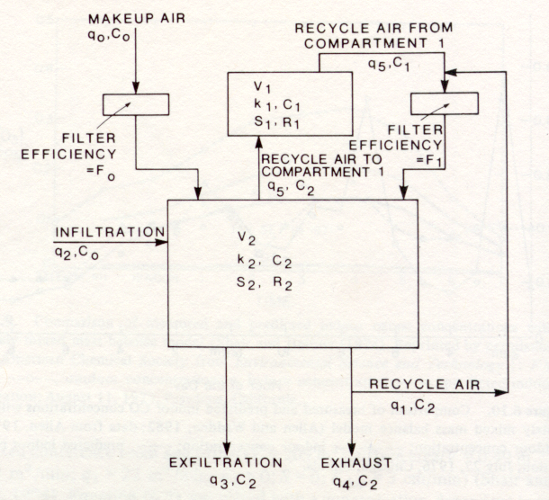
Two-compartment Indoor Air Quality Model

Compartment 1

Air Mass Balance

Pollutant Mass Balance

Compartment 2

Air Mass Balance

Pollutant Mass Balance



