Classnote – 2 Air Pollutants

Particulate Matter

National Ambient Air Quality Standard for Particulate Matter (National Ambient Air Quality Standards for Particulate Matter and Ozone; Final Rules July 18, 1997, 40 CFR Part 50, Section II-H):

- Twenty-four hour average PM_{2.5} is met when the three-year average of annual 98th percentiles of 24-hr PM_{2.5} concentrations at each population-oriented monitor within an area is less than or equal to 65 μg/m³, with fractional parts of 0.5 or greater rounding up;

- The annual PM_{2.5} standard is met when the three-year average of the annual arithmetic mean PM_{2.5} concentrations, from single or multiple community-oriented monitors is less than or equal to 15 μg/m³, with fractional parts of 0.05 or greater rounding up;

- The 24-hour average PM₁₀ is met when the three-year average of annual 99th percentiles of 24-hr PM₁₀ concentrations at each monitor within an area is less than or equal to 150 μg/m³;

- The annual PM₁₀ standard is met when the three-year average of the annual arithmetic mean PM₁₀ concentrations at each monitor within an area is less than or equal to 50 μg/m³, with fractional parts of 0.5 or greater rounding up.

The first two standards for PM2.5 are new. The third standard for 24-hour average PM₁₀ is revised to be based on the three-year average of annual 99th percentiles of 24-hr PM₁₀ concentrations at each monitor within an area from “with no more than one expected exceedance per year”.

Along with a National Ambient Air Quality Standard, the measurement instruments, methods, data collection, quality assurance protocols, laboratory methods, laboratory QA/QC, data reporting, time line for compliance. Many times, the sampling results are not only used for compliance purposes but also for identifying sources, assessing health risks, evaluating effectiveness of control devices, and determining areas of impacts. Thus, it is important to understand what we actually collect from the samplers.

Ideal PM size distribution with three modes in ambient air
- Nucleation mode: varies from 0.005 to 0.1 μm and peaks at ~ 0.08 μm, accounting for the preponderance of particles by number. Nucleation particle lifetimes are usually less than 1 hour because they rapidly coagulate with larger particles or serve as nuclei for cloud or fog droplets.
- Accumulation mode: extends from 0.1 to 2.5 μm, which accounts for most of the aerosol (particle) surface areas. The majority of sulfuric acid, ammonium, bisulfate, ammonium sulfate, ammonium nitrate, organic carbon, and elemental carbon is found in this range.
- Coarse mode (or sedimentation mode): It varies between 2.5 to 25 μm and peaks at around 10μm. The peak of the coarse mode may shift between 6 and 25 μm depending on the common emission sources in the region.

Major chemical components in PM

- Geologic Elements: Al, Ca, Si, K, P, Na, and other trace elements
- Sulfate: Ammonium sulfate, ammonium bisulfate, sulfuric acid, sodium sulfate
- Nitrate: Ammonium nitrate, sodium nitrate
- Ammonium: Ammonium sulfate, ammonium bisulfate, ammonium nitrate
- Sodium Chloride
- Organic Carbon: compounds containing more than 20 carbon atoms (<C₂₀)
- Element Carbon (soot)
- Liquid Water

Sampling Technologies

PM exists in the air with various shapes and densities. No sampling instrument (or at least not developed) can provide stepwise sharp cut of passing 100 % of PM small than a specific size and excluding 100 % of PM large than that specified size. As a result, the PM samples we collected in the air always include various sizes of PM. The methods used in PM sampling include inlet size selection, filtration, impaction, virtual impaction, and other technologies based on particle aerodynamics that are applicable in air pollution control. In any cases, size selective inlets are commonly used in every sampling instrument.

As stated before, sharp size cut-off cannot be achieved. Therefore, the goal is to develop an inlet that can have as sharp size cut-off as possible.

Size Cut-off: an instrument’s size cut-off is defined by the 50 % cut-point (d₅₀). d₅₀ represents the aerodynamic diameter at which 50 % of the sampled particles penetrate an inlet. The effectiveness of the sharp cut-off is defined by the slope of the sample effectiveness (or the ratio of d₁₆/d₈₄). A slope of 1 indicates that 100 % of the particles with aerodynamic diameter less than the cut-off pass through the inlet to the filter, and 0 % of those larger than the cut-point are collected. Typical values of the slope vary between 1.3 and 2. Figure 4.1 of EPA 1997 shows typical characteristics of sampling effectiveness curve for inlets. Figure 4.2 shows a conceptual graph of PM size distribution collected on filters. It appears that coarse PM collected on the filters are likely to be attenuated from what actually exist in ambient air.

References
J.C. Chow. 1995. Measurement methods to determine compliance with ambient air quality standards for suspended particles. JA&WMA. 45:320-382.

U.S. EPA. 1997. Draft guideline on speciated particulate monitoring.

U.S. EPA. 1997. 40 CFR Part 50. National Ambient Air Quality Standards for Particulate Matter and Ozone; Final Rules July 18, 1997.
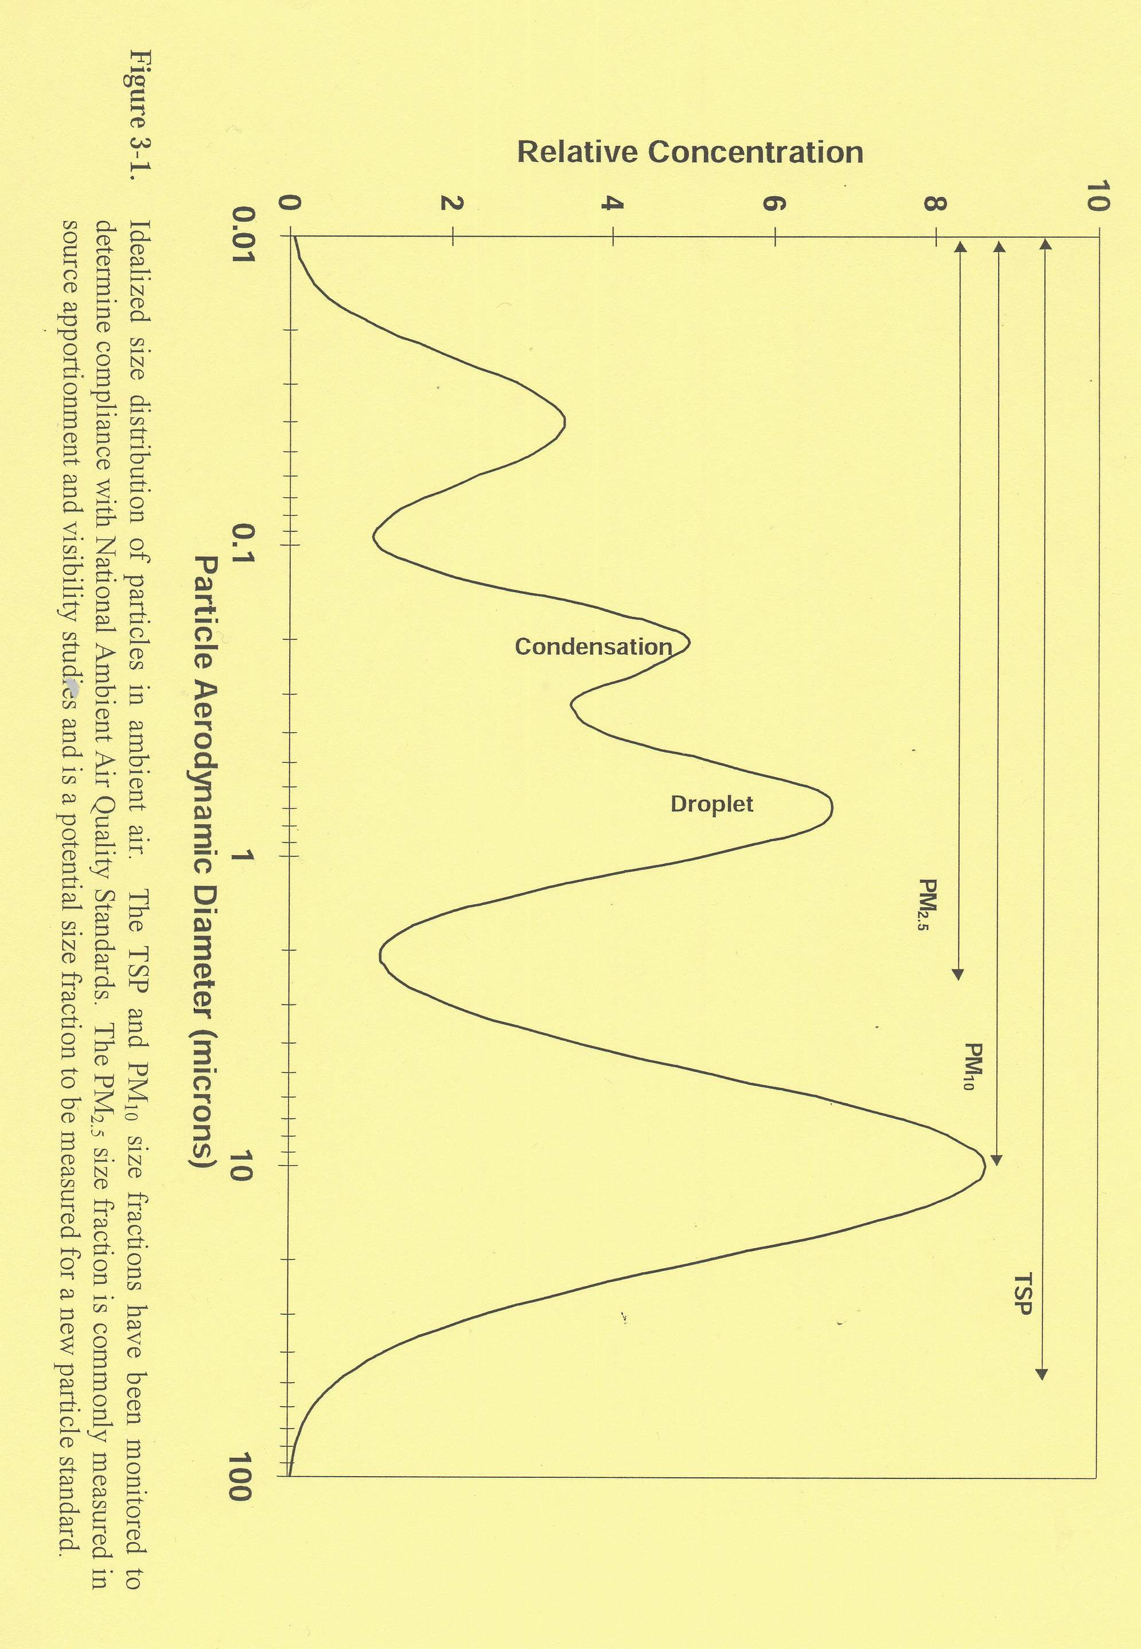
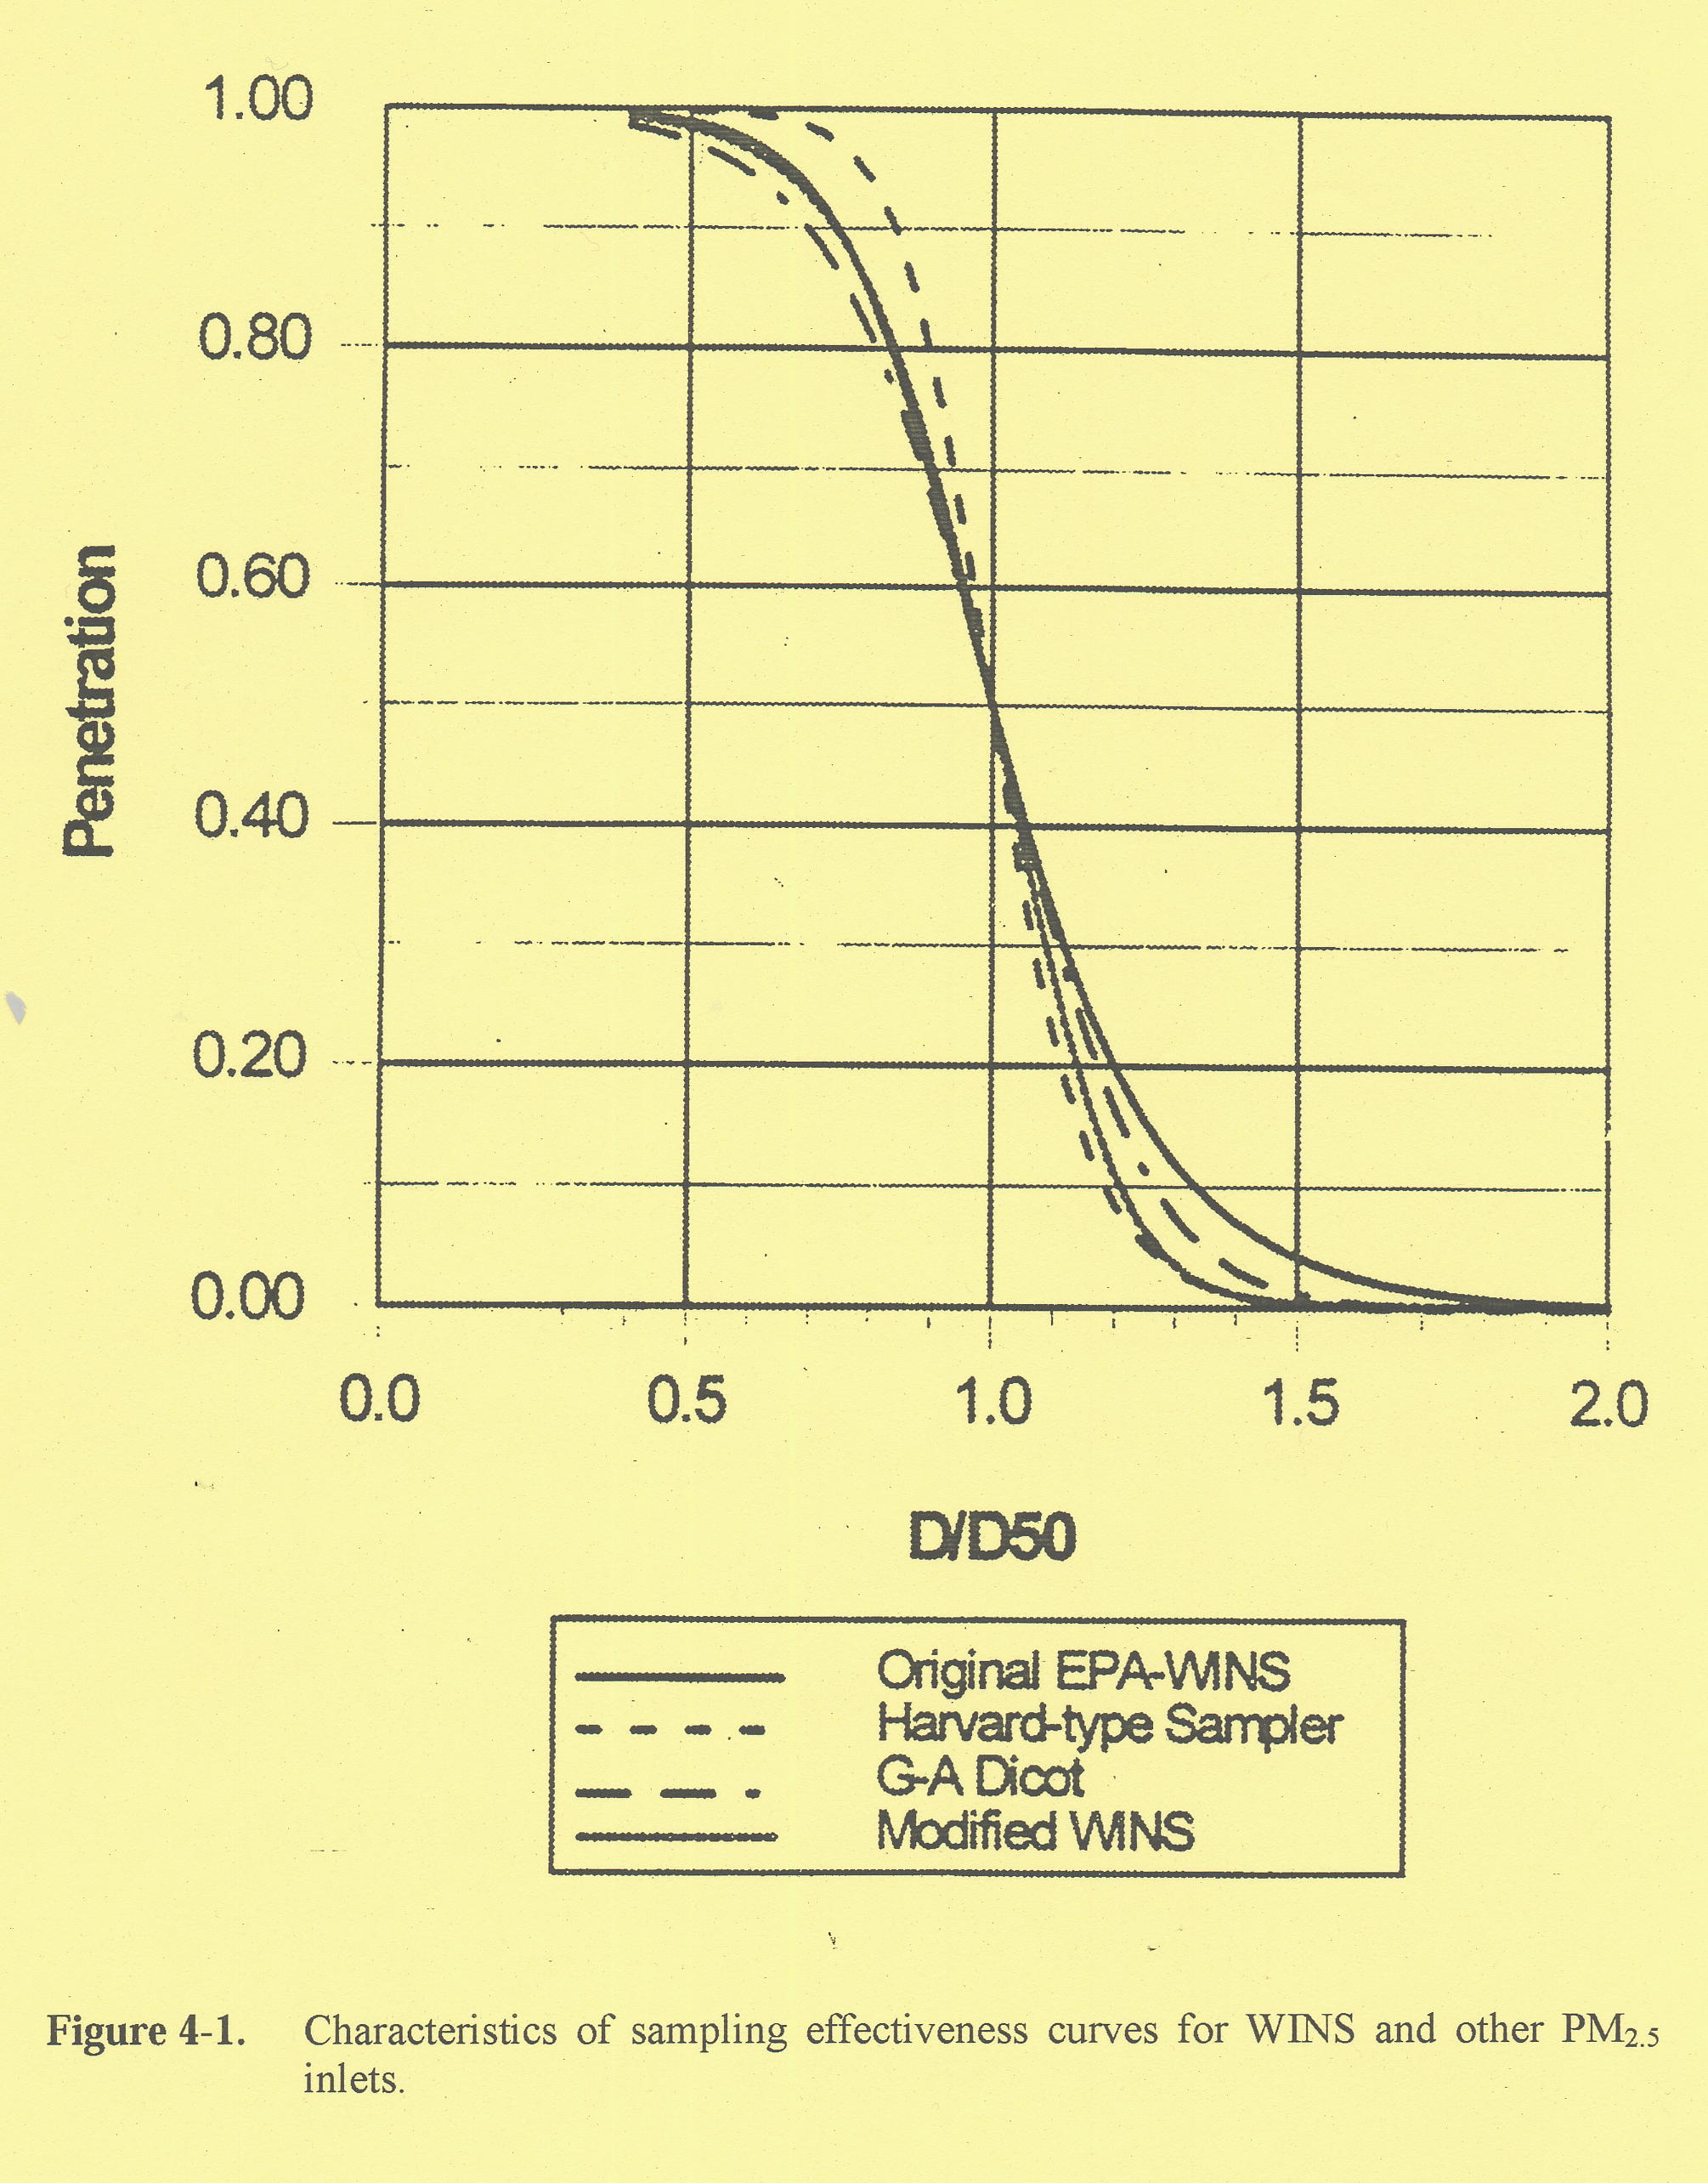

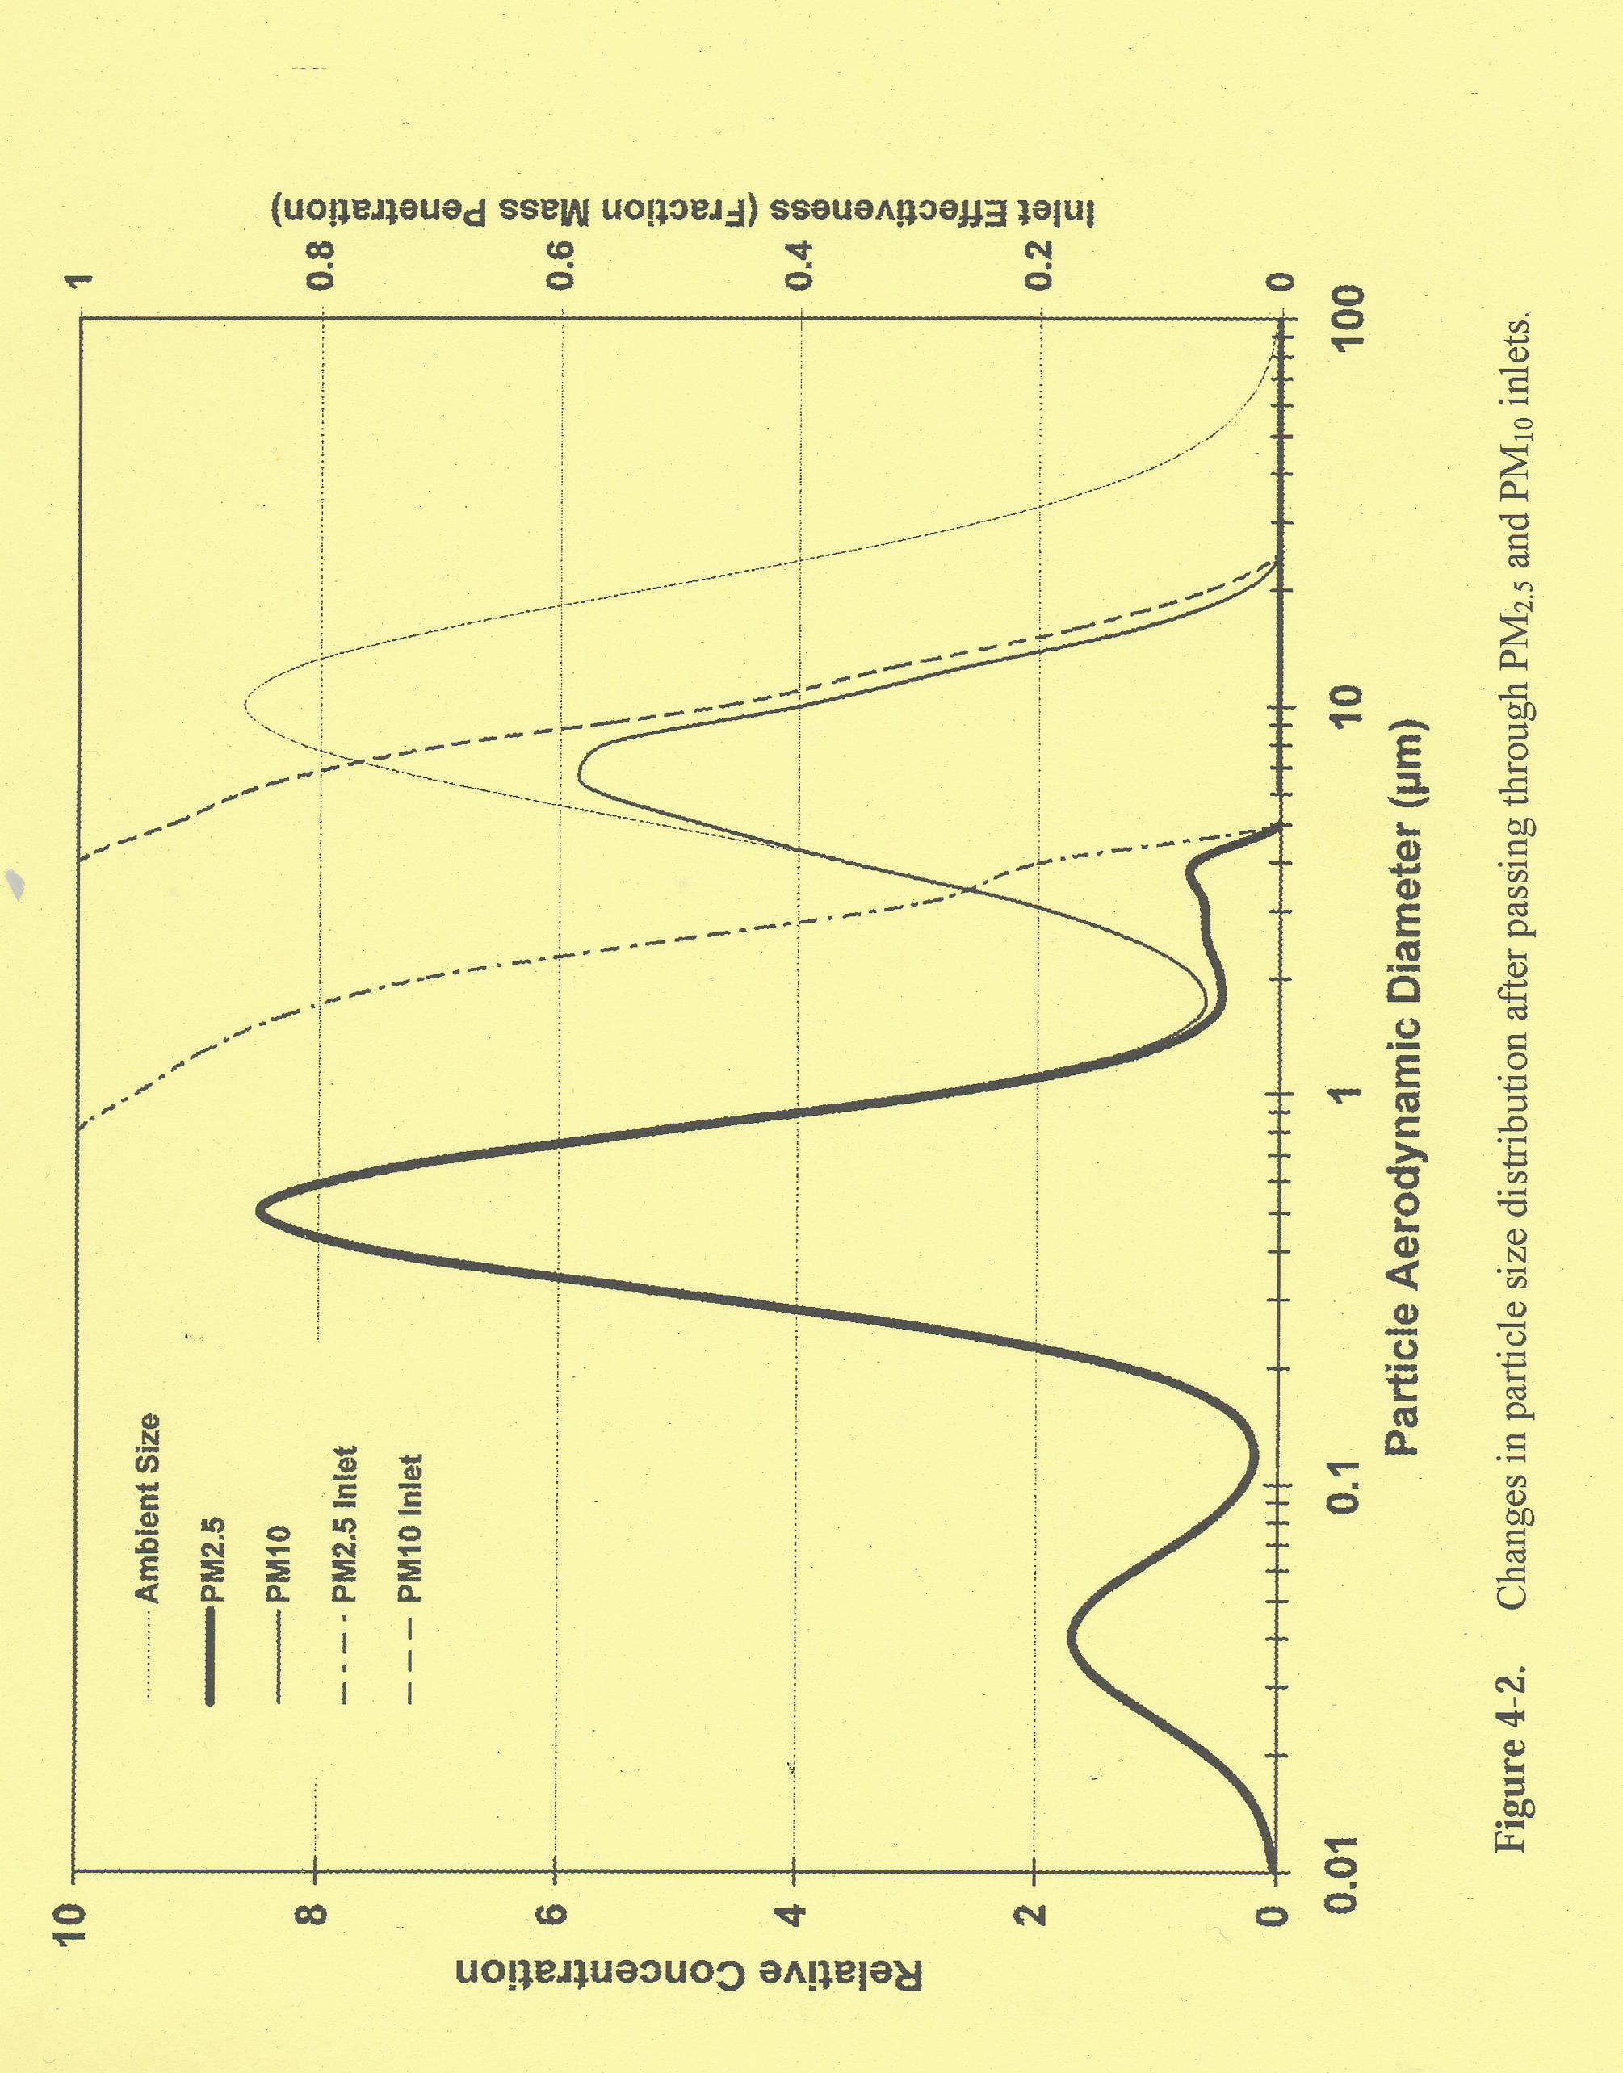
Nitrogen Containing Compounds
N₂: Major gas in the atmosphere (79 %), stable
Nitrogen is abundant in the atmosphere and is an essential nutrient to all living organisms. Nitrogen is “fixed” by either microorganisms on earth or ionizing phenomenon in the atmosphere. Microorganisms in the soil convert nitrogen to ammonia, ammonium ion (NH₄⁺), organic nitrogen compounds. Atmospheric ionization of nitrogen, through cosmic radiation or lightning, forms various nitrogen oxides.
N₂O: Nitrous Oxide
- Colorless gas released by natural causes
- Products of bacterial action in the soil and in water
- Also known as the laughing gas
- Energy absorption property is 300 times that of CO₂
- Inert in the troposphere and reacts with atomic oxygen (O) to form NO in the stratosphere
- Lifetime = 120 + 30 yrs

NO_{x}: Nitrogen Oxides (NO_{x} = NO + NO₂)

NO_{y}: Nitrogen Oxides (NO_{y} = NO_{x} + products of atmospheric oxidation of NO_{x})

NO_{z}: Products of atmospheric oxidation of NO_{x} only (NO_{z} = NO_{y} - NO_{x})

Products of Atmospheric Oxidation

HNO₃: Nitric Acid

- Major oxidation product of NOx
- Water Soluble
- In the presence of NH₃, it can form HN₄ONO₃ aerosol
- Night concentrations are at about 300 pptv

NO₃: Nitrate Radical

N₂O₅: Di-Nitrate Pentoxide

HNO₄: Peroxynitric Acid

RC(O)OONO₂: Peroxyacetyl Nitrate (PAN)

RONO₂: Alkyl Nitrates

ROONO₂: Peroxyalkyl Nitrates

NH₃: Ammonia, third most abundant gas of nitrogen

- Readily absorbed by surface
- 10 days residence time in the atmosphere
- Removed by wet and dry deposition
- Background concentration ranges from 0.1 to 10 ppbv

Atmospheric cycle of nitrogen compounds
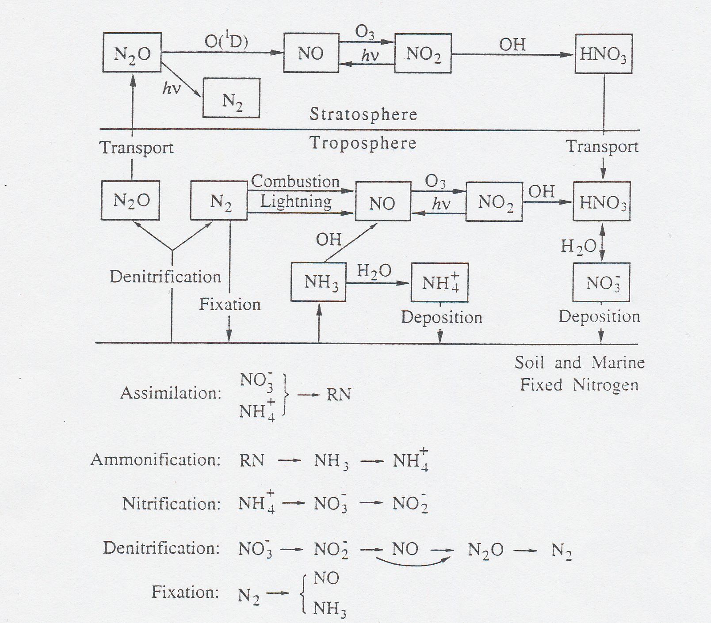

Sulfur-Containing Compounds

- Common atmospheric sulfur compounds: H₂S, CH₃SCH₃, CS₂, OCS, and SO₂
- Chemical reactivity of atmospheric sulfur compounds is inversely related to their sulfur oxidation state. For example, H₂S (oxidation state of –2) is much more reactive than SO₂ (oxidation state of +4)
- Hydrogen sulfide, H₂S, is a colorless gas with a strong odor of rotten eggs. It’s also commonly know as sewer gas
- Dimethyl sulfide, CH₃SCH₃, is the dominant sulfur compound emitted from the oceans. Imbalance of CH₃SCH₃ results in continuous emissions of dimethyl sulfide from the oceans.
- Carbonyl sulfide, OCS, naturally exists in the atmosphere and is the only sulfur compound survives to enter into the stratosphere.
- Sulfur dioxide, SO₂, is the predominant antorpogenic sulfur-containing compounds and is one of the criteria pollutants regulated by the U.S. EPA.

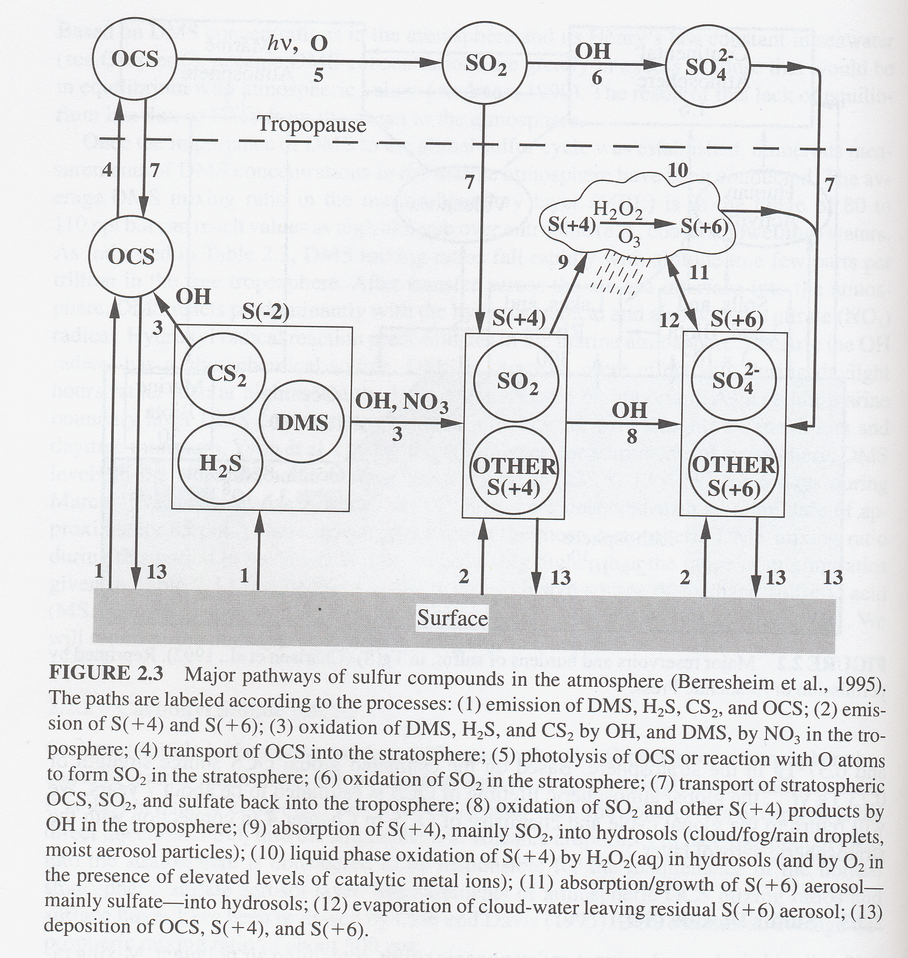

Carbon-Containing Compounds

•Lewis Structures: They help us visualize how atoms connect with each other by either sharing electrons (covalent bond) or losing / gaining electrons (ionic bond) as to achieve an octet of electros therefore resembling the noble gases.
H
• •
H • • C • • H

• •
H
Lewis Representation of methane

•Isomers: Compounds having the same molecular formula, but different structural formula (different connectivity between atoms).

Example

CH3-CH2-CH2-CH3 CH3
butane |
CH3-CH-CH3
isobutane

•Alkanes and Alkenes (open-chain)
Hydrocarbons in which each carbon atom forms four single bonds to other atoms are called saturated hydrocarbons, paraffins, or alkanes. Hydrocarbons that have at least two carbon atoms joined by a double bond are called undersaturated or alkenes.

Methane:

Ethane:

Propane:

Butane:

Pentane:

Hexane:

Heptane:

Aromatic hydrocarbons (close-chain) are benzene compounds and compounds that resemble benzene in chemical behavior

•Example of important alkanes and alkenes on the environment as well as aromatic hydrocarbons.

CCl3-CH3 CH2Cl-CH2Cl
1,1,1-Trichloroethane (TCA) 1,2-Dichloroethane (1,2-DCA)

CCl2F-CF2Cl
1,1,2-Trichloro-1,2,2-trifluroethane

CH2=CH2 CCl2=CHCl
Ethyne (ethylene) Trichloroethylene (TCE)

•Nomenclature of open-chain compounds:

- Find the longest continuous chain of carbon atoms. Assign a parent name based on total number of carbons.

- Find whatever groups are not part of the longest continuous chain. Name these prefixes

- Assign numbers to groups by counting from one end of the chain. A chain has two ends, and the end we start from is the one that gives the lowest possible numbers to the groups.

- If there are two or more identical groups, we use these prefixes:

Number of identical groups prefix
2 di
3 tri-
4 tetra-
5 penta-
6 hexa-

5.
If there are two or more different groups, we put all of them into the prefix in alphabetical order.

- The four halogens are named by prefixes:
F fluoro- Br bromo-
Cl chloro- I Iodo-

Answer: Heptane → 2,5 dichloro → 2-methyl → 4-ethyl

→ 2,5-dichloro-4-ethyl-2-methyl-heptane

- Methane

- Volatile Organic Compounds (VOCs)

Aromatic Compounds

Nomeclature of benzene derivatives (aromatic):
-prefix the name of the substituent group to the word –benzene

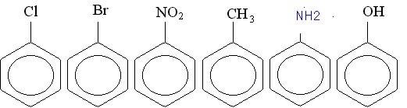Ex.

(a) (b) (c) (d) (e) (f)

a- Chlorobenzene
b-Bromobenzene
c- Nitrobenzene
d- methylbenzene (Toluene)
e- aminobenzene (Aniline)
f- hydroxybenzene (Phenol)

•Nomenclature if several are attached to the benzene ring
-We must not only tell what they are, but also indicate their relative positions.
Ex.
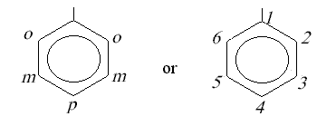

o- ortho position
m- meta position
p- para position
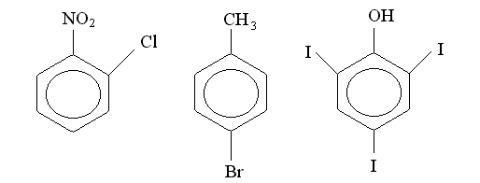

a b c

Name
a) 2- Chloronitrobenzene or o-chloronitrobenzene
b) 4-Bromomethylbenzene or 4-Bromotoluene or p-Bromotoluene
c) 2,4,6-triiodohydroxybenzene or 2,4,6-triiodophenol

- Methane (CH₄)

- Volatile Organic Compounds (VOCs)

- Biogenic Hydrocarbons

- Carbon Monoxide
Carbon monoxide is a colorless and odorless gas. It is very stable and has a lifetime of 2 to 4 months in the atmosphere. There are many studies that show that high concentrations of CO can cause physiological and pathological changes and also ultimately death. CO is a poisonous inhalant that deprives the body tissues of necessary oxygen. At high concentration (>750 ppmv), it is known to cause death. Dissolved CO combines with hemoglobin to form caboxyhemoglobin (COHb) in the blood and thus reduces the oxygen carrying capacity of blood.

- Carbon Dioxide

Halogen-Containing Compounds

- Chlorofluorocarbons (CFCs)
- Hydrochlorofluorocarbons (HCFCs)
- Hydrofluorocarbons (HFCs)
- Perhalocarbons: halocarbons in which every available carbon bond contains a halogen atom (compounds saturated with halogen atoms)
- Halons (bromine-containing halocarbons, especially used as fire extinguishing agents

COHb in blood due to exposures to CO
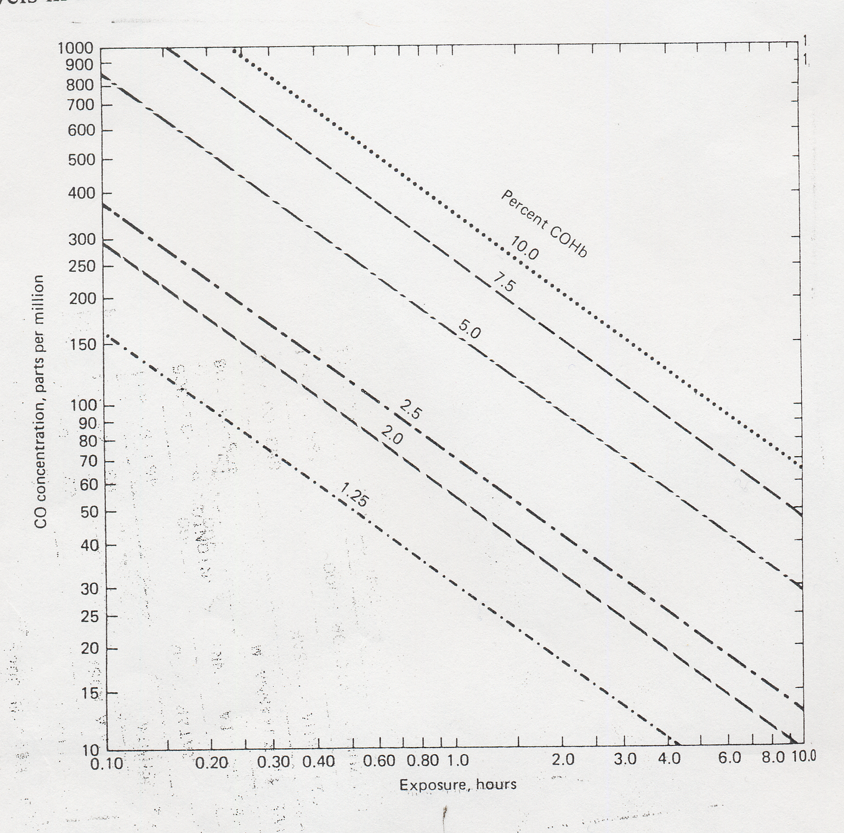

Health effects associated with CO exposures
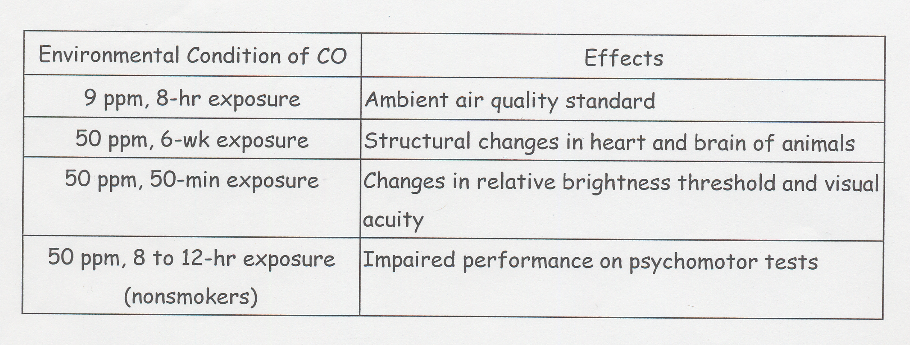
Health effects associated with the level of COHb in blood
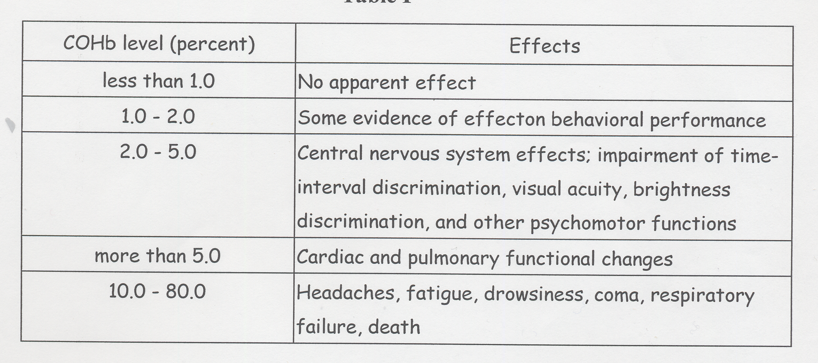

Ozone

Health and environmental effects associated with ozone exposures
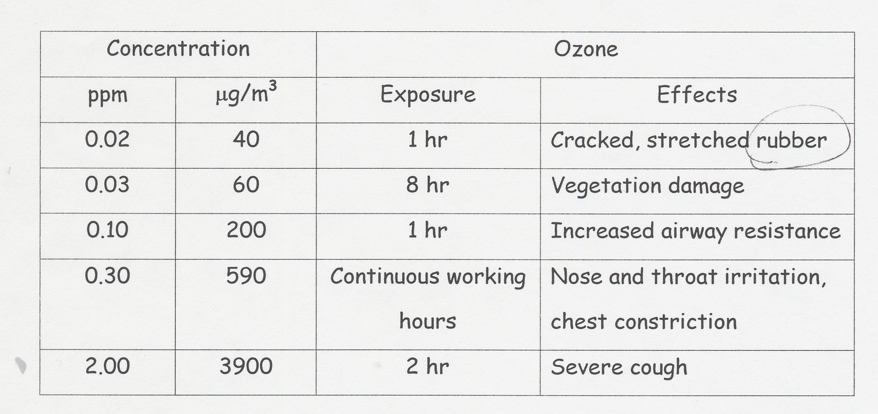

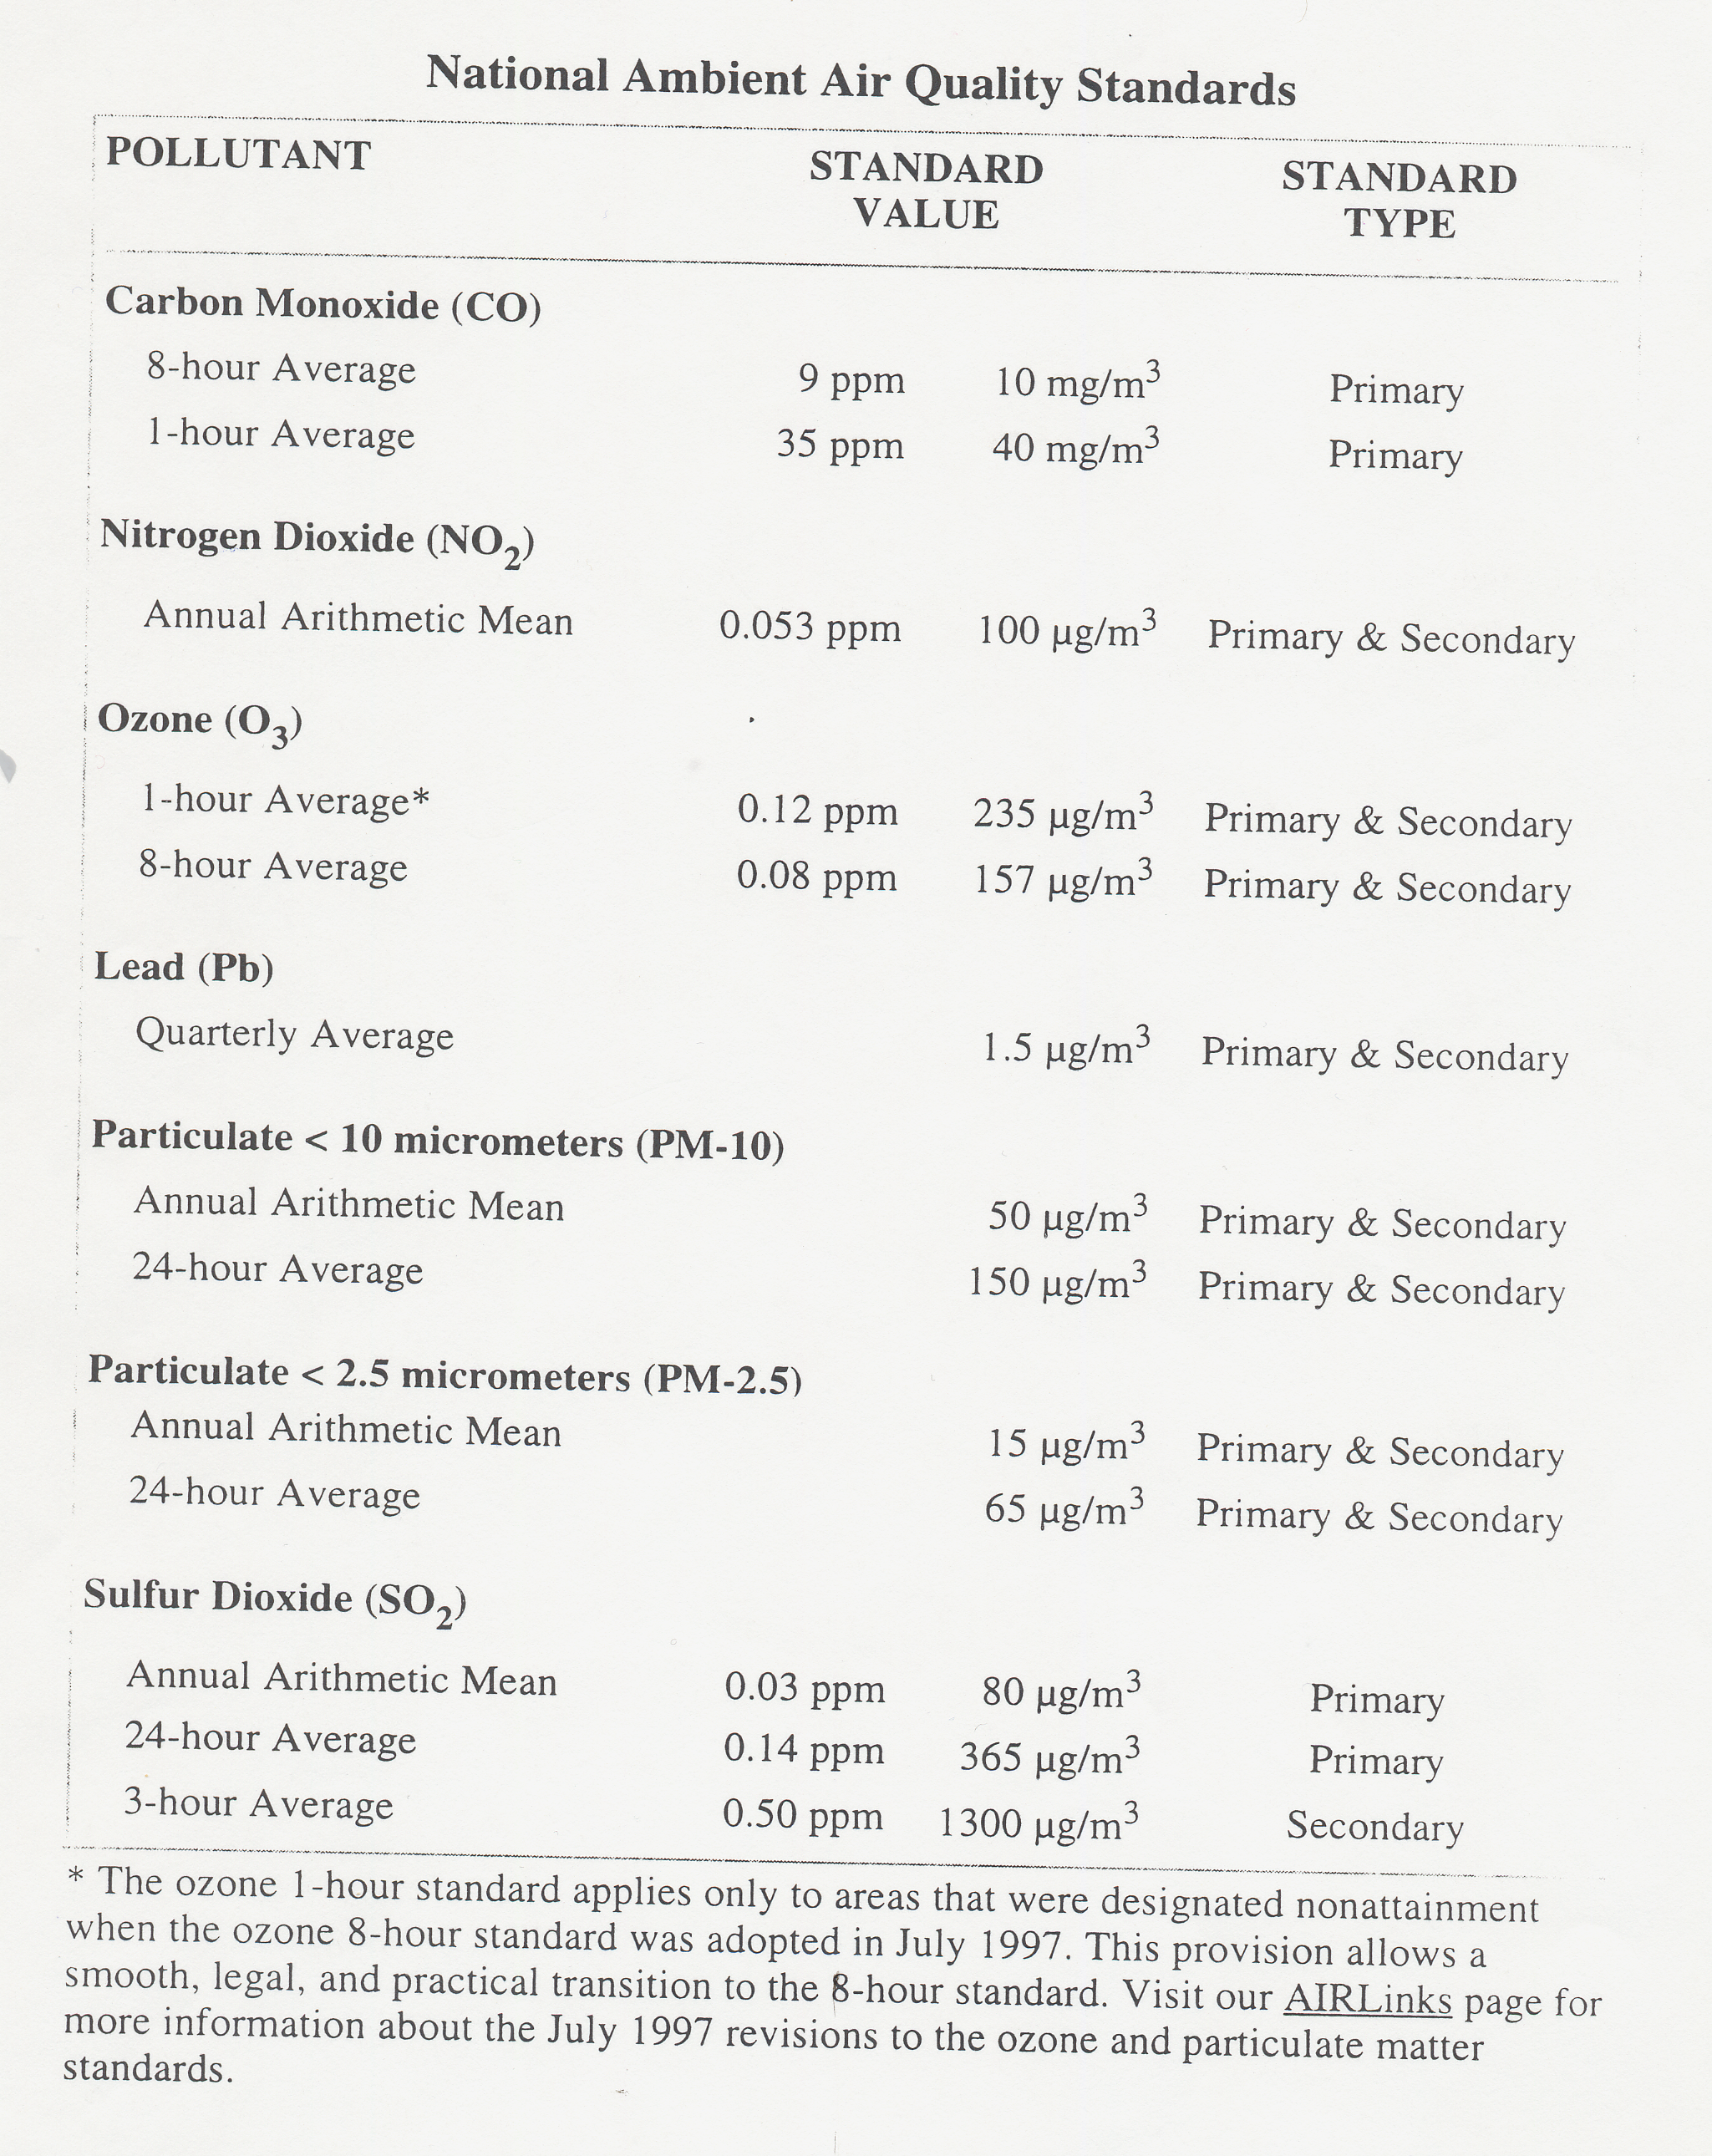

Methemoglobinemia

Nitrate, a relatively non-toxic substance, occurs naturally as part of the nitrogen cycle. However, bacteria can convert nitrate to nitrite in the environment, in foods and in the human body.
Until infants reach about six months of age, their digestive system secretes lower amounts of gastric acid and the pH level in their digestive system is higher than most adults. Adults with a diminished capability to secrete gastric acid also can experience a rise in pH in their digestive system. In both situations, bacteria can proliferate, increasing the transformation of nitrate to nitrite.
Once in the blood, nitrite oxidizes iron in the hemoglobin of red blood cells to form methemoglobin, which lacks hemoglobin's oxygen-carrying ability. The nitrite can come from nitrate in drinking water or from food, some drugs or other sources.
Although methemoglobin is continually produced in humans, an enzyme in the human body reduces methemoglobin to hemoglobin. In most individuals, methemoglobin is rapidly converted back to hemoglobin. Typically, less than 1 percent of the total circulating hemoglobin in a healthy adult is present in the form of methemoglobin. Infants, however, have a low concentration (about 60 percent of the adult concentration) of the reducing enzyme, as do some older individuals with an enzyme deficiency. In these people, methemoglobin is not converted to hemoglobin as readily.
When methemoglobin levels are elevated, the condition known as methemoglobinemia, often referred to as "blue baby syndrome", can result as the blood lacks the ability to carry sufficient oxygen to individual body cells.

- Methemoglobinemia Signs and Symptoms
Infants suffering from methemoglobinemia may seem healthy but show intermittent signs of blueness around the mouth, hands and feet. They may have episodes of breathing trouble, some diarrhea and vomiting. In some cases, an infant with methemoglobinemia has a peculiar lavender color but shows little distress. Blood samples appear chocolate brown and don't turn pink when exposed to air. When the methemoglobin level is high, infants express a marked lethargy, excessive salivation and loss of consciousness. Convulsions and death can occur at extreme methemoglobin levels.

- Methemoglobinemia Case Histories
Cases of infant methemoglobinemia have been reported in the United States. The majority of reported cases were in infants under the age of four months and who were fed milk formulas prepared with contaminated well water. A Nebraska survey of physicians reported in the Nebraska Medical Journal in 1981 indicated at least eight cases of infant methemoglobinemia were treated in Nebraska between 1973 and 1978. More recently, two infants with methemoglobinemia were identified by the South Dakota Department of Health. The private well water was found to have a nitrate-nitrogen concentration of 150 mg/l in one instance and 54 mg/l in the other. In Colorado, a case of methemoglobinemia involved an infant ingesting water containing 13.3 mg/l nitrate-nitrogen. No cases have been identified with water at or below the MCL of 10 mg/l nitrate-nitrogen.

Source: http://www.ianr.unl.edu/pubs/water/g1369.htm#meth

Atmospheric Residence Times

Rate of the species flowing in
Rate of the species flowing out
Rate of emission of the species

Rate of removal of the species
Rate of accumu. of the species in the control volume

- + - =

Where Q = Total mass of the substance in the control volume
F_{in} = Rate of the species flowing in
F_{out} = Rate of the species flowing out
P = Rate of emission of the species
R = Rate of removal of the species
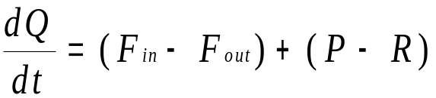

For steady-state condition,
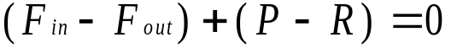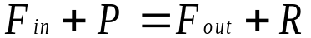or

The average residence time, τ,
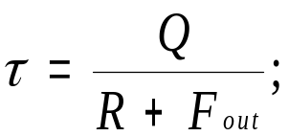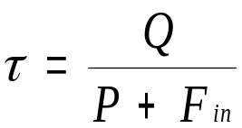

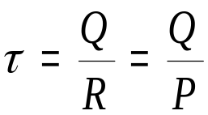Assuming there is no substances coming in or getting out of the atmosphere, F_{in} = F_{out} = 0. Thus,

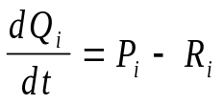A general form of the expression for a pollutant is:

Where pollutants flowing in and out are zeros if we treat the earth atmospheric as one closed system and P_{i} and R_{i} consist of the following contributions:

P_{i}^{n}: Natural emissions

P_{i}ª: Anthropogenic emissions

P_{i}^{c}: Emissions due to chemical reaction

R_{i}^{d}: Removal by dry deposition

R_{i}^{w}: Removal by wet deposition (precipitation scavenging)

R_{i}^{c}: Removal due to chemical reaction

R_{i}^{t}: Transport to the stratosphere

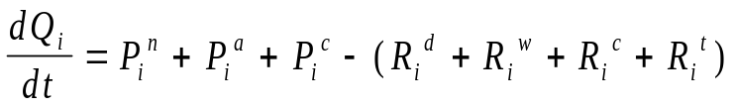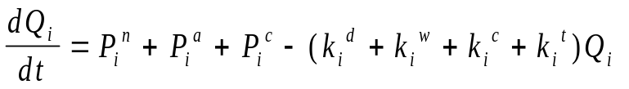If one assumes that removal follows the first-order decay, R=kQ, we have

Thus, the residence time for a species at steady-state becomes


