Effects of Air Pollution

- Effects on Human Health
The American Thoracic Society defines an adverse health effect of air pollution as including, but not being limited to, increased mortality as well as cancer, asthma, lower respiratory tract infections, upper respiratory tract infections, and eye, nose, and throat irritation that interfere with normal activity.

Key potential health endpoints include, but are not limited to, the following:

- mortality
- hospital admissions for cardiovascular or respiratory causes
- respiratory illness and symptoms (outpatient medical visits, asthma, wheeze, cough, phlegm, increased use of medication)
- physiologic changes (altered pulmonary or cardiovascular function)
- nonrespiratory indicators (eg. Blood, neurologic indicators), and
- biomarkers of exposure and health effects.

- Effects on Vegetation and Animals
  - Crops and Ornamental Plants
  - Forests
  - Domestic Animals

- Effects on Materials and Structures
  - Metals
  - Building Materials
  - Fabrics, Leather, and Paper
  - Rubber

- Effects on the Atmosphere
  - Visibility
  - Radiative Effects
  - Fog Formation and Precipitation
  - Stratospheric Ozone Depletion
  - Climate

The Respiratory System

- Head airways region (extrathoracic or nasopharyngeal region): nose, mouth, pharynx, and larynx

- Lung airways region (tracheobronchial region): from trachea to the terminal bronchioles.

- Pulmonary region (alveolar region): beyond the terminal bronchioles where gas exchange takes places

Statistics:

- Adult breathing rate: 10 - 25 m³
- Surface area for gas exchange: 75 m²
- Length of capillaries: 2000 km
- Adult breathing rate: 12 times/minute (at rest)
36 times/minute (heavy work)
- Particle residence time in the lung: varies depending on the physicochemical properties, locations in the lung, and the type of clearance mechanism involved.

Known Human Carcinogens (defined by International Agency for Research on Cancer (IARC) )
"Carcinogenic to Humans" (Group 1)
Agents and Groups of Agents
- Aflatoxins (naturally occurring mixtures of)
- 4-Aminobiphenyl
- Arsenic and arsenic compounds
(Note: This evaluation applies to the group of compounds as a whole and not necessarily to all individual compounds within the group)
- Asbestos
- Azathioprine
- Benzene
- Benzidine
- Beryllium and beryllium compounds
- N,N-Bis(2-chloroethyl)-2-naphthylamine (Chlornaphazine)
- Bis(chloromethyl)ether and chloromethyl methyl ether (technical-grade)
- 1,4-Butanediol dimethanesulfonate (Busulphan; Myleran)
- Cadmium and cadmium compounds
- Chlorambucil
- 1-(2-Chloroethyl)-3-(4-methylcyclohexyl)-1-nitrosourea (Methyl-CCNU; Semustine)
- Chromium [VI] compounds
- Cyclophosphamide
- Cyclosporin (ciclosporin)
- Diethylstilbestrol (DES)
- Epstein-Barr virus
- Erionite
- Estrogen therapy, postmenopausal
- Estrogens, nonsteroidal
(Note: This evaluation applies to the group of compounds as a whole and not necessarily to all individual compounds within the group)
- Estrogens, steroidal
(Note: This evaluation applies to the group of compounds as a whole and not necessarily to all individual compounds within the group)
- Ethylene oxide
- Etoposide in combination with cisplatin and bleomycin
- Formaldehyde
- Gallium arsenide
- Gamma radiation
- Helicobacter pylori (infection with)
- Hepatitis B virus (chronic infection with)
- Hepatitis C virus (chronic infection with)
- Herbal remedies containing plant species of the genus Aristolochia
- Human immunodeficiency virus type 1 (infection with)
- Human papillomavirus type 16
- Human papillomavirus type 18
- Human T-cell lymphotropic virus type I
- Melphalan
- 8-Methoxypsoralen (Methoxsalen) plus ultraviolet A radiation
- MOPP and other combined chemotherapy including alkylating agents
- Mustard gas (Sulfur mustard)
- 2-Naphthylamine
- Neutrons
- Nickel compounds
- Opisthorchis viverrini (infection with)
- Oral contraceptives, combined
(Note: There is also conclusive evidence that these agents have a protective effect against cancers of the ovary and endometrium)
- Oral contraceptives, sequential
- Phosphorus-32, as phosphate
- Plutonium-239 and its decay products (may contain plutonium-240 and other isotopes), as aerosols
- Radioiodines, short-lived isotopes, including iodine-131, from atomic reactor accidents and nuclear weapons detonation (exposure during childhood)
- Radionuclides, alpha-particle-emitting, internally deposited
(Note: Specific radionuclides for which there is sufficient evidence for carcinogenicity to humans are also listed individually as Group 1 agents)
- Radionuclides, beta-particle-emitting, internally deposited
(Note: Specific radionuclides for which there is sufficient evidence for carcinogenicity to humans are also listed individually as Group 1 agents)
- Radium-224 and its decay products
- Radium-226 and its decay products
- Radium-228 and its decay products
- Radon-222 and its decay products
- Schistosoma haematobium (infection with)
- Silica, crystalline (inhaled in the form of quartz or cristobalite from occupational sources)
- Solar radiation
- Talc containing asbestiform fibers
- Tamoxifen
(Note: There is also conclusive evidence that this agent (tamoxifen) reduces the risk of contralateral breast cancer)
- 2,3,7,8-Tetrachlorodibenzo-para-dioxin
- Thiotepa
- Thorium-232 and its decay products, administered intravenously as a colloidal dispersion of thorium-232 dioxide
- Treosulfan
- Vinyl chloride
- X- and Gamma radiation
Mixtures
- Alcoholic beverages
- Analgesic mixtures containing phenacetin
- Areca nut
- Betel quid with tobacco
- Betel quid without tobacco
- Coal-tar pitches
- Coal-tars
- Mineral oils, untreated and mildly treated
- Salted fish (Chinese-style)
- Shale-oils
- Soots
- Tobacco products, smokeless
- Wood dust
Exposure Circumstances
- Aluminum production
- Arsenic in drinking water
- Auramine, manufacture of
- Boot and shoe manufacture and repair
- Coal gasification
- Coke production
- Furniture and cabinet making
- Hematite mining (underground) with exposure to radon
- Involuntary smoking
- Iron and steel founding
- Isopropanol manufacture (strong-acid process)
- Magenta, manufacture of
- Painter (occupational exposure as a)
- Rubber industry
- Strong inorganic acid mists containing sulfuric acid (occupational exposure to)
- Tobacco smoking

Also defined by National Toxicology Program (NTP) 11th Report on Carcinogens as
"Known to Be Human Carcinogens"
- Aflatoxins
- Alcoholic Beverage Consumption
- 4-Aminobiphenyl
- Analgesic Mixtures Containing Phenacetin
- Arsenic Compounds, Inorganic
- Asbestos
- Azathioprine
- Benzene
- Benzidine
- Beryllium and Beryllium Compounds
- 1,3-Butadiene
- 1,4-Butanediol Dimethylsulfonate (busulfan, Myleran ?
- Cadmium and Cadmium Compounds
- Chlorambucil
- 1-(2-Chloroethyl)-3-(4-methylcyclohexyl)-1-nitrosourea (MeCCNU)
- bis(Chloromethyl) Ether and Technical-Grade Chloromethyl Methyl Ether
- Chromium Hexavalent Compounds
- Coal Tar Pitches
- Coal Tars
- Coke Oven Emissions
- Cyclophosphamide
- Cyclosporin A (Ciclosporin)
- Diethylstilbestrol (DES)
- Dyes Metabolized to Benzidine
- Environmental Tobacco Smoke
- Erionite
- Estrogens, Steroidal
- Ethylene Oxide
- Hepatitis B Virus
- Hepatitis C Virus
- Human Papilloma Viruses: Some Genital-Mucosal Types
- Melphalan
- Methoxsalen with Ultraviolet A Therapy (PUVA)
- Mineral Oils (Untreated and Mildly Treated)
- Mustard Gas
- 2-Naphthylamine
- Neutrons
- Nickel Compounds
- Radon
- Silica, Crystalline (Respirable Size)
- Smokeless Tobacco
- Solar Radiation
- Soots
- Strong Inorganic Acid Mists Containing Sulfuric Acid
- Sunlamps or Sunbeds, Exposure to
- Tamoxifen
- 2,3,7,8-Tetrachlorodibenzo-p-dioxin (TCDD); "Dioxin"
- Thiotepa
- Thorium Dioxide
- Tobacco Smoking
- Vinyl Chloride
- Ultraviolet Radiation, Broad Spectrum UV Radiation
- Wood Dust
- X-Radiation and Gamma Radiation

Probable Carcinogens (as defined by the International Agency for Research on Cancer (IARC))
"Probably Carcinogenic to Humans" (Group 2A)
Agents and Groups of Agents
- Acrylamide
- Adriamycin
- Androgenic (anabolic) steroids
- Aristolochic acids (naturally occurring mixtures of)
- Azacitidine
- Benz[a]anthracene
- Benzidine-based dyes
- Benzo[a]pyrene
- Bischloroethyl nitrosourea (BCNU)
- 1,3-Butadiene
- Captafol
- Chloramphenicol
- a-Chlorinated toluenes (benzal chloride, benzotrichloride, benzyl chloride) and benzoyl chloride (combined exposures)
- 1-(2-Chloroethyl)-3-cyclohexyl-1-nitrosourea (CCNU)
- 4-Chloro-ortho-toluidine
- Chlorozotocin
- Cisplatin
- Clonorchis sinensis (infection with)
- Dibenz[a,h]anthracene
- Diethyl sulfate
- Dimethylcarbamoyl chloride
- 1,2-Dimethylhydrazine
- Dimethyl sulfate
- Epichlorohydrin
- Ethylene dibromide
- N-Ethyl-N-nitrosourea
- Etoposide
- Glycidol
- Human papillomavirus type 31
- Human papillomavirus type 33
- Indium phosphide
- IQ (2-Amino-3-methylimidazo[4,5-f]quinoline)
- Kaposi's sarcoma herpesvirus/human herpesvirus 8 (KSHV/HHV-8)
- Lead compounds, inorganic
- 5-Methoxypsoralen
- 4,4?Methylene bis(2-chloroaniline) (MOCA)
- Methyl methanesulfonate
- N-Methyl-N?/i>-nitro-N-nitrosoguanidine (MNNG)
- N-Methyl-N-nitrosourea
- Nitrogen mustard
- N-Nitrosodiethylamine
- N-Nitrosodimethylamine
- Phenacetin
- Procarbazine hydrochloride
- Styrene-7,8-oxide
- Teniposide
- Tetrachloroethylene
- ortho-Toluidine
- Trichloroethylene
- 1,2,3-Trichloropropane
- Tris(2,3-dibromopropyl) phosphate
- Ultraviolet radiation A
- Ultraviolet radiation B
- Ultraviolet radiation C
- Vinyl bromide
- Vinyl fluoride
Mixtures
- Creosotes (from coal-tars)
- Diesel engine exhaust
- Hot mate
- Non-arsenical insecticides (occupational exposures in spraying and application of)
- Polychlorinated biphenyls
Exposure Circumstances
- Art glass, glass containers and pressed ware (manufacture of)
- Cobalt metal with tungsten carbide
- Hairdresser or barber (occupational exposure as a)
- Petroleum refining (occupational exposures in)
- Sunlamps and sunbeds (use of)

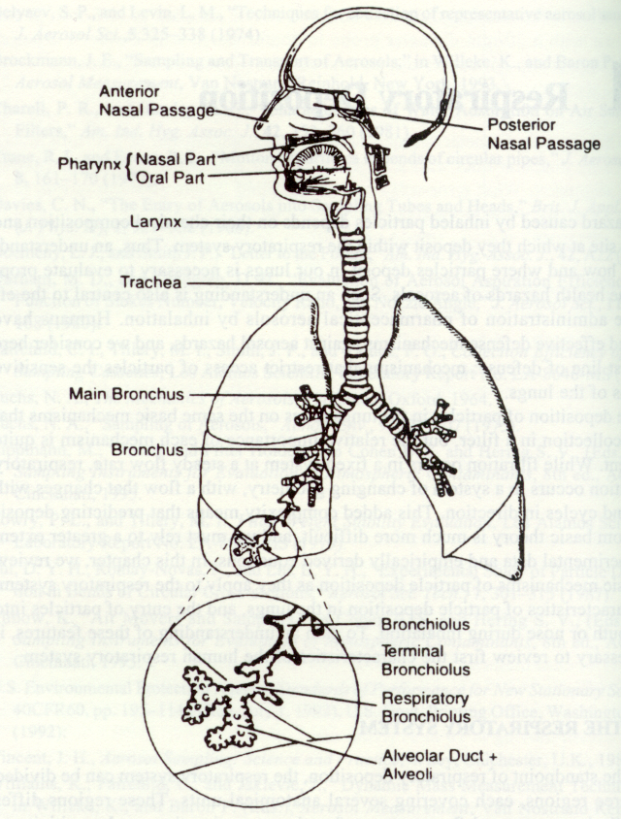
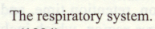
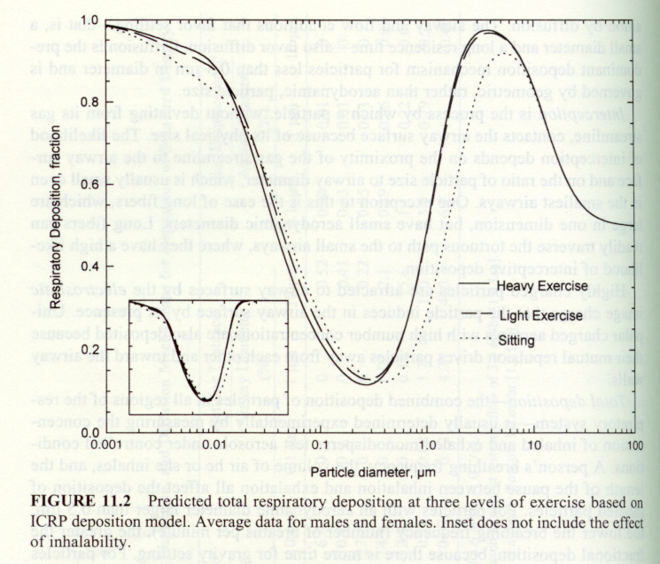
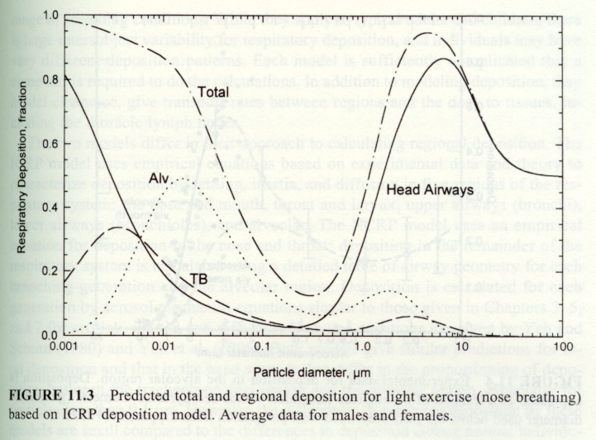
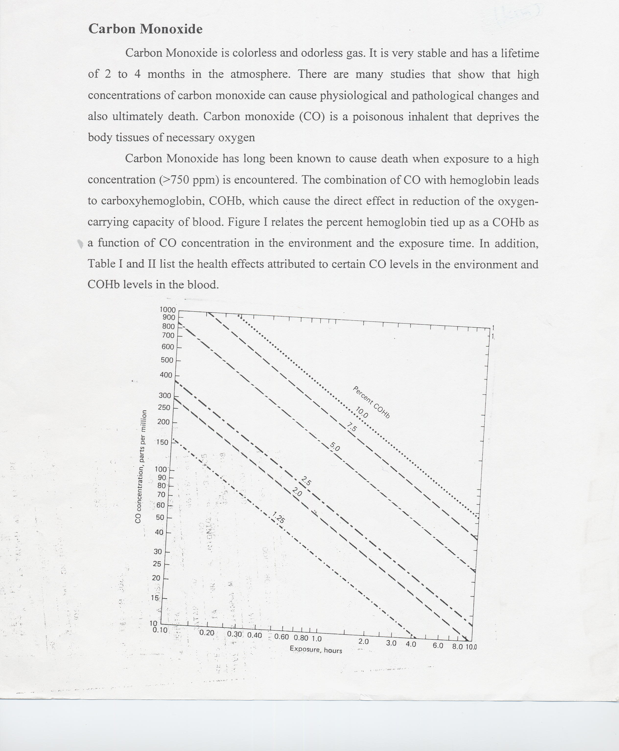
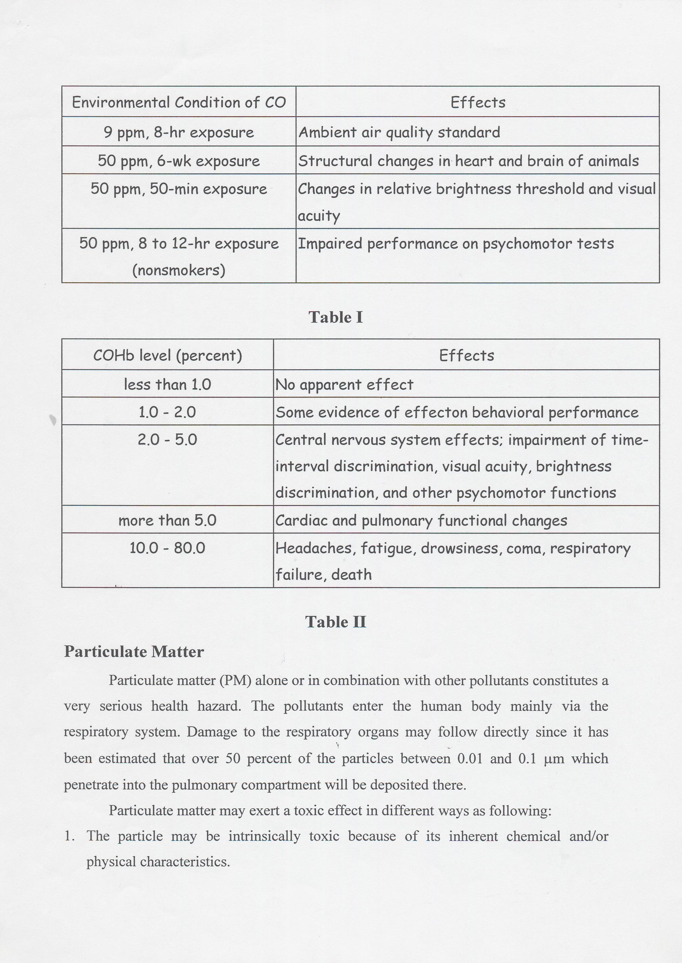
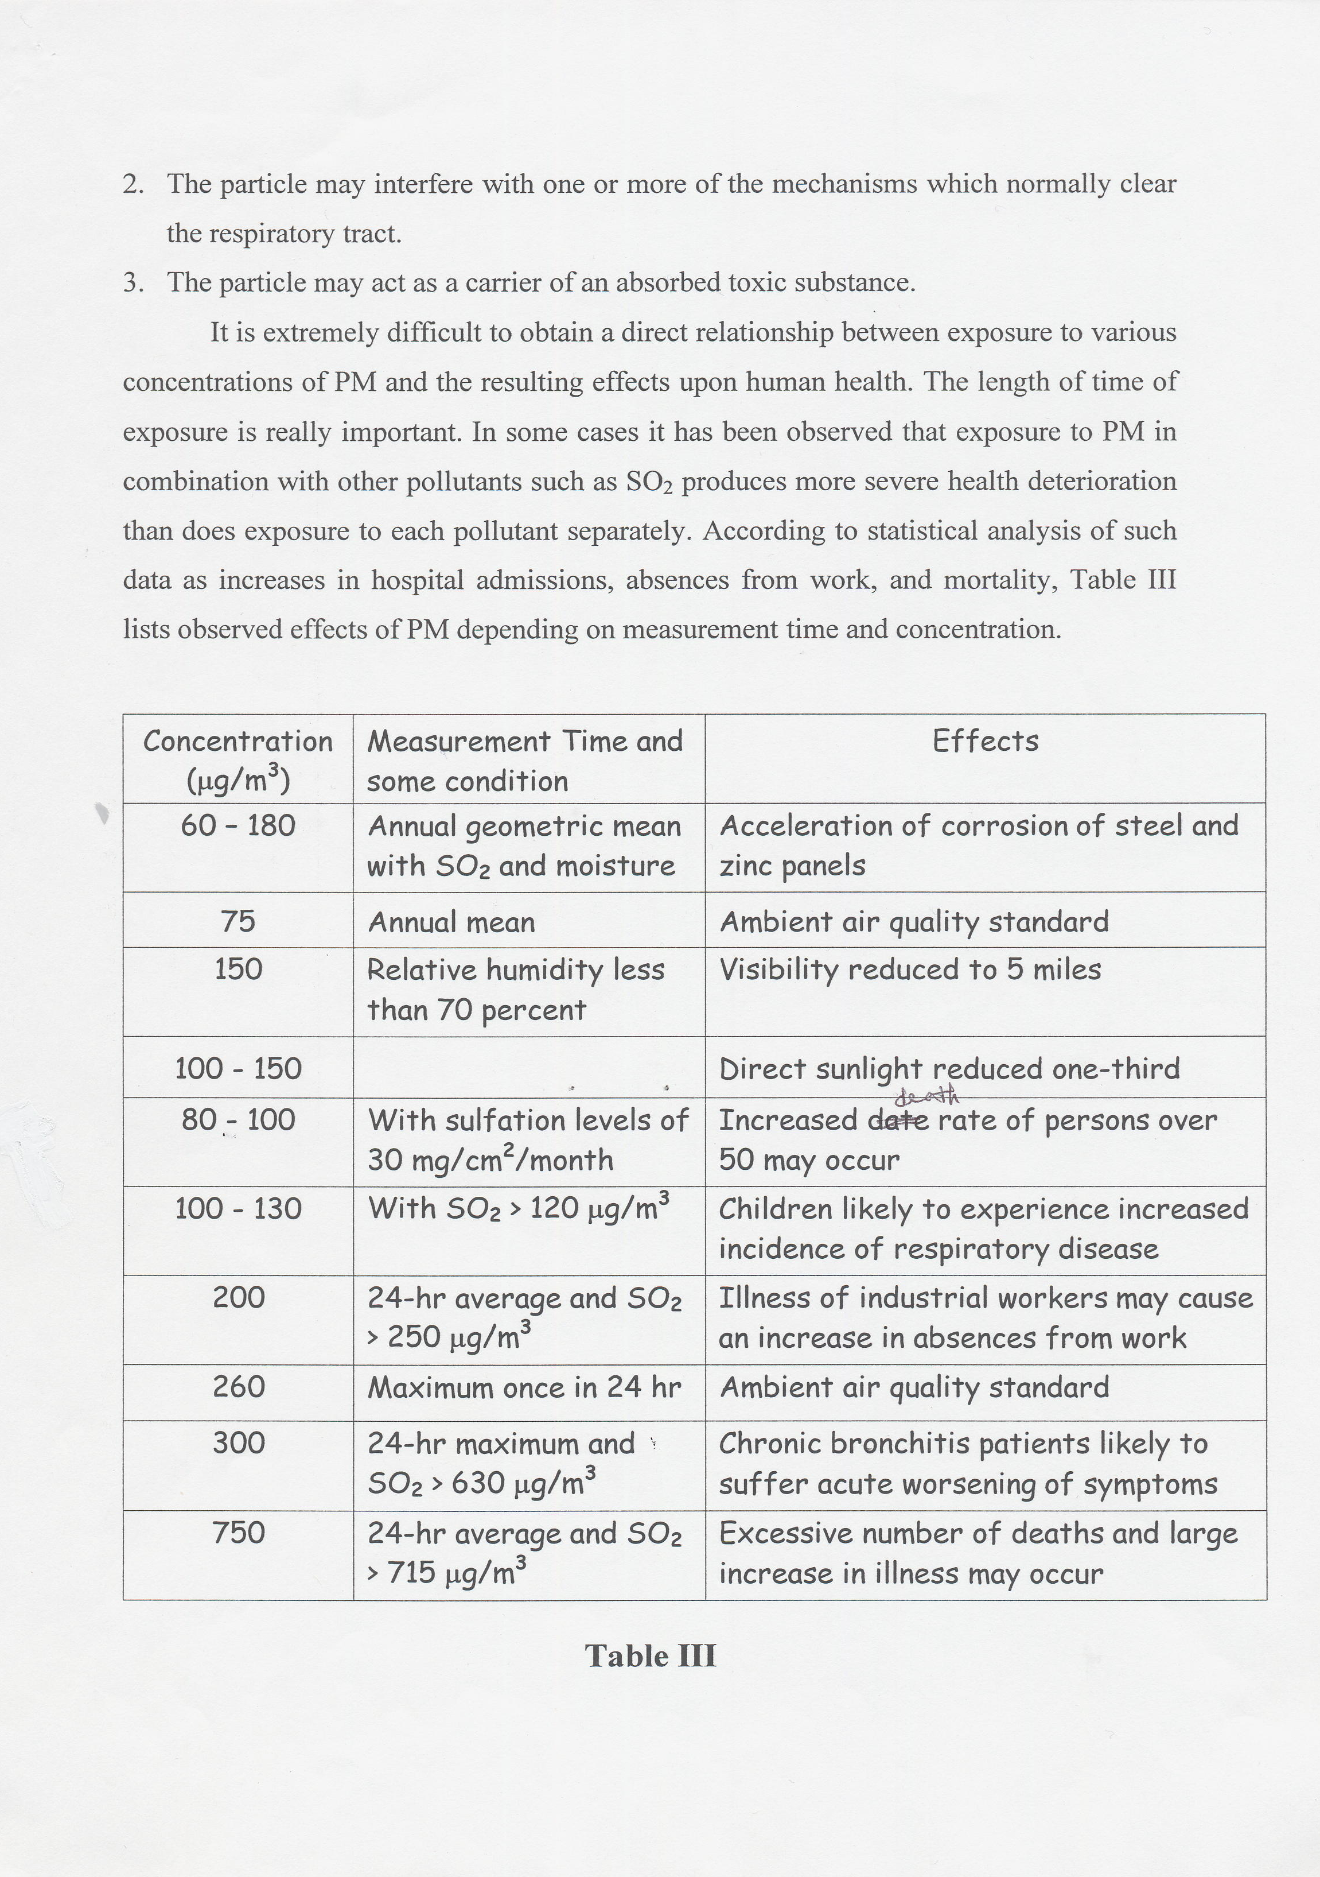

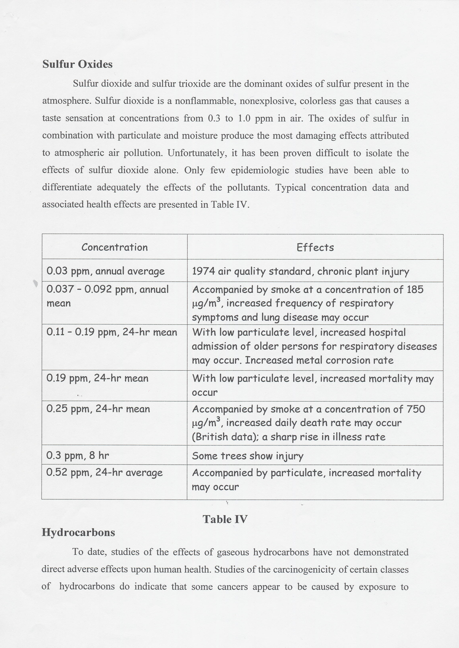
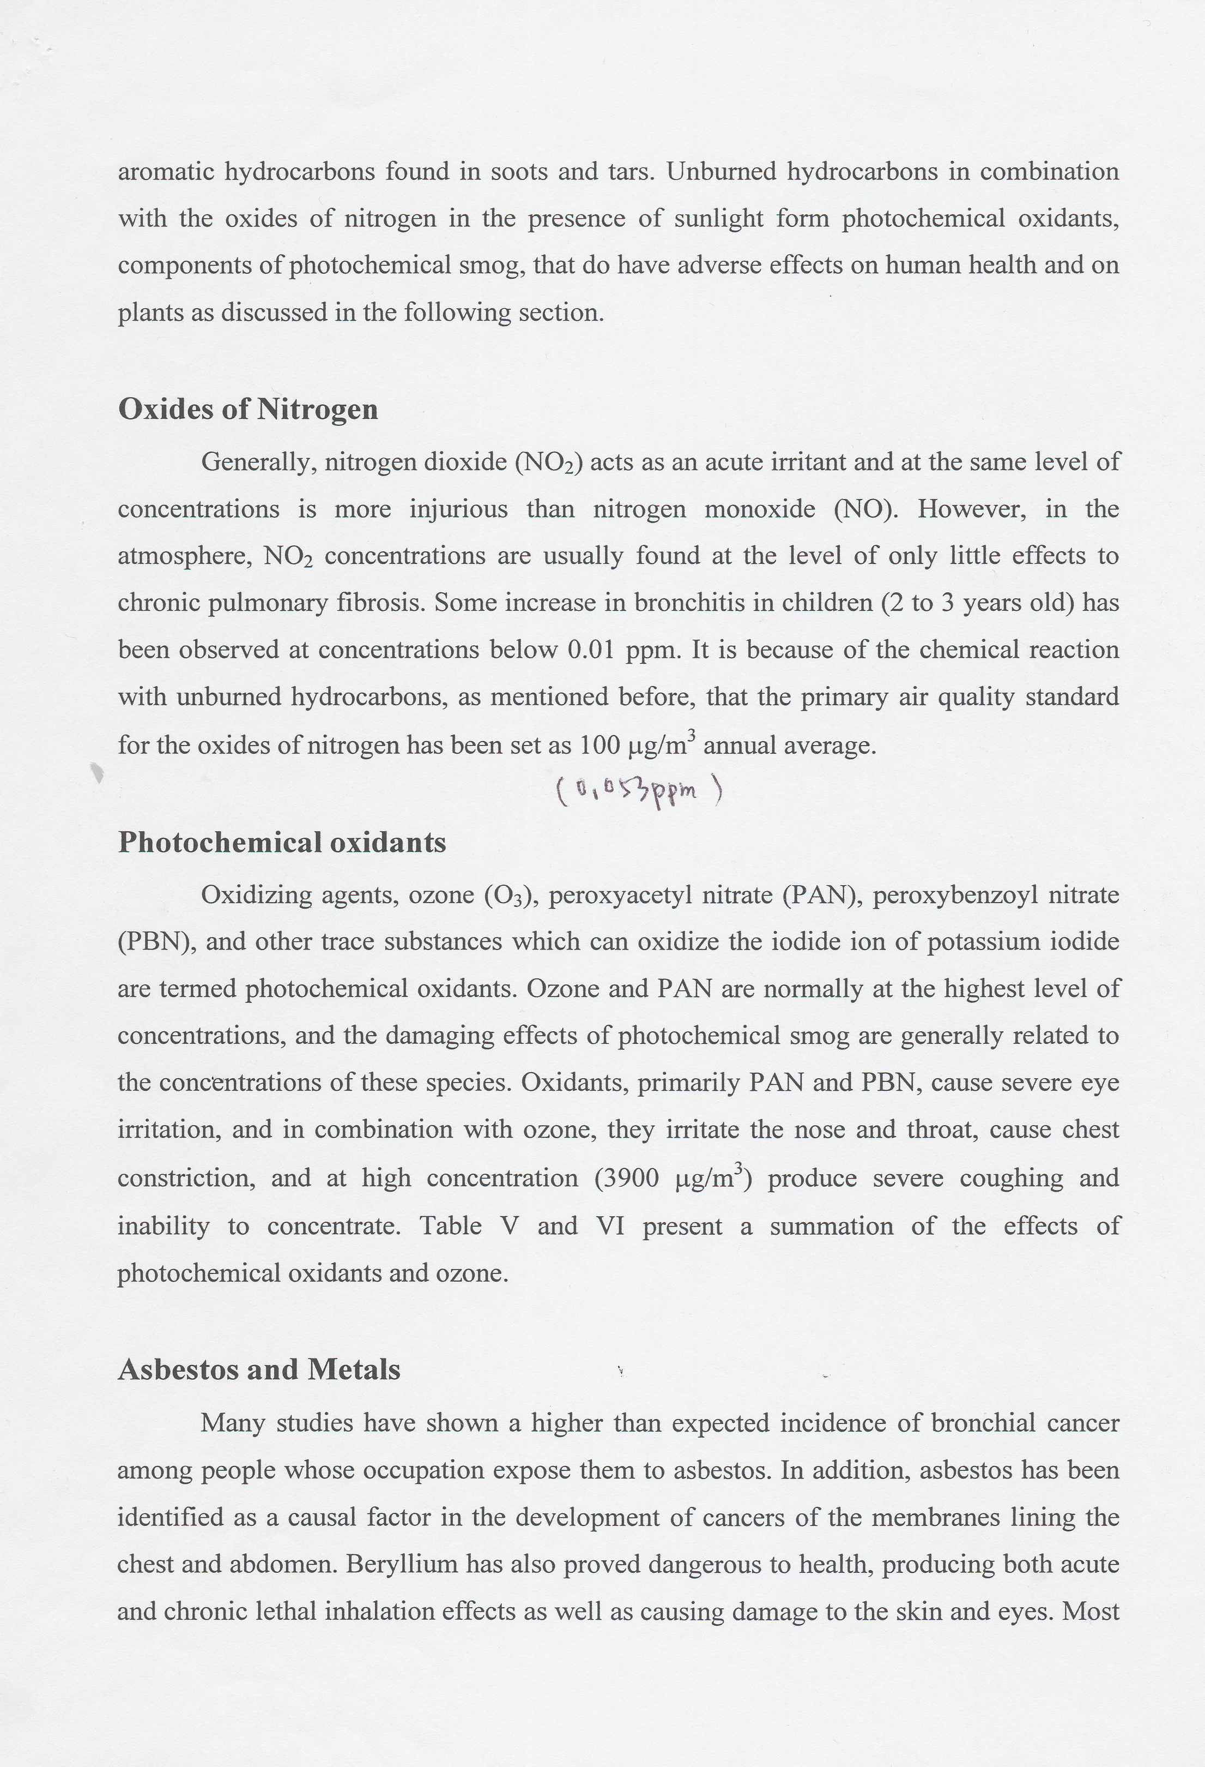
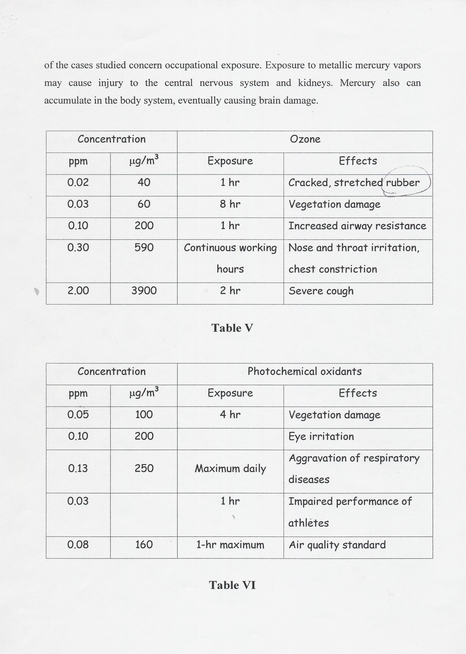
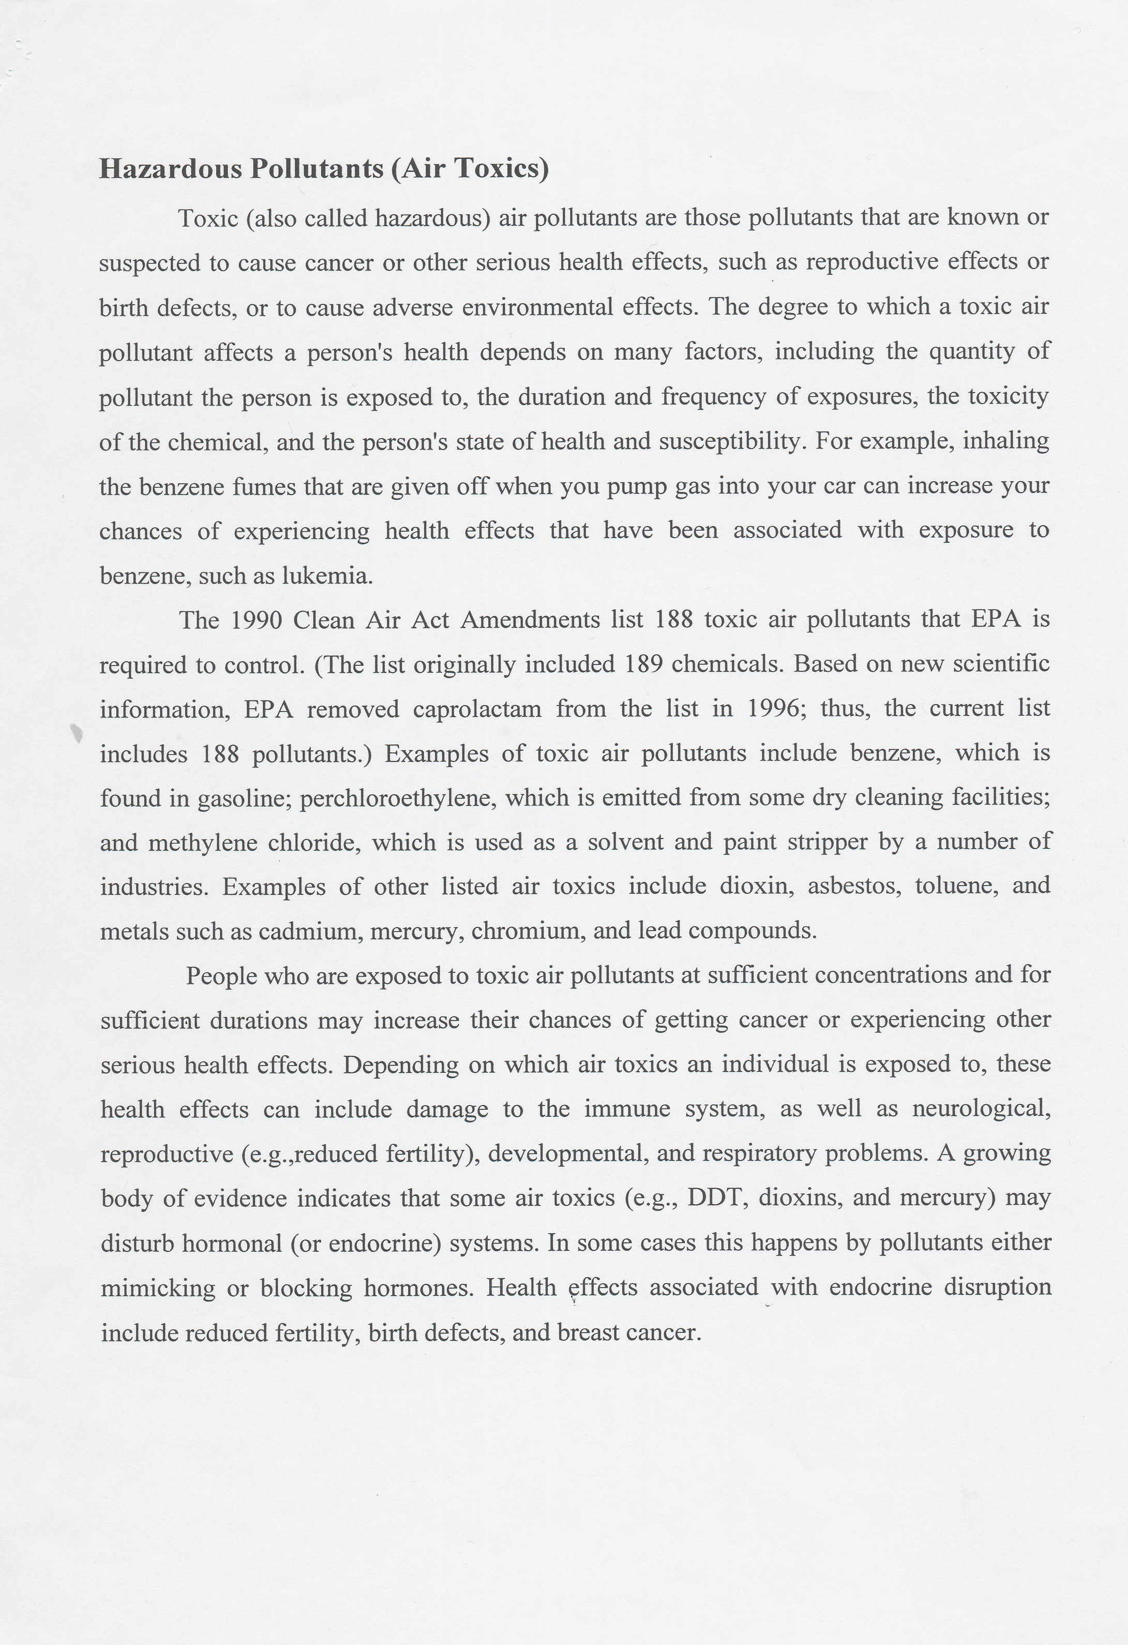

Sources of Air Pollution

- Urban and Industrial Sources
  - Power Generation
  - Industrial Facilities
  - Transportation
  - Process Emissions
  - Waste Disposal
  - Construction Activities

- Agricultural and Other Rural Sources
  - Dust blowing
  - Slashing Burning
  - Soil Emissions
  - Pesticides
  - Decaying Wastes

- Natural Sources
  - Wind Erosion of Soil
  - Volcanic Eruptions
  - Biogenic Emissions
  - Sea Spray and Evaporation
  - Soil Microbial Processes
  - Natural Decay of Organic Matter
  - Lightning

Atmospheric Pollutants

Particulate Matter

Particulate Matter: Solid or liquid particles suspended in a gas. Particulate matter may be emitted directly as particles or formed in the atmosphere by gas-to-particle conversion processes. They include a wide range of phenomena such as dust, fog, fume, smoke, mist, fog, clouds, smog, soot, and haze. Atmospheric particulate matter ranges in size from a few nanometers to tens of micrometers in diameter (up to 30 - 50 μm).

Size of Atmospheric Particles: Atmospheric particles come in various shapes. The majority of atmospheric particles are not spheres, may be with the exception of some combustion products. Thus, equivalent diameter is the used to characterize the size of the particles. An equivalent diameter is the diameter of the sphere that has the same value of a particular physical property as that of an irregular shape. Traditionally, we use aerodynamic diameter to describe the size of the particle.

Aerodynamic diameter: two particles with the same Stoke stopping distance for any initial velocity in air with the same viscosity are called to have the same aerodynamic diameter. If one refers to an unit density (1 g/cm³) and the same terminal gravitational settling velocity in still air as the actual particle in question, then the aerodynamic diameter is defined as

d_{aerodynamic} = d_{particle} x (ρ_{particle}) ^{0.5} , where

d_{aerodynamic} = equivalent aerodynamic diameter of a particle, micrometer;
d_{particle} = actual diameter of a particle, micrometer;
ρ_{particle} = actual density of a particle, g/cm³

Ultrafine particles: particles cover the range from large molecules to about 100 nm (0.001 to 0.1 μm)

Fine particles: particles less than 2.5 μm in diameter

Coarse particles: particles greater than 2.5 μm in diameter

PM_{2.5}: particles less than 2.5 μm in diameter

PM₁₀: particles less than 10 μm in diameter

Particle Modes: The mass distribution of particle size. More particles are found in three (or four) modes:
- Nucleation mode: varies from 0.005 to 0.1 μm and peaks at ~ 0.08 μm, accounting for the preponderance of particles by number. Particles are emitted directly from combustion sources or that condense from cooled gases soon after emission. The mass accounts for a very small percentage of the total mass.
- Accumulation mode: extends from 0.1 to 2.5 μm, which accounts for most of the aerosol (particle) surface areas. The mass accounts for a substantial amount of the total mass. These particles are formed by coagulation of particles in the nuclei mode or from condensation of vapor onto existing particles, or from anthropogenic/geologic sources of fine dust. It is reported in the literature that two sub-modes may show in the accumulation range: mode dominated by the "condensation" mode and mode dominated by the "droplet" mode.
- Coarse mode (or sedimentation mode): It varies between 2.5 to 25 μm and peaks at around 10μm. The mode is formed by mechanical processes that usually consist of man-made and natural dust particles.

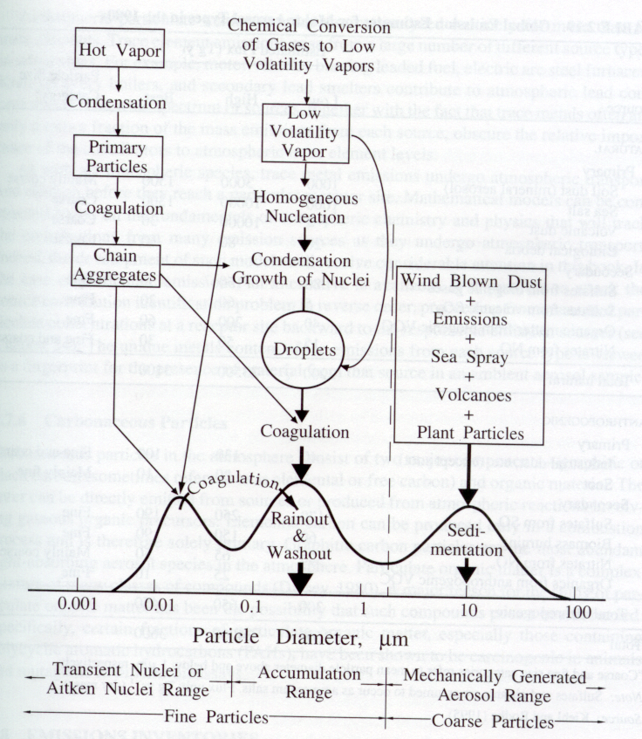

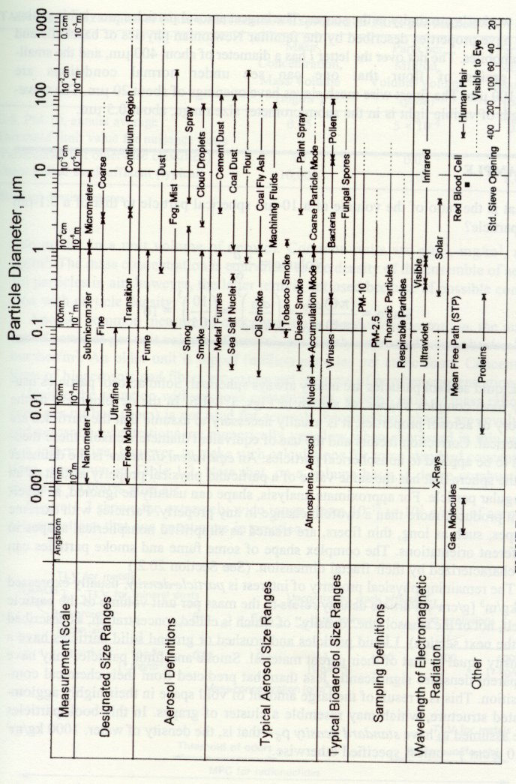
Chemical Components of Particles: Sulfate, ammonium, nitrate, sodium, chloride, trace metals, carbonaceous material (organic carbon and element carbon), crustal elements (oxides of aluminum, silicon, calcium, titanium, and iron), and water. Chemical components give fingerprints of the emission sources.

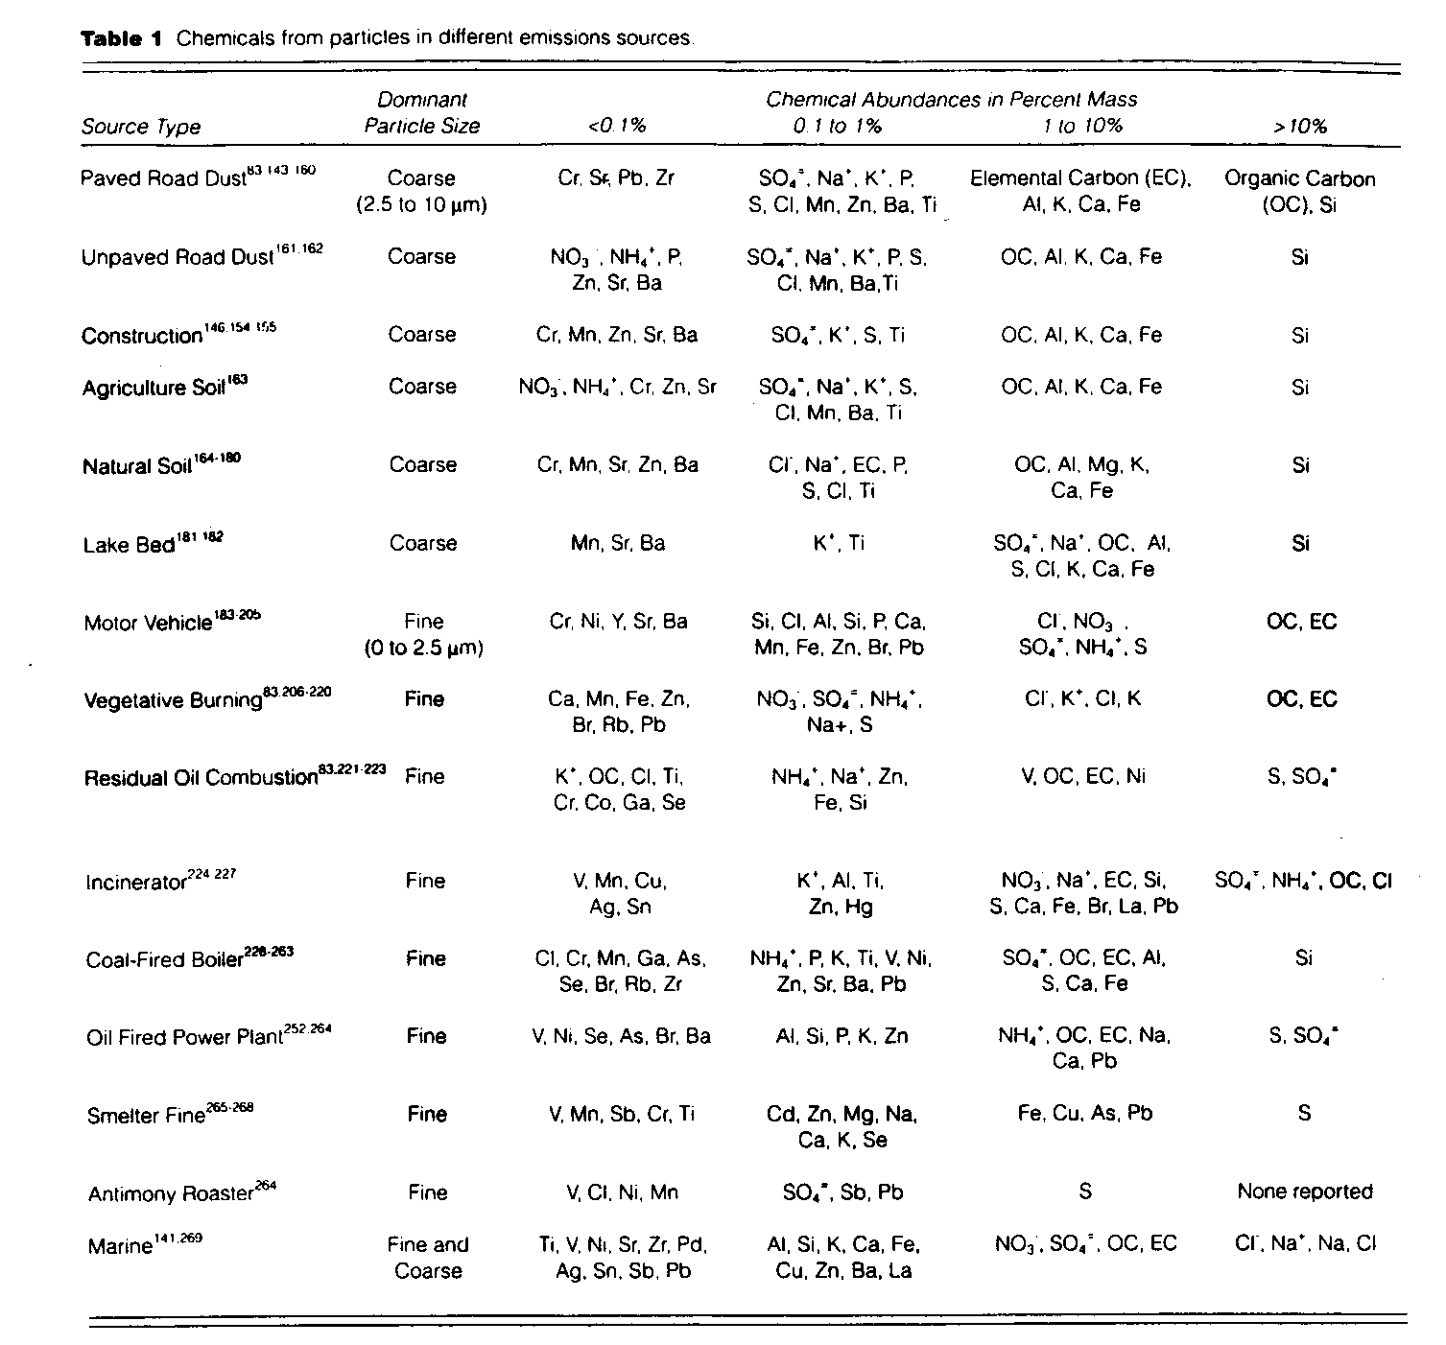

Effects of PM on Atmospheric Visibility
Rayleigh scattering: Any scattering process produced by spherical particles whose radii are small than about one-tenth the wavelength of the scattered radiation.
-dI = b_{ext} I dx
where
I = Intensity
b_{ext} = Extinction coefficient
dx = Length of the light path
Integrate the equation and apply the boundary condition (x = 0, I = I_{o}), we have,
I = I_{o} exp(-b_{ext} d)
Where I_{o} is the original intensity at x = 0.
The extinction coefficient typically represents the effects of light scattering and absorption by gas molecules.
b_{ext} = b_{Rayleigh} + b_{abs-gas} + b_{abs-part} + b_{scat-part}
The lower limit of visibility for most people occur when the light intensity (or contrast) is reduced to be 2 % of the unattenuated light beam, i.e., I / I_{o} = 0.02
ln(I/ I_{o}) = - b_{ext} d
ln(0.02) = - b_{ext} L
L = 3.9/ b_{ext} (Koschmieder Equation)

