Classnote – 4 Air Pollution Monitoring and Surveillance

There are two types of air pollution measurements required in air quality study, namely, the ambient monitoring and the source monitoring. Ambient monitoring aims at monitoring ambient air concentrations at specific locations and times for targeted pollutants. Source monitoring is conducted to determine the emissions of pollutants. Ambient air quality data can be used for regulatory compliance, exposure and health assessment, and receptor modeling. Source data are used for emission compliance at industrial facilities and in source modeling for estimating onsite and offsite exposure concentrations. Along with the pollution measurements, other parameters are routinely monitored to supplement the air pollution data. Depending on the applications and purposes of the pollution data, these parameters include atmospheric conditions (such as upper-air and surface meteorological data of wind direction, wind speed, humidity, temperature, etc), traffic data (fleet mix, traffic counts, etc), facility operating conditions (such as operating temperature, on/off time, material used etc), … etc.

- Ambient Monitoring

A. Ambient Air Monitoring

a. Measurements of Air Pollutants

1. Time-integrated Air Monitoring

Particulate Matter

Hi-vol: 1 m³/min

Mid-vol: 100 l - 1 m³/min

Low-vol: 10 l - 100 l /min

Quite often the sampling rate will be set at 1 m³/hr, which is approximately the same as the inhalation rate of an adult.

Personal: < 10 l/min

Vapor
Grab samples
Canister
Media

2. Continuous Air Monitoring

b. Measurements of Meteorological Parameters

1. Measurements of Surface Meteorology

Wind Direction
Wind Speed
Atmospheric Temperature
Atmospheric Humidity
Atmospheric Pressure
Vertical Temperature Profile

2. Upper Air Measurement

Balloon Measurements
Radiosonde: A balloon-borne instrument fitted with radio transmitters for simultaneous measurements and transmission of meteorological parameters of temperature, pressure, and relative humidity.

Rawinsonde: When the radiosonde is tracked by radar in order to obtain data on wind speed and direction at various altitudes, the system is known as rawinsonde. They are ypically tracked by a radar or radio direction finder.

Rocket-fired Equipment falling through the atmosphere: A Rocket is fired to release a sphere in the atmosphere. The sphere falls toward the earth. The velocity and accelerations are determined and the air density at different level can be deduced through the use of a ground-based radar. Air density can be determined because the air density increases and the drag force increases as the sphere falls through the atmosphere. Instrument packages are ejected from the sphere and slowly descend by parachute. Data is radioed to the ground.

Remote Sensing: Remote sensing attempts to measure the characteristics of the atmosphere with instrumentation that does not have a sensing element in or surrounding the volume of interest in the atmosphere. The instruments include sodar, long-wavelength radar, short-wavelength radar, CW lidar, and pulsed lidar.

- Air Monitoring Design

a. Stage of Air Monitoring

1. Pre-construction/remediation (Background) Monitoring

2. Post-construction/remediation Monitoring
3. Monitoring during Construction/remediation Activities

b. Pollutants to be Monitored

1. Criteria Pollutants

2. Non-criteria Pollutants

c. Monitoring Locations

1. Case I: Free from the impacts from other sources
2. Case II: Multisource emissions in flat terrain
3. Case III: Multisource emissions in complex terrain

d. Duration of Monitoring
Instantaneous: grab samples
Integrated: time-weighted average
Continuous: continuous recording of data

e. Sampling Methods and Procedures

1. Integrated Samples
PM Sampling
High-vol: >1 m³/min
Medium-vol: <1 m³/min but >0.1 m³/min
Low-vol: <0.1 m³/min
Personal sampling: portable low-vol monitors of <0.005 m³/min
Size cutoff: PM10, PM2.5, PM1.0 or cascade impactions for various sizes.

Gaseous Sampling
Absorption: the process of transferring one or more gaseous components into a liquid or solid medium in which they dissolve.

Physical Absorption: typically reversible

Chemical Absorption: by chemical reaction and typically non-reversible

Adsorption: the phenomenon by which gases, liquids, and solutes within liquids are attracted, concentrated, and retained at a boundary surface.

Physical Adsorption: by Van der Waal's interaction, dipole-dipole interaction, electrostatic interaction with adsorbents such as carbon, molecular sieve.
Chemical Adsorption: chemisorption

Condensation

2. Continuous Samples

f. Sampling Frequency: How often air samples will be collected

- Sampling Plan

h. Sampling Media

- PM
A common misconception is that particulate matter work like microscopic sieves in which particles smaller than the holes can get through the filters. In reality, particles are collected on the filters when they collide and attach to the surface of the fibers.
Fibrous filters: consist of a mat of fine fibers arranged so that most are perpendicular to the direction of flow. Typical fibrous filters are Cellulose fiber (wood fibers) filters, glass filters, and plastic fiber filters. The face velocity is generally low, about 0.1 m/sec. The size of the fibers range from submicrometer to 100 micrometer with high porosity, 70 - 99 %.
Porous membrane filters: have a structure different from that of fibrous filter with less porosity, 50- 90 %, than fibrous filters. Membrane filters have a higher collection efficiency and, as a result, a greater pressure resistance. They can collect particles much smaller than the manufacturer's stated pore size. The manufacturer's state pore size is defined based on liquid filtration. Porous membrane filters include filters made from cellulose ethers, sintered metals, polyvinyl chloride, Teflon, and plastics.

Capillary pore membrane filter (Nuclepore): The filters have arrays of microscopic cylindrical holes of uniform diameter. The material use for this type of filters is typically polycarbonate film of 10-micrometer thick. The efficiency of collecting particles smaller than the pore size is not as good as porous membrane filters. They are typically used for collecting particles for scanning electron microscopic analyses.

2. Gaseous Materials
Collection of gaseous materials depends strongly on the chemicals of concern. Different sampling media and techniques are required based on the laboratory procedures. Instantaneous and integrated sampling for non-reactive, non-degrading, high concentration chemicals are typically done using a pre-calibrated, cleaned canister. Samples are brought back to a chemical laboratory for GC/MS analyses. Other media are used to compensate low concentration and the requirements of various sampling times. Media commonly used are Tenex tube, silica gel, activated carbon, etc.

i. Network Design and Siting Criteria

1. Procedures
Collect and review information
- Source data
- Receptor data
- Environmental features

Determine level of sophistication for monitoring
- Screening
- Refined

Develop air monitoring plan
- Contaminants of concern
- Meteorological monitoring
- Monitoring network
- Monitoring methods
- QA/QC design

Conducting air monitoring
- Routine operation
- Quality control
- Field documentation

Determine whether further monitoring is required, If yes …..

Data Analysis/Reporting
- Data review and validation
- Data summary
- Uncertainty analysis
- Data evaluation
Decision making and follow-up analysis

Mission Completed

- Network Design: Consider topography, climatology, population, and existing sources

Source area

Emissions

Constituents of concern

Physical and chemical properties

Health effects

Available sampling methods

Project objectives

Resource constraints

Receptors of concern and sensitive receptors

Upwind-downwind configuration

Population of concern

Impact zone

Land use characterization

Prevailing wind conditions and general meteorology

Climatology

3. Number and Location of Monitors:

Meteorological monitors

Air monitors

Receptor characteristics

Source characteristics

Environmental characteristics

Siting constraints

Sampling duration

3. Siting Criteria
Sampling Height: Breathing zone, avoiding obstruction and traffic
2 - 3 m above ground, 2- 15 m above ground near roadways
Spacing: >10 m from trees
>2 m from walls, parapets, penthouses, etc if on roof.
twice the height difference between the inlet height and the building protrusion above the sampler
>2 m between sampler inlets
Obstruction and Road Interference: Unrestricted air flow from at least 270 degrees around the sampler.
5 - 25 m from the edge of the nearest traffic lane on the roadway depending on the vertical placement of the sampler inlet which could be 2-15 m above ground

Sampling Time:
Screening: 15 - 30 minutes integrated or continuous monitors
Refined: 24-hr integrated

Sampling Duration:
Screening: 1 - 2 days
Refined: 4 - 6 weeks

Sampling Frequency: Daily, alternate days, or every 6 days

Weather Consideration

j. Field QA/QC Procedures

1. Chain-of-Custody Information
Strict chain-of-custody protocol should be followed in the disposition of samples. The form should be signed off by a sample custodian upon arrival at the laboratory.

2. Air Monitoring Field Sampling Data
Record field data including ambient air temperature, flow rate, pressure, etc. Routine check of flow setting.

3. Sampling Quality Assurance

Flow measurements: Pre- and post- sampling measurement of air flow using primary standard flow calibrators.
Volume measurements
Temperature measurements
Pressure measurements
Determination of response factors, precision, and accuracy for continuous monitoring using span gases and zero gases.

4. Calibration of Instruments
Instruments should be calibrated using known standards or established calibration procedures

5. Collect Field Blanks

6. Collect Duplicate Samples
Approximately 20 - 25 % of the samples

7. Background Air Sampling

C. Data Reduction and Analysis

a. Wind data presentation and analysis

b. On-site reading confirmation

D. Laboratory Analysis and QA/QC Procedures

1. Analytical Methods

2. Sample Holding Time

3. Sample Holding Procedures

4. Sampler Cleaning and Certification

5. GC/MS Tuning and System calibration
Daily calibration using standards. Apply acceptance criteria for percent relative standard deviation in initial calibration to less than 30 % and percent difference in continuing calibration to 30 %.

6. GC Calibration and Retention Time Windows

7. Laboratory QC Samples

8. Detail Report

9. Reproducibility of Analysis
- Dichotomous PM Monitoring

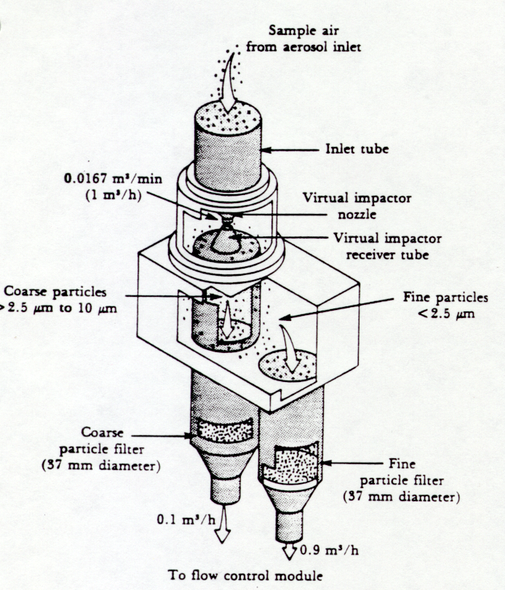
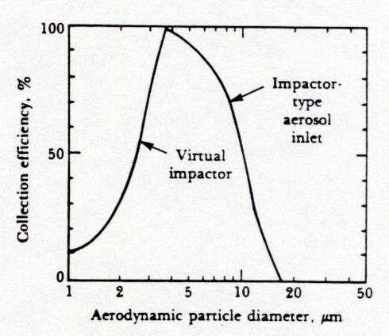
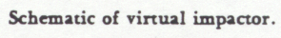
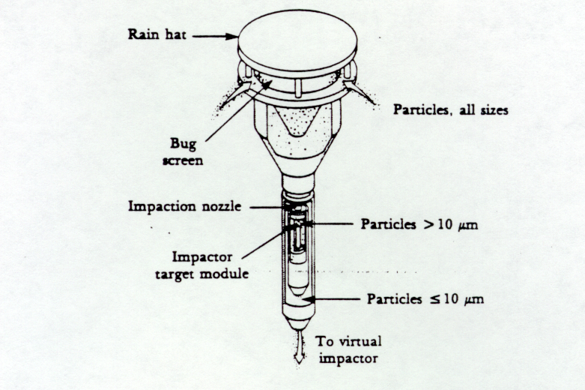
Determination of Air Concentration for a Dichotomous Air Monitor

Let
t = sampling time, sec Subscript
A= mass collected during time t, g T: total
M= mass collected on the filter, g F: fine particulate
F= flowrate, m³/sec C: coarse particulate
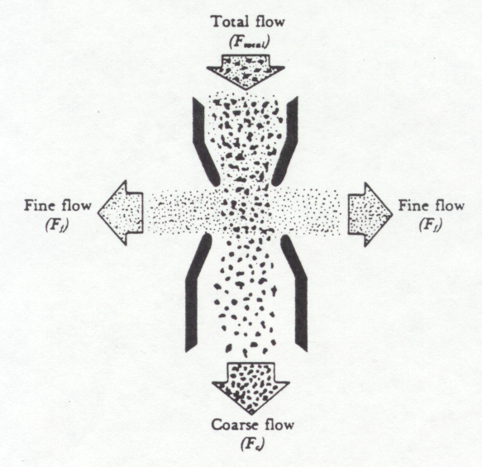
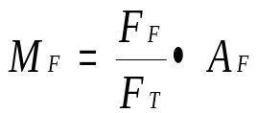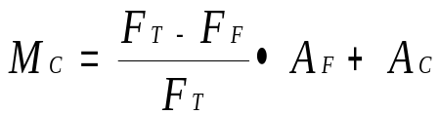
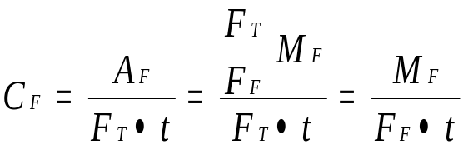
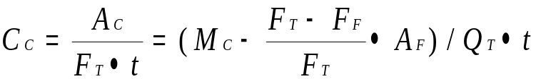
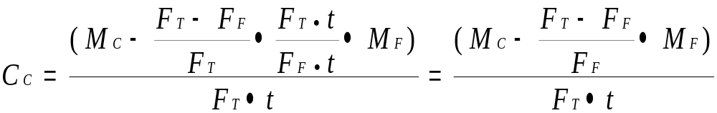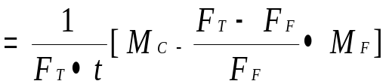
or
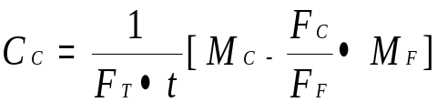 since F_{T} = F_{C} + F_{F}
- Source Monitoring

Qualitative Visual Emission Estimation by Opacity

Ringelmann Smoke Chart

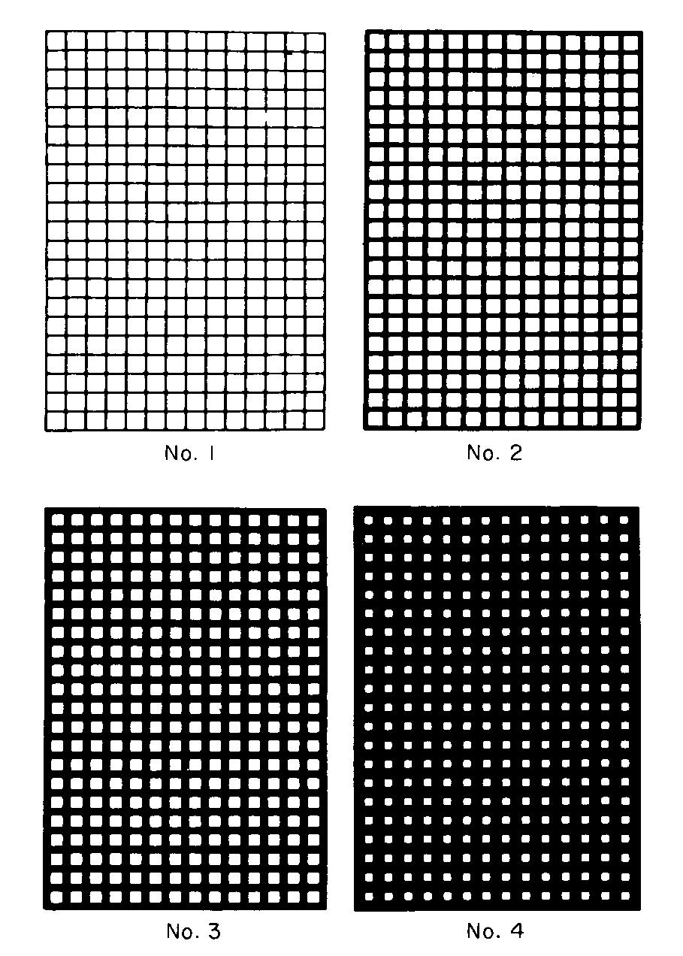

Figure 5-1 Ringelmann’s smoke chart, No. 1: 20 % opacity, No. 2: 40 % opacity, No. 3: 60 % opacity, No. 4: 80 % opacity.

Emission Estimation, Monitoring, and Modeling

A. Emission Estimation

1. Obtaining Existing Data from Available Sources

a. Plans of Plant
b. Preconstruction Permits
c. Certificates to Operate
d. Purchase Records of Chemicals
e. Emission Control Equipment Specifications
f. Stack Testing Results
g. MSDS of Products/Raw Materials
h. Compliance Reports
i. Operation Records

2. Methods Used for Emission Estimation

a. Actual Emissions
b. Potential to Emit
c. Methods Used to Estimate Emission Rates
- Mass Balance
- Emission Factors
- Engineering Calculations
- Emission Modeling
- Emission Measurements

3. Plant Inspection

- Identify All Emission Sources including

- Point Sources

- UST/ASTs
- Fuel Burning Equipment
- Process Tanks/Equipment
- Incinerators
- Pollution Control Equipment Discharges
- R&D Laboratories

- Fugitive Sources

- Process Tanks with No Hooded Venting
- Process Tanks with No Hooded Venting
- Painting in Open Areas
- Wastewater Treatment Tanks
- Metal Fabrication Operations

- Identify the Locations of Equipment

- Dimensions of Units
- Processes Conducted in Units
- Size of Vents
- Model Numbers of Pollution Control Equipment/Burners
- Hours of Operation
- Capacity of Equipment

4. Apply Existing Emission Factors

- Typically Developed by Regulatory Agencies
- Based on Ratio of Pollutants Emitted per Unit of Process Material Consumed
- Requires Minimal Process Knowledge
- Make Conservative Emission Estimates
- Available for Many Types of Sources (fuel burning, plating, etc)
- Use EPA Documents
- AP-42
- Toxic Air Pollutant Emission Factors
- Locating and Estimating Series
- Air CHIEF Software
- FIRE (use search engine for emission factors)
- NTIS
- EPA Website

5. Perform Engineering Calculations for Emissions not Found in Documented Existing Factors

- Utilizing Chemistry and Physical Principles
- Physical Change Associated with Processes
- Mixing
- Distillation
- Chemical Change Associated with Processes
- Combustion
- Chemical Conversion
- Established Methods for the Chemical Process Industry

- Source Categories

- Major Source
Any source (i.e., a contiguous area under common control) of toxic air pollution that emit or has the potential to emit 10 tons per year of any listed hazardous air pollutant, or a combination of listed hazardous air pollutants of 25 tons or more. The list of hazardous air pollutant is referred to the 188 chemicals listed in the 1990 Clean Air Act Amendment.

- Less Quantity Major Source
Certain other sources that are considered major sources even though they emit less than the 10/25 ton limit figure. Lesser quantities (meaning less than the 10 or 25 ton per year definition in the Act) can be set for pollutants which are highly toxic to human health or the environment. If WPA sets a lesser quantity limit for a particular industrial group, all sources within that group that emit more than the established limit, will be classified as major sources.

- Area Sources
These smaller sources emit less than 10 tons per year of a single air toxic, or less than 25 tons per year of a combination of air toxics. EPA has discretion over whether to regulate categories of these sources. Most area source emissions are small, but the collective volume can be hazardous in densely developed areas where large numbers of such facilities are packed tightly into urban neighborhoods and industrial areas.

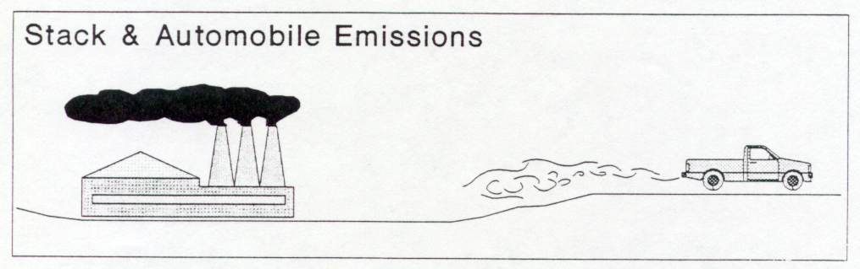
- Sources of Contaminant Emissions
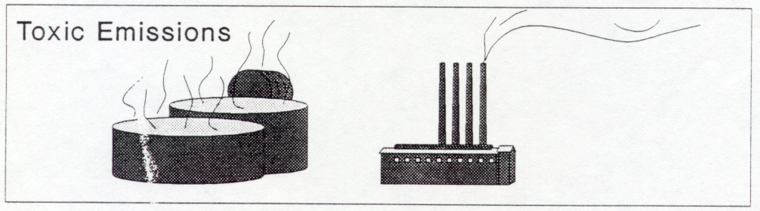

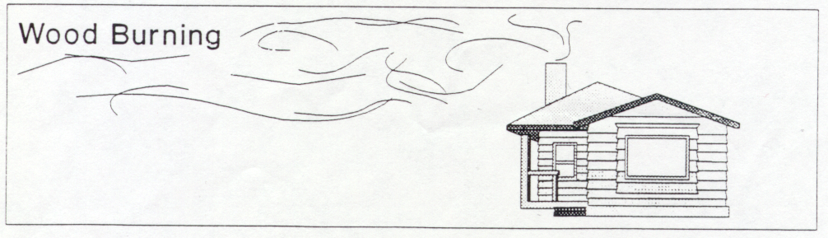
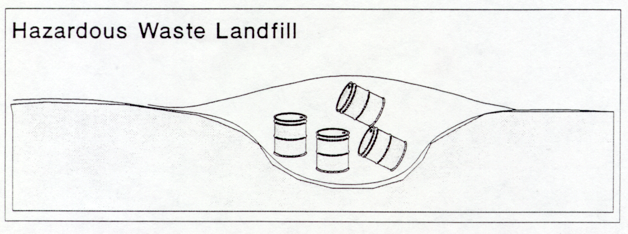
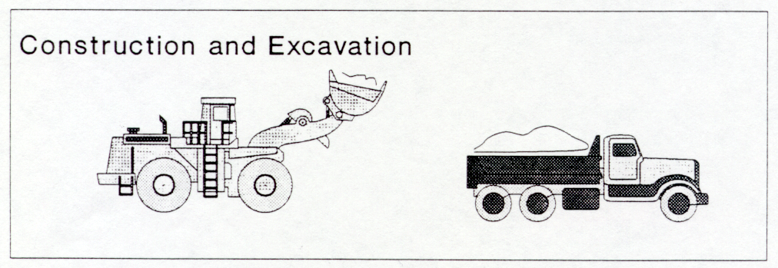
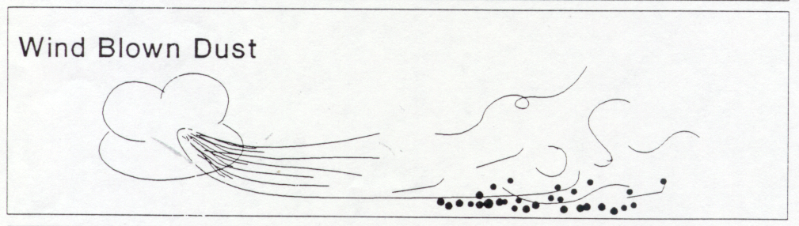
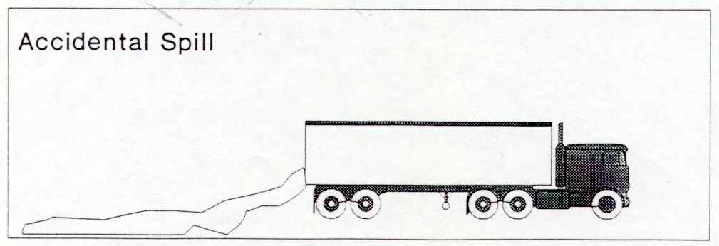

- Emission Monitoring
(Ref: EPA-450/1-89-002, Estimation of Baseline Air Emissions at Superfund Sites)

- Direct Emission Measurements
- Head Space Concentration Sampling (Vapors)
- Headspace Sampler: A chamber is placed on the surface of emission and the chemical concentration, the time elapsed, surface area covered, and the volume of the chamber are recorded.

Static Mode: A chamber is placed on the surface for a limited time and removed afterward.

E = (C V)/ (t A)

Where E= Emission rate, g/m²-s
C= Concentration of the chemical of concern, g/m³
T= Length of time, sec
V= Volume of the enclosure, m³
A= Surface area enclosed by the chamber, m²

Dynamic Mode: Clean air is brought into the chamber at a known flow rate and exit from the opposite side of the chamber.

E = C q/ A

Where E= Emission rate, g/m²-s
C= Concentration of the chemical of concern, g/m³
q= flow rate of sweeping air, m³/sec
A= Surface area enclosed by the chamber, m²

- Headspace Analysis of Bottled Samples
In this technique, samples are collected in a container and immediately sealed to prevent any loss of VOCs. After 5 to 30 minutes, the headspace vapor in the container is analyzed by field analytical equipment.

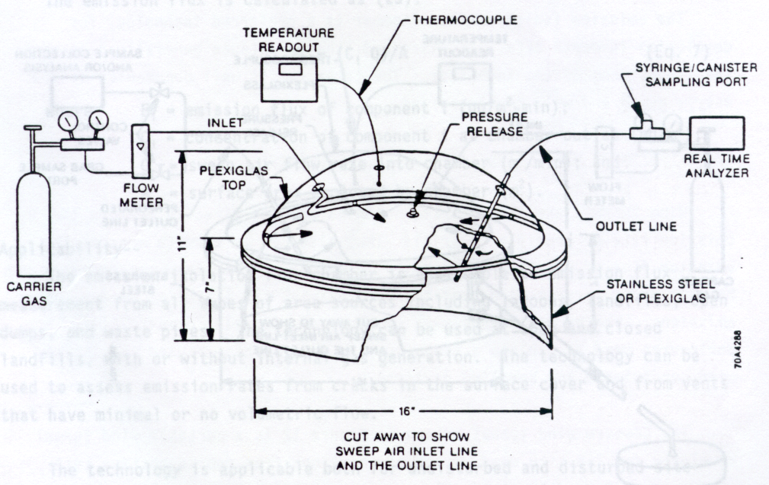
- Emission Isolation Flux Chamber (Vapors): This is a refined device of dynamic mode headspace sampling. A typical set-up of the flux chamber is shown below.

- Portable Wind Tunnel (Vapors, PM)
A portable wind tunnel applies the same technique used for the emission isolation flux chamber. It is primarily designed to aid the PM emissions.

- Soil Vapor Probes (Vapors): A device for monitoring the horizontal extent of soil gas plumes in near surface soils.

- Soil Vapor Monitoring Well (Vapors): Typically used to monitor the emission flux from subsurface soil and waste.

- Downhole Chamber (Vapors): The technique is the same as inserting an emission flux chamber into the subsurface for emission measurement.

- Vent Sampling (Vapors): Use the vents installed in landfills to calculate the emission rates.

- Indirect Emission Measurements
- Upwind/downwind sampling (Vapors, PM): Apply the Gaussian plume dispersion characteristics to estimate the emissions

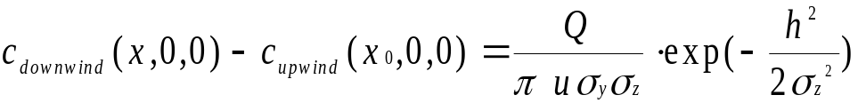For stack releases,

For area sources,
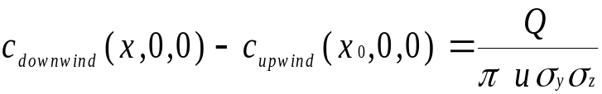

- Mass Balance (Vapors)
- Real-time Instrument Survey (Vapors, PM): Direct continuous concentration measurements above an area source
- Concentration Profile (Vapors, PM)
- Transect (Vapors, PM) Lateral ground-level concentration profile at a specific downwind distance and vertical concentration profile at a specific downwind distance.
- Boundary Layer Emission Monitoring (Vapors, PM): Apply a modified box model to estimate the emissions.

Example: Procedures for estimating CO emissions from oil furnaces emitted per day for a city of 50,000 population (using emission factors)

- The source is oil furnaces within the boundary area of the city
- The pollutant of concern is CO
- Determine the emission factors for CO from AP-42 Table 1.3-1 (see below).
5 lb/10³ gal of fuel oil = 600 g/1000 l of fuel oil
- Obtain the fuel oil sale figures from the local dealers association, say, 40,000 l/day
- Compute the emissions of CO per day
600 g/1000 x 40,000 l/day = 24,000 g/day

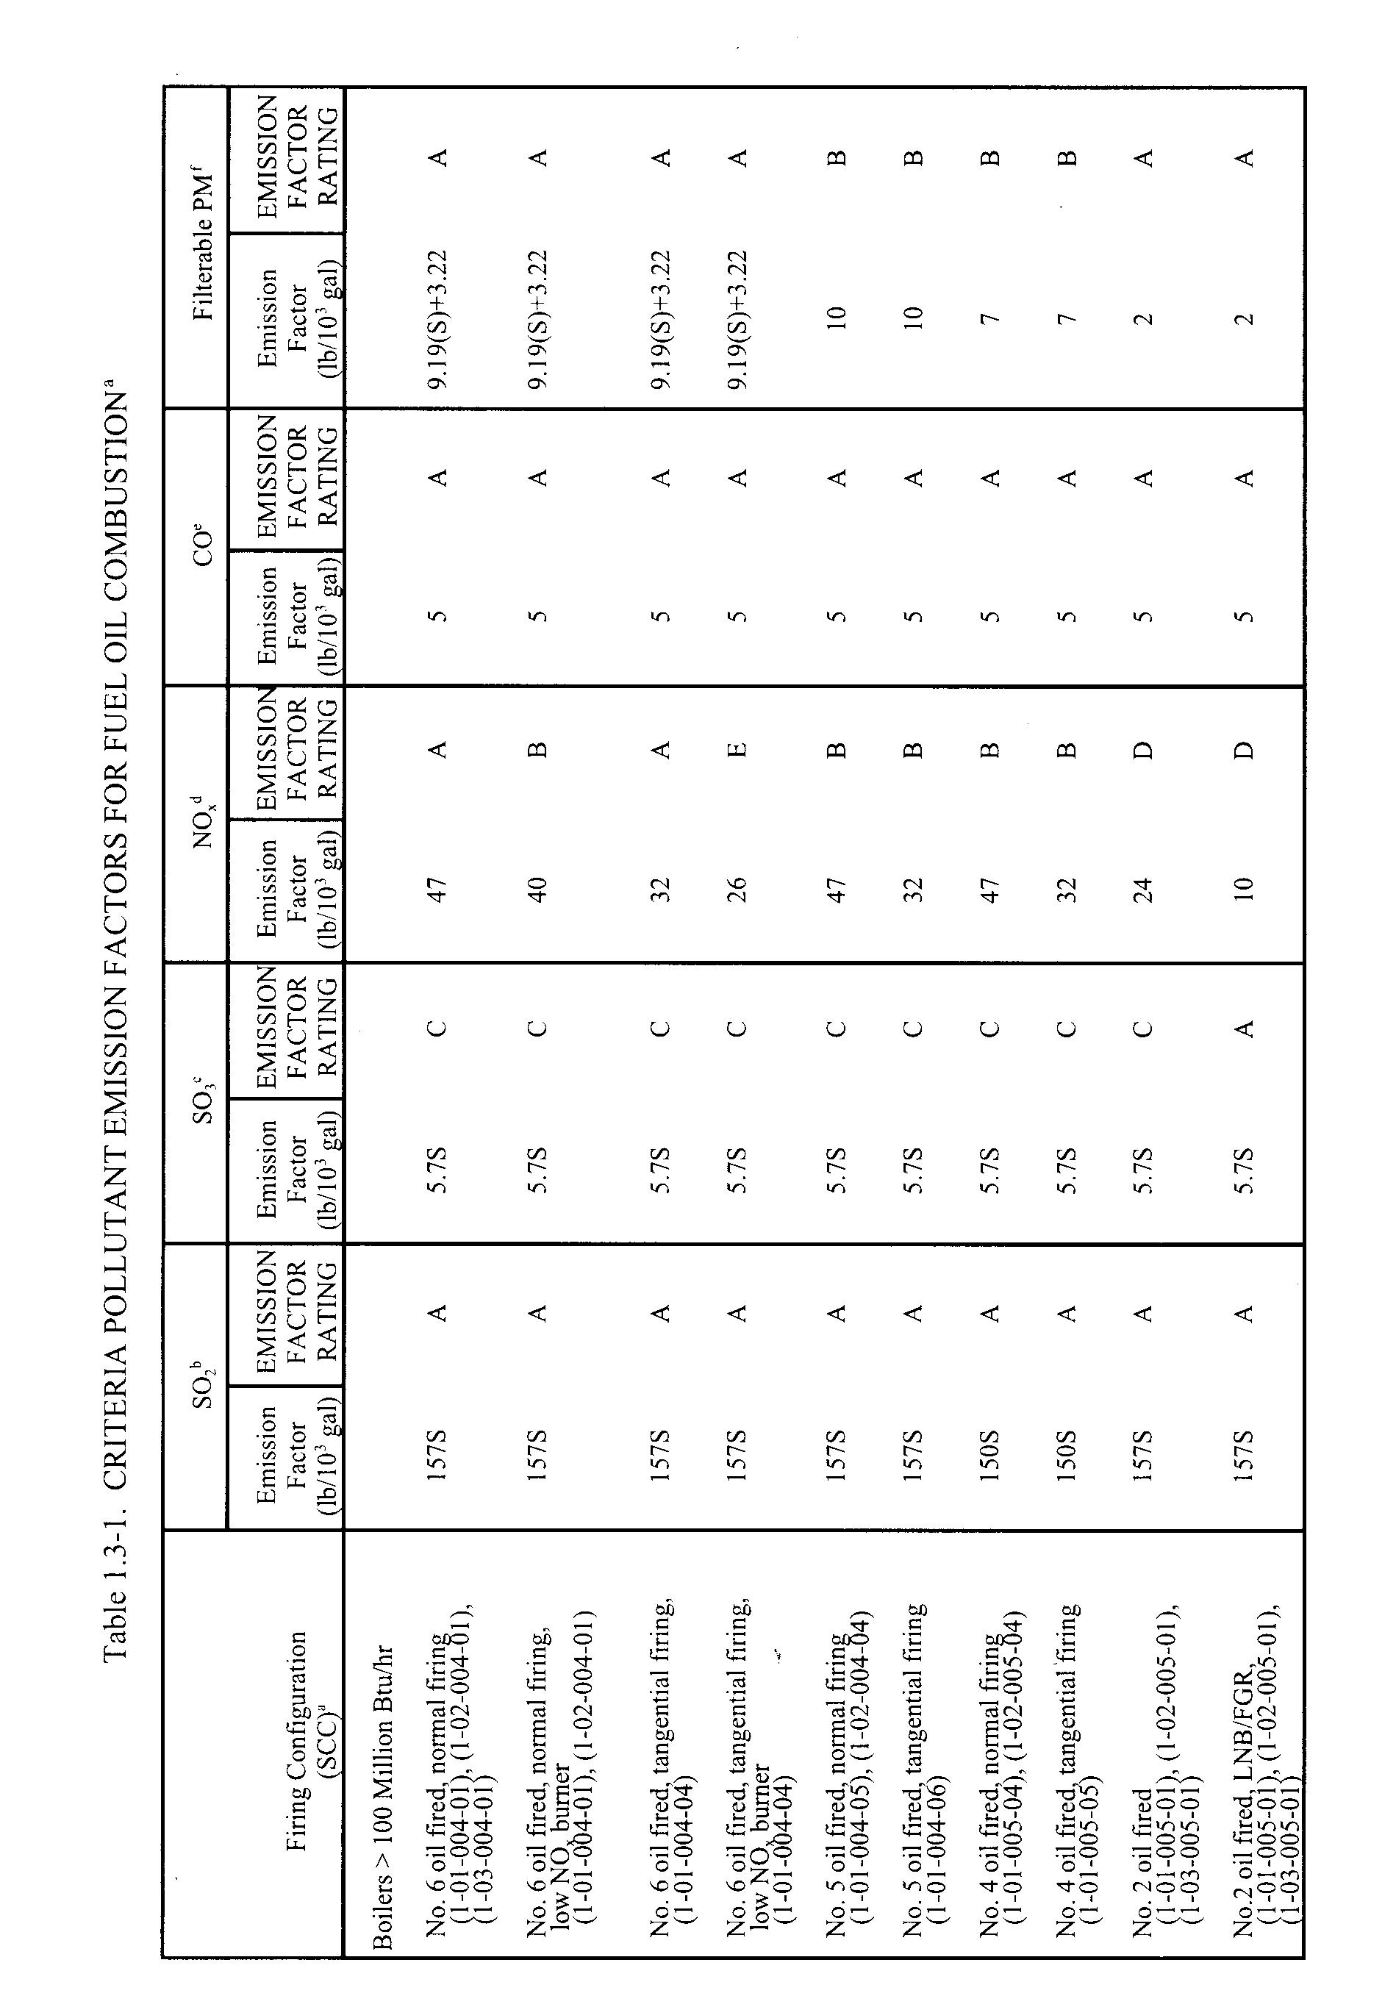

Emission Modeling

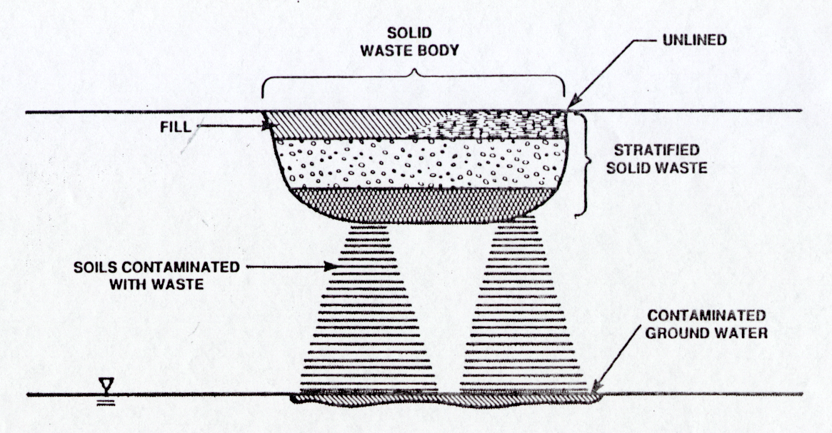

- Mass Transfer between Liquid Phase and Vapor Phase
- Pure/High grade Liquid
- Aqueous

- Emissions from Closed Landfills without Internal Gas generation

- Emissions from Open Landfills/Exposed Wastes

- Emissions from Groundwater

5. Emissions with Activities Related to Wastewater Treatment

6. General Form of One-dimensional Unsteady-state Emissions
(Jury, et al, 1990. Water Res. Res. Vol. 26, No.1, p 13-20; EMSOFT, 1997. NCEA-W-0073, Section 2)
Emissions from combustion by stoichiometric analysis
Let's consider the combustion of some hydrocarbon compounds, C_{x}H_{y}. C_{x}H_{y} can be any compounds such as CH₄ , C₂H₆ , C₆H₆, C₆H₁₄ etc. During the combustion process, typically excessive air will be provided to ensure that sufficient oxygen gas is available for complete combustion. The amount of excess air is indicated as a fraction (E) of air by stoichiometric requirement. In addition, water vapor is always present in the air fed into the combustor. The water vapor is generally expressed as a fraction (X) of the dry air. Let's now look at the stoichiometric requirement for combustion 1 mol of C_{x}H_{y.} i.e.,
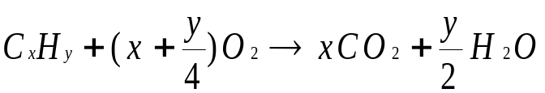
To be more specific about the amount of air required and amount of gas generated by the combustion, we can rewrite the above equation to include all components of the air as below:

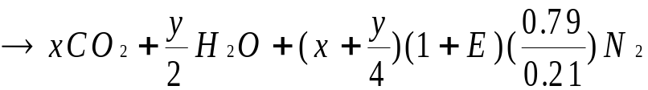
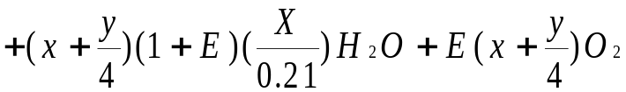

Thus, by providing sufficient amount of air, with E excess air and X humidity, we generate the following gases each time we burn 1 mol of hydrocarbons:

x mol of CO₂
y/2 mol of H₂O from combustion and additional (x + y/4)(1+E)(X/0.21) mol from supply air
(x + y/4)(1+E)(0.79/0.21) mol of N₂ from supply air
E(x + y/4) mol of O₂ from excess air

The total amount of gases generated by the combustion process is
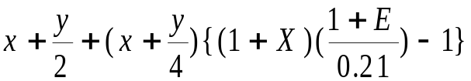
Fugitive vapor emissions (steady-state)

a) Low volatility compounds

Emissions from landfills (or buried materials) without internal gas generation
Emissions from landfills or covered waste can be described by the steady-state diffusion equation:
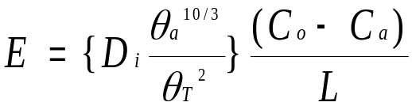

Where
E = Vapor emission flux through the soil surface, g/m²-sec;
D_{i} = Chemical-specific diffusion coefficient in air, m²/sec;
_{a} = Air-filled soil porosity, m³/ m³;
_{T} = Total soil porosity, m³/ m³;
C_{o} = Air concentration of the chemical in the soil pore beneath the cover, g/m³;
C_{a} = Air concentration of the chemical at the soil-air interface, g/m³; and
L = Depth of the cover soil, m.

D_{i} varies between 1 x 10⁻⁷ and 1 x 10⁻⁵ m²/sec for the majority of the chemicals. C_{a} is assumed to be 0 at the zone immediately above the surface based on the assumption that the atmospheric winds rapidly disperse the concentration such that no vapor accumulation would occur. For a worst-case analysis, assume the total soil porosity equals the air-filled soil porosity (i.e., dry soil).
Spills and Leaks
Spills or leaks of liquid chemicals will form pools of liquid on the surface. Chemicals will quickly absorbed by the soil and depletion of chemicals from the soil depends on the three-phase equilibrium in the soil and the quantity of the chemical available for evaporation. The process is typically not considered steady-state. For a simplified approach, we assume that a visible pool is formed such that sufficient amount of chemical is available for a stead-state emission.

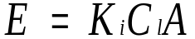
Where
E = Vapor emission flux through the liquid surface, g/sec;
K_{i} = Overall mass transfer coefficient, cm/sec;
C_{l} = Concentration of the chemical constituent in the liquid phase, g/cm³; and
A = Area of the pool, cm².

The overall mass transfer coefficient for aqueous solution (much diluted, low-concentration liquid) can be determined by the following equation:
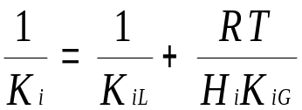

Where
K_{i} = Overall mass transfer coefficient, cm/sec;
K_{iL} = Liquid phase mass transfer coefficient, cm/sec;
K_{iG} = Gas-phase mass transfer coefficient, cm/sec;
H_{i} = Henry's law constant for compound I, atm-m³/mol;
R = Ideal gas law constant, 8.2 x 10⁻⁵ atm-m³/mol-K; and
T = Temperature, K.

K_{iL} and K_{iG} are available in many handbooks and technical references. Different forms of the coefficients have been developed for different environmental conditions.

b) High volatility compounds

Emissions of a high volatility compound depend strongly on the physical state of the compound as it leaves the containment and the manner in which it enters the atmosphere to form a vapor cloud. The physical properties of the compound and the storage conditions define the emissions. A liquid can volatilize completely or partially as it leaves the containment. It can form an immediate vapor cloud, a pool of liquid, a mist of droplets, or combination of all. Emissions of highly volatile compounds can be classified into the following categories:

- Two-phase choked gas release
- Two-phase unchoked gas release
- Two-phase pressurized liquid release
- Two-phase refrigerated liquid release
- Single-phase choked gas release
- Single-phase unchoked gas release
- Single-phase liquid release

Fugitive vapor emissions (unsteady-state)

See EMSOFT Chapter 2.

http://cfpub.epa.gov/ncea/cfm/recordisplay.cfm?deid=2862

